Basic scone recipe: Our best scones, with only four ingredients 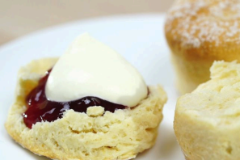

 419 ratings

Prep 15m

Cook 25m

Makes 16

Ingredients (6)

3 cups self-raising our

80g butter, chilled and cubed

1 to 1 1/4 cups milk

Plain our, for dusting Jam, to serve

Whipped cream, to serve

Method

Step 1

Preheat oven to 200°C. Sift self-raising our into a large bowl.

Step 2

Using your ngertips, rub butter into self-raising our until mixture resembles breadcrumbs.

Step 3

Make a well in the centre. Add 1 cup of the milk. Mix with a at-bladed knife until mixture forms a soft dough, adding more milk if required. Turn onto a lightly oured surface. Knead gently until smooth (don't knead dough too much or scones will be tough).

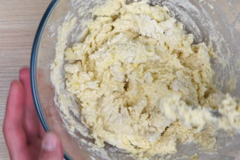

Step 4

Lightly dust a at baking tray with plain our.

Step 5

Pat dough into a 2cm-thick round. Using a 5cm

(diameter) round cutter, cut out 12 rounds. Press

dough together and cut out remaining 4 rounds.

Place scones onto prepared baking tray, 1cm apart.

Sprinkle tops with a little plain our. Bake for 20 to

25 minutes or until golden and well risen. Transfer

to a wire rack. Serve warm with jam and cream.

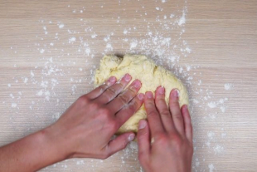

Recipe notes

What’s the secret to a good scone?

There are a few tricks to consider when making the perfect scone recipe, one being to make sure all the ingredients used are chilled. Cold butter prevents the butter from melting before the scones are baked, and instead will help you achieve a lighter crumb. It’s also important to not over-mix the dough as this will create a tough and chewy scone. This is why we don't recommend using a food processor.

While some recipes use baking powder to help scones rise, this recipe doesn't require baking powder as a raising agent, as the scone dough contains a mixture of plain and SR our for a light and uffy result. There are few things better than uffy freshly baked scones. And we think this might be our best scone recipe yet. Afternoon tea, anyone?

What were the original ingredients of scones?

Believe it or not, scones were originally made out of oats. They were also typically griddle-baked over an open re instead of in an oven. This ideal afternoon tea scone recipe is far from these humble beginnings. Some people like to add chocolate chips, or opt for cheese scones, and this classic scone recipe serves as a great basic base from which to get creative.

What can I put on a plain scone?

Scones are super versatile, so forget the jam and cream (or clotted cream) and get creative with what you put on top of them! We love adding lemon curd to ours (try this lemon squash scone recipe) if you want to take your lemon scones up a level), but we also enjoy adding savoury tomato pesto and mozzarella cheese to plain scones like these.

What’s the best way to keep scones soft?

By freezing the dough before baking, this will help keep the butter solid, creating little air pockets in the scones once cooked. This gives them a super soft and airy texture when the scones rise. While you can also freeze scones, they're much better baked and eaten fresh. You can enjoy scones cooled or served warm.