2023 MUSIC CAMP PARENT PAYMENT

Dear Families,

Our Music Camp for 2023 will be held at Urban Camp, Parkville (near the zoo) and is planned for the weekend commencing Friday, the 5th May, from Period 4 and will run until Sunday the 7th May (Term 2 Week 2). We will be travelling to Urban Camp by tram so all students will need to have their Myki card.

Ellyce Calder, Les Gyori, Tony Hicks, Susan De Jong, Andy Clarke and Anne Corry will be the staff attending the camp.

The camp will culminate with a celebratory concert performance at 11:00am on Sunday, 7th May. Parents, Carers, Grandparents and Friends are invited to attend. Students will be dismissed to families following the conclusion of the concert at noon. Parking is available at the Hockey Centre

This is a great opportunity for students involved in our various ensembles, such as Choir, Acapella Choir, Orchestra, Senior and Junior Rock Bands and our String Ensembles to develop new friendships within their ensemble and get to know their fellow ensemble members better. The camp provides an important opportunity for students to develop their repertoire, harmonising, music reading and intonation skills.

The key focus for the camp is to learn a large range of repertoire both in sectional and whole ensemble rehearsals in preparation for our combined Music Concert later in the year to celebrate the opening of our new Performing Arts Centre!

Other activities will include a Movie Night on Friday and an “MGC’s Got Talent”/Band Jam on Saturday night. We may also walk to Lygon Street (weather permitting) on Saturday afternoon as a break from rehearsals. Students will need to bring money if they wish to purchase a gelato.

All students enrolled in our ensembles are strongly encouraged to attend the camp. The camp cost is $200 per student. This cost includes all activities, meals, and accommodation.

We can accommodate students’ needs in the instance they may have a weekend sporting or work commitment so they can still attend.

If you would like further information regarding the extra-curricular program, please email the Program Leader, Anne Corry anne.corry@mgc.vic.edu.au

If you have any payment inquiries or wish to discuss alternative payment options, please contact Darcy Lynch in the General Office via email Darcy.lynch@mgc.vic.edu.au or 9428 8955.

Payment details need to be returned to the General Office by Friday 31st March 2023.

The camp payment is non-refundable.
NB: Payments will not be processed until the minimum number of students attending (40) is reached.

Yours sincerely,

Anne Corry
Instrumental Music Leader

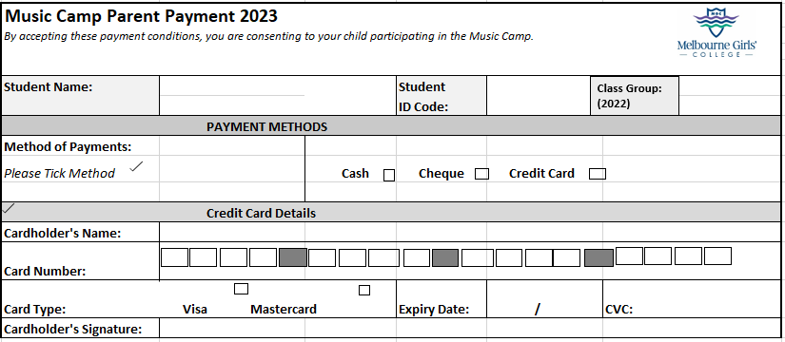

MOVIE PERMISSION

I give my child permission to watch a PG movie on Friday night.

Please Circle: Yes / No Name:…………………………………………

