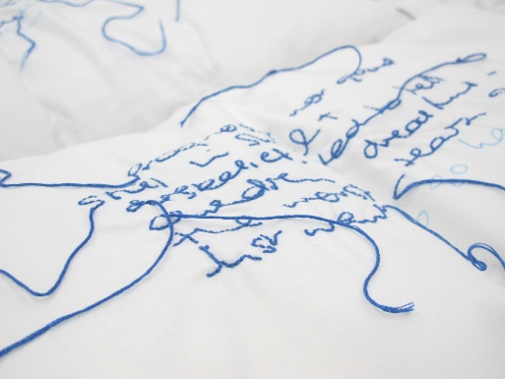

VISUAL ART STUDIO TERM 3 2026
Lamentation 2014
Handee II 2025
Palimpsest of Place 2025
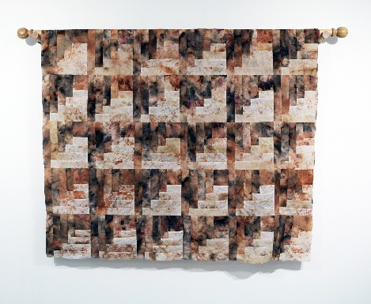
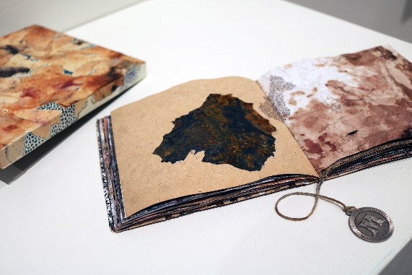
The Artist Book: material memory – mapping place
with our ARTIST IN RESIDENCE – KARIKE ASHWORTH
Term 3 / 2026/ Fridays / 2.30—4.15 pm
In this hands-on workshop, students will explore the idea of place through natural dye, frottage and expanded drawing. Using aerial imagery and layered stained papers, participants will investigate how surfaces hold memory and how books can function as contemporary artworks.
Students will create natural dye bundles using tea, onion skins and plant materials, allowing the sun to transform their papers with organic colour and texture. These dyed pages will then be constructed into a small square hand-stitched artist book, which students will develop further through graphite drawing, frottage and subtle stitch.
The workshop culminates in an exhibition of the finished books in the Tula Gallery.
Dr Karike Ashworth is a multidisciplinary artist, researcher and teacher based in Samford Valley. Over more than a decade of professional practice, she has exhibited widely across Queensland and nationally, with work spanning installation, textiles, paper and material-based processes. She holds a PhD in Visual Arts and her practice explores themes of place, memory and the domestic through hand-based techniques such as dyeing, stitching and weaving. Karike has been the recipient of several art awards and has undertaken residencies and community-engaged projects across regional Queensland. She is an active member of the local arts community and continues to exhibit and develop new bodies of work.
Visual Art Studio 2026 - INVITATION TO ENROL
Term 3 Artist Book: material memory – mapping place
Classes are on Friday 2:30pm – 4:15pm - $210 per student 7-week course.
Visual Art Building, G2 commencing, TERM 3 Week 3

Enrolment Application TERM 3: ARTIST BOOK
Name:_____________________________________________________________________
Class: _____________________________________________________________________
Parent Name : _______________________________________________________________
Parent Email :_______________________________________________________________
Parent Mobile :_________________________________________________________
Please complete and return to: visualartextension@thegapshs.eq.edu.au

