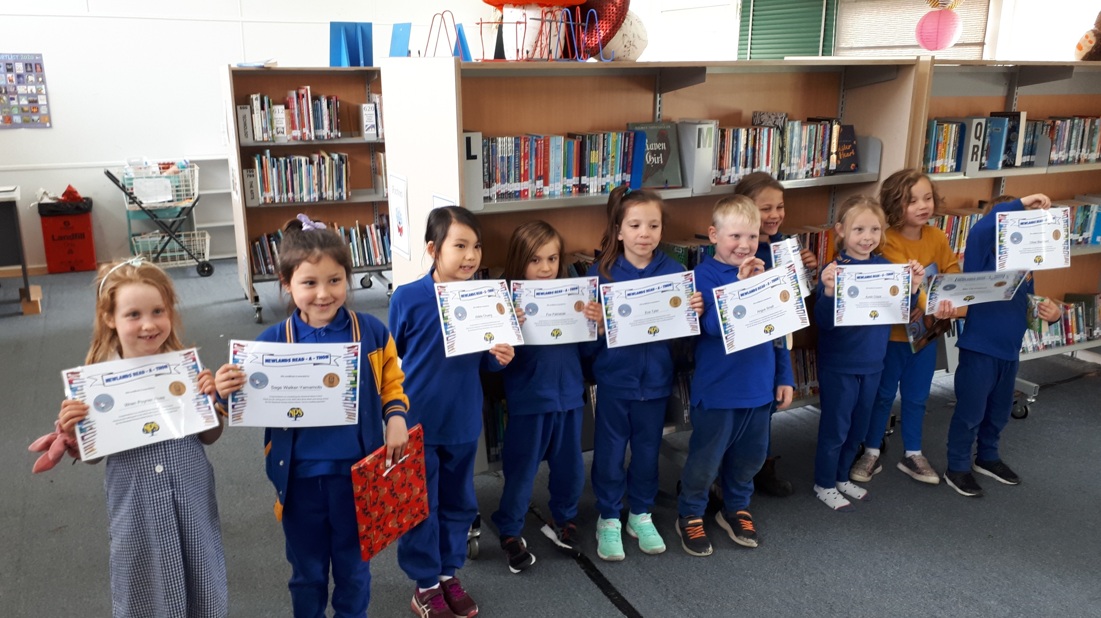Readathon participants  The library collection contains:  - Spanish language books  - Picture books, fiction and non-fiction  - ‘Easy story’ section for readers in transition  - A large graphic novels and comics section  - Lunchtime chess, card games & craft activities  You can search the library catalogue via the link on the school website.  https://newlandsps.vic.edu.au/community/#library |  |  | About NPS Library  The library is located in Block C near the OSHC room.  The library is staffed three days a week by our librarian, David Honeybone.  New books are added every month from a range of suppliers.  We welcome book suggestions and new volunteers.  Contact  General enquiries  9354 2928  newlands.ps@edumail.vic.gov.au  https://newlandsps.vic.edu.au/  NewlandS Primary School  2-26 Murphy Street  Preston West VIC 3072 |  |  | 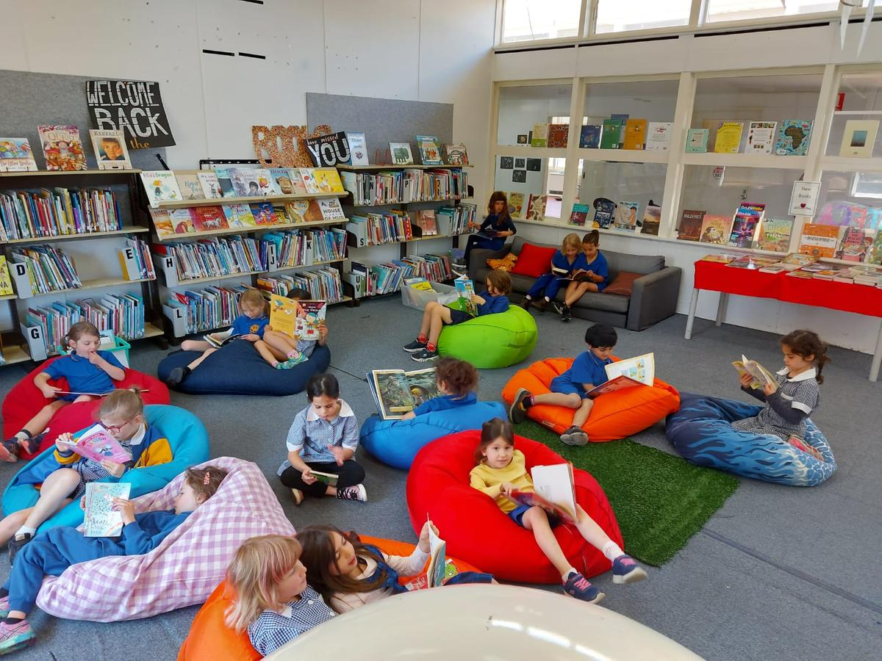  Welcome to  Newlands Primary School  Library  Nurturing a lifetime love of reading  *Opening hours  Lunch time 11-11.45am  Tuesday, Wednesday and Thursday  After school 3.30-4pm  Wednesday  *Library currently closed due to COVID restrictions

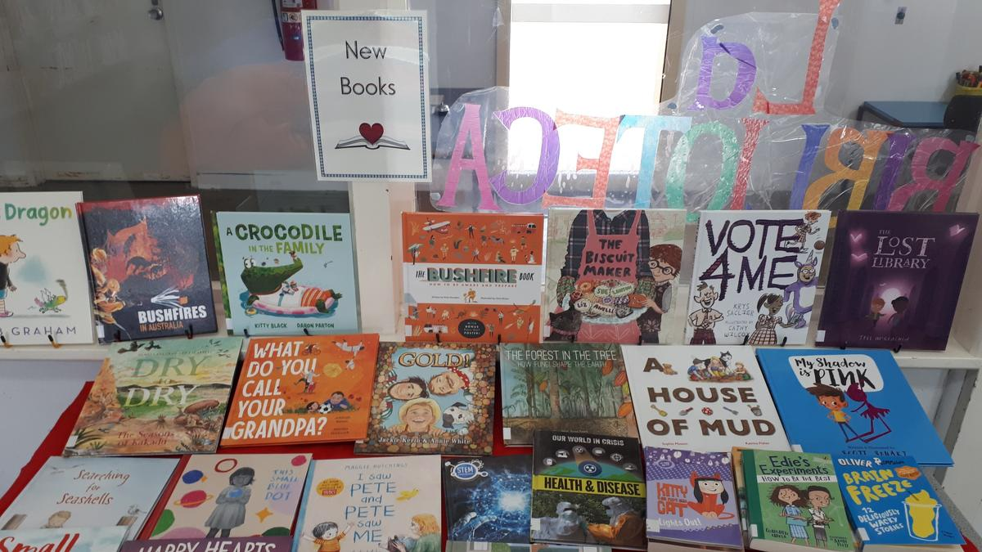  Borrowing  Preps & Grade 1 2 books  Grade 2 & 3 4 books  Grade 4, 5 & 6 6 books  All books are loaned for two weeks.  There are no fines for overdue books but we encourage children to return their books as soon as they have read them so they may borrow new ones.  Overdue reminder notes are sent out at the end of each term.  If you have any concerns in relation to missing books, please mention it to your child’s teacher. |  |  | Philosophy  We believe a love of books is the cornerstone for lifetime learning.  The NPS library is staffed three days a week by our librarian, David Honeybone, and is supported by our library leaders, a committee and volunteers.  Your child and the library  *The library is open at lunch times on Tuesday, Wednesday and Thursday for children to browse, borrow, read and play quietly.  Classroom teachers also arrange a regular time for their class to visit the library.  The library is also open after school every Wednesday from 3:30pm – 4:00pm.  *Due to COVID restrictions the library is currently closed until further notice at these times.  We encourage parents to visit the library after school every Wednesday to browse the shelves with their children.  Volunteer  Volunteers assist with covering books, fundraising events or may join the roster for library opening times. Even if you can only attend an occasional working bee, all help is valued. |  |  | 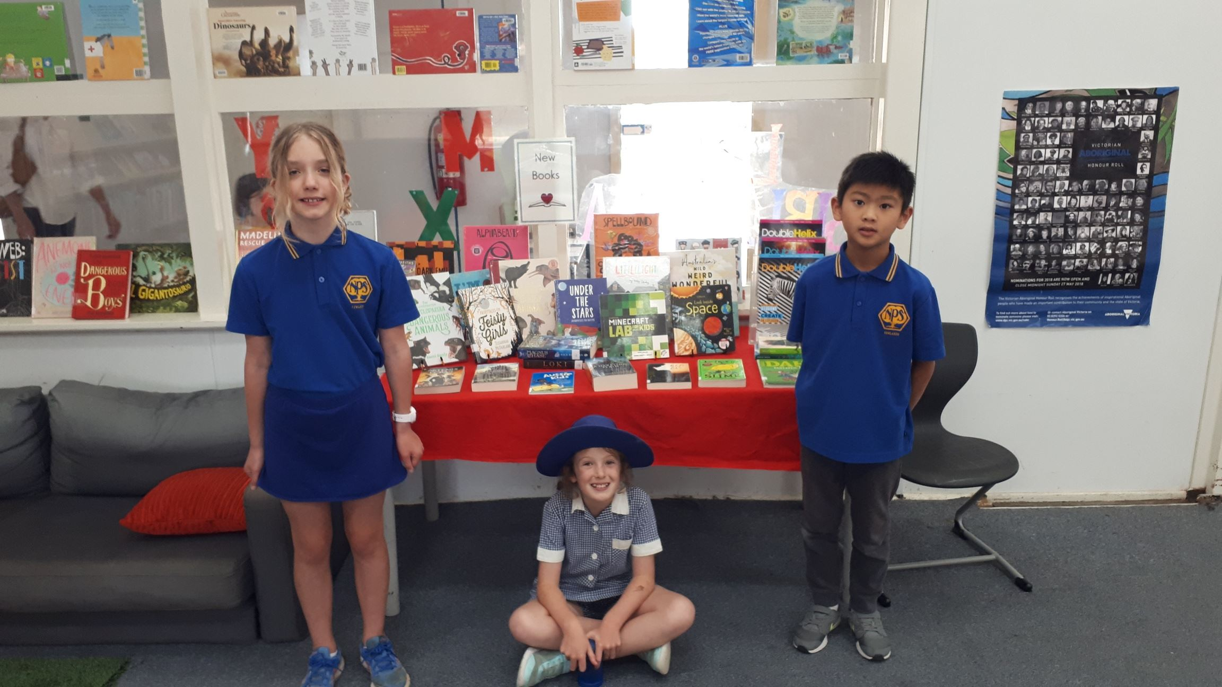Library leaders  Donations  Please contact the librarian regarding book donations. david.honeybone@education.vic.gov.au  Donations of money to help purchase new books for the library are tax-deductible and greatly appreciated.  Lost and Damaged Books  We request parents pay for all lost and damaged books. Payment should be made at the school office, not the library.  Replacement costs usually range between $10.00 and $25.00, depending on the item.  Scholastic Book Club  There are eight book club issues a year. Catalogues are distributed at school but all purchases need to be made online. Orders are delivered to the school. 20% of all sales go to the school library budget as credit for future Scholastic purchases.

