

*Letter of Informed Consent*

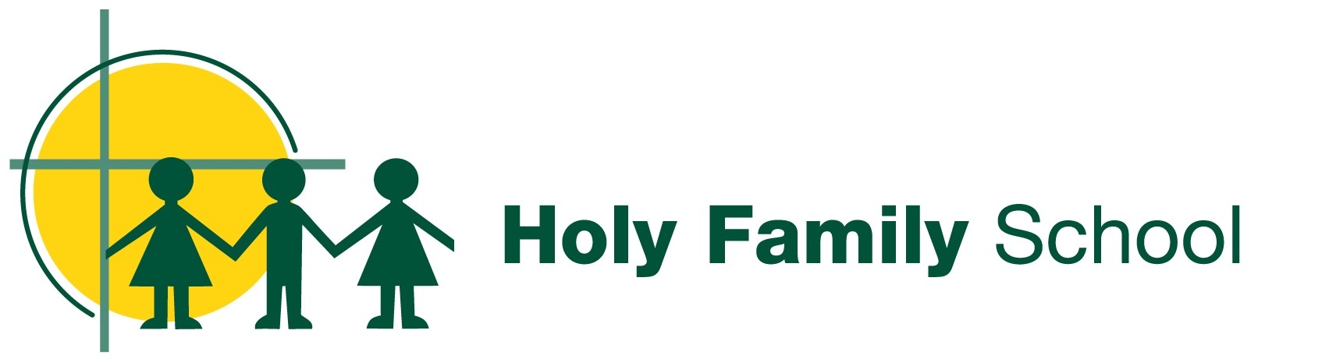

Dear students, families and staff,

***Melbourne Archdiocese Catholic Schools – School Improvement Surveys (MACSSIS): Monday 2 September – Friday 20 September 2024***

Throughout each year, we pause to listen to our students, families and staff to gauge how our learning community is travelling. This feedback is invaluable to our progress as effective school communities and is backed by evidence-based research and best practices.

A significant and formal way in which we engage and gather data is through **MACSSIS**, the Melbourne Archdiocese Catholic Schools ***–*** School Improvement Surveys.

MACSSIS is a set of surveys that have been built specifically for Catholic schools in Melbourne by the Learning Services team at MACS, in partnership with researchers at Learning First and in wide consultation with principals in our schools.

In 2024, students, families and staff are invited to participate in MACSSIS via our secure and purpose-built online platform. The online platform is where our school leaders will access the summary reports that visualise the results of the student, family and staff surveys.

The MACSSIS survey platform is operated by an independent supplier, ORIMA Research Pty Ltd. The platform meets with the high security and privacy standards for handling student and school data. Participating schools are in the process of updating their privacy policy to ensure school communities are fully informed and protected.

Students at our school will be provided with supervised sessions, where teachers are on hand to help and answer any questions. Families and staff can complete the survey anytime over the three-week window via an emailed link and password. Feedback has indicated that previous surveys were completed across a range of mobile devices and different web browsers. Schools will be providing more information about MACSSIS throughout Term 2 and 3, via newsletters and social media.

*Our community’s opinions are critical to understanding how our school is performing – MACSSIS is a key data source for guiding the ongoing work to improve our school.*

**All participation is invited, welcomed and 100 per cent voluntary**. The surveys are not a test; they are an inclusive way to support the work we are already doing to improve our school. Everyone has the right to refuse to participate, or withdraw from the survey at any point before, during or after completion of the survey. Please notify the school if your child does not wish to participate.

If you would like more information, please contact the school.

Yours sincerely,

Principal