Jane Goodall

Jane was born in 1936 .Her father gave her a stuffed monkey. She threshed Mr H [her stuffed monkey] like no other monkey. After that she was very interred by monkeys, and wished to study them in university.

Her parents Margaret and Mortimer got a divorce and were very poor so couldn’t afford a university for her, so she moved to Africa to study monkey.

There, a very famous scientist who was studying throw monkeys to learn about human revolution, and needed someone to watch monkey’s behaviour. She was very delighted indeed. But unlike other monkey scientists she did not number them she named them, David, Gigi, Fifi, Flint and Flo.

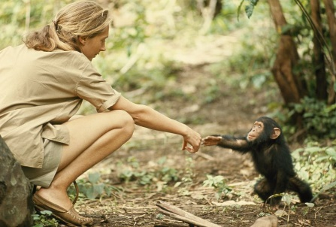 She found out they were not so different from us, another thing she found out is that they could make their own tolls witch was something people were only thought to do. She was welcomed into the monkey family.

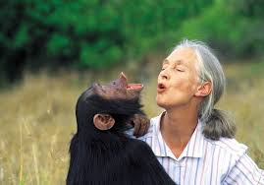Many years later she came bake to Africa, and found her monkey friend but sadly the jungles were disappearing Jane knew she had to do something . She joined nature gropes to help the environment

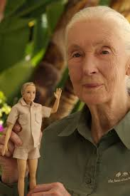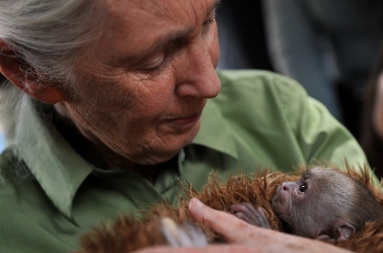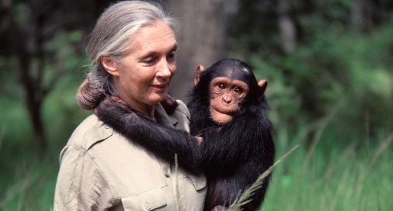 And still nurtures Mr H and stands for nature