LUDWIG van BEETHOVEN

BY PETER R

BORN
Beethoven was born at December 1770 in Germany
DIED
He died in Austria 26 March 1827

FACTS

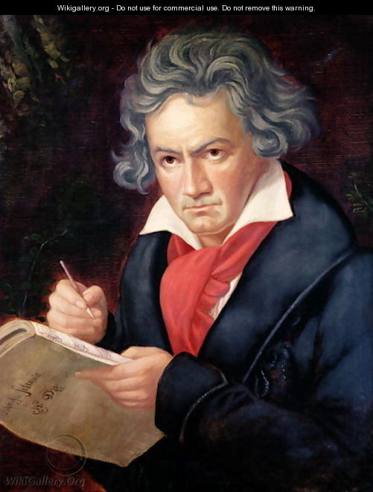

Beethoven was a composer and pianist in classical music.
He left school early to support his family.
He started to lose his hearing at age 26 and was deaf by the time he died.
He composed his most famous music after he went deaf.
Some famous music pieces are Fur Elise and 5th Symphony in C Minor.
He died during a thunderstorm at the age of 56.
He studied with Mozart’s teacher Franz Haydn.
He wrote 722 pieces of music including 9 symphonies.

