Give your child an EPIC Summer with Holiday Club.
Children across Australia have shown their bravery and resilience this year, and Holiday Club is making sure that they have the best school holidays with a jam-packed Summer program. Come on an exciting off-site adventure, experience something new when we’re visited by special guests or get into project-based fun – there’s fun for everyone.
Plus, we’ve enhanced our safety and hygiene measures, so you can have peace of mind knowing your children can focus on having fun.
Check out some of the experiences that are happening this Summer, exclusive to Holiday Club:
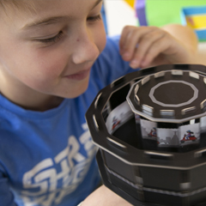
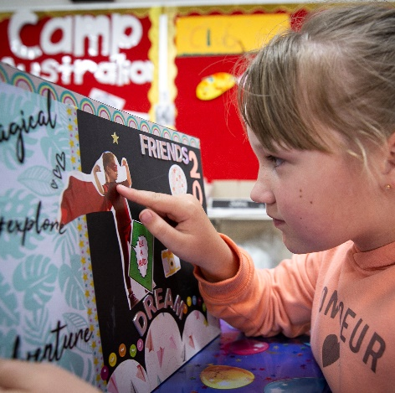
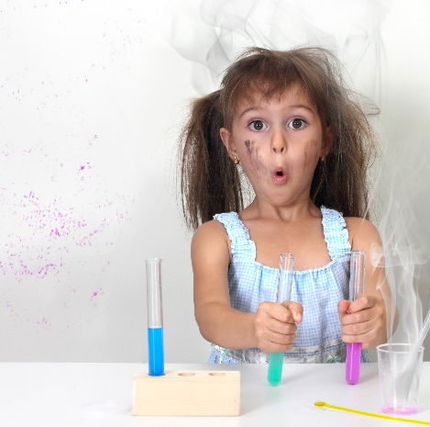

Cinema Animated
Learn all about strobing images and animation by making your very own zoetrope – a pre-film animation device that produces motion via illusion!
Visionary Creations
As we head into 2021, let’s set some goals and get our creative energy flowing when we make vision boards. Plus, we’re making snap bands for you and your friends.
Science is Magic
Get in the know when we learn all about magic, and the science behind it.
These cool experiments will teach you all the tricks of the trade.

Book now. To find out when these activities are on during the school holidays and to find your nearest service, visit: www.campaustralia.com.au/holidayclubs.
We look forward to seeing you at Holiday Club.
The Camp Australia Team

