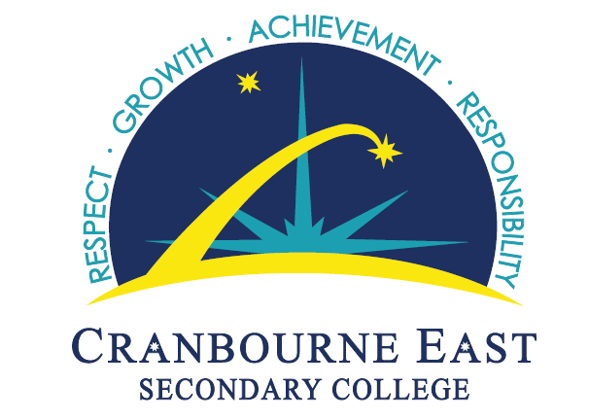

Cranbourne East Secondary College
Student Representative Council
Constitution
The following document is the constitution for the Cranbourne East Secondary College Student Representative Council (CESC SRC).

VALUES
The CESC SRC is a student run and governed body. It exists for the benefit of students and provides a space for students to express their voice, agency and governance.
The CESC SRC has the school values that underpin this constitution, Responsibility, Growth, Achievement and Respect. All the constitution needs to be read and interpreted in line with these values.

- Responsibility - includes Teamwork, Fairness and Creating Safe spaces.
- Respect - includes Equality and Fairness.

AIMS
The purpose of the SRC is to:

- Represent students
- Encourage students to have a voice
- Promote unity in the student body
- Inspire change
- Provide a safe and inclusive space for all students
- Listen to student suggestions and complaints and find solutions for any issues. This may taking the issue to SRC meetings, writing proposals to the appropriate teams (such as the Principal team and/or School council).
- Running surveys with the student body to find solutions for the issues.
- Using suggestion boxes to provide students with an avenue to express their ideas, needs and wants.
- Liaise between student body and the Leadership of the school

ACTIVITES
The SRC will:

- Run student led whole school assemblies on a termly basis.
- Run fundraising activities for the SRC
- Provide peer support to students i.e.: Listening to student ideas, offering encouragement or constructive criticism, referring students to other areas of the school such as wellbeing, careers councillor, school lawyer and/or other leaders or teachers.
- Communicate with the school leadership to convey ideas, issues and suggestions from the student body
- Take part in student leadership training activities, such as workshops, incursions and excursions.
- Support students with making proposals for student led events and activities
- Run meetings that welcome all students.
MEMBERSHIP
The SRC Executive is composed of:

- Elected Student Leadership – School captains and Vice captains will be part of whole school elections including staff. Year level leaders will be elected by respective year level.
- SRC facilitator (teacher)
- Year 7 – 12 Students
The SRC is open to and inclusive of
- Students of all genders
- Students from all diverse backgrounds
- Students that identify from all sexualities.
CONDUCT
Executives of SRC will:

- Attend meetings weekly. If unable to attend a SRC meeting students should send in apologies to the SRC facilitator or any members of the SRC.
- Create and tend to suggestion boxes
- Take part in Home Group Assemblies
- Survey students to get ideas and opinions
- Represent students positively
Termination of membership of executive will occur:
In the event that an SRC Executive or elected member:

- Talks negatively about the SRC
- Continuously fails to attend SRC meetings with no legitimate excuse/apology sent
- Gets multiple suspensions for reasons that contradict the values of the SRC, while acting as an elected representative of the SRC
- Acts in a racist homophobic, sexist manner towards students or staff
- Represents the SRC or the school negatively in the community

Process of Termination:
- Warning by members of SRC during a lunchtime meeting
- A meeting with from SRC facilitator with the student to affirm commitment to the SRC and reflect on behaviour. The year level coordinators will also be informed of this.
- After deliberation with the executive members, SRC facilitator will inform the student of their termination from the Student Representative Council.
- In the event of termination of a leadership role from the SRC executive this does not mean that the student is not allowed to be a part of the SRC, as the SRC is open to all students at all times.
- Upon termination – new elections can be held to elect another member to the executive should the SRC and the SRC agree unanimously that this is required.

Moved: Layla Cerna Seconded: Olympia Ward
Vote Count: Unanimous.
Agreed upon and signed by all members of the SRC executive on the 26th Day of October, 2020 at 1.35pm.

