

**09/02/2024**

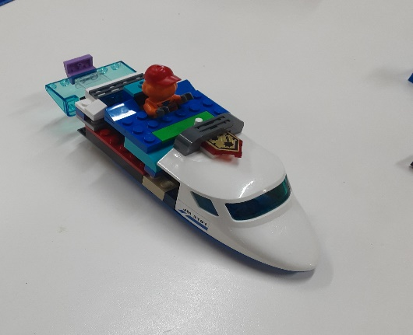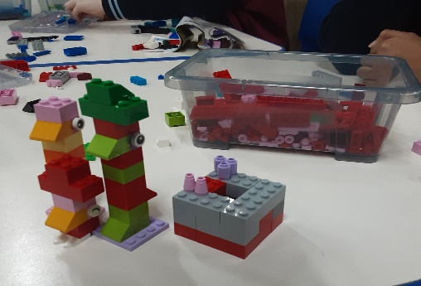[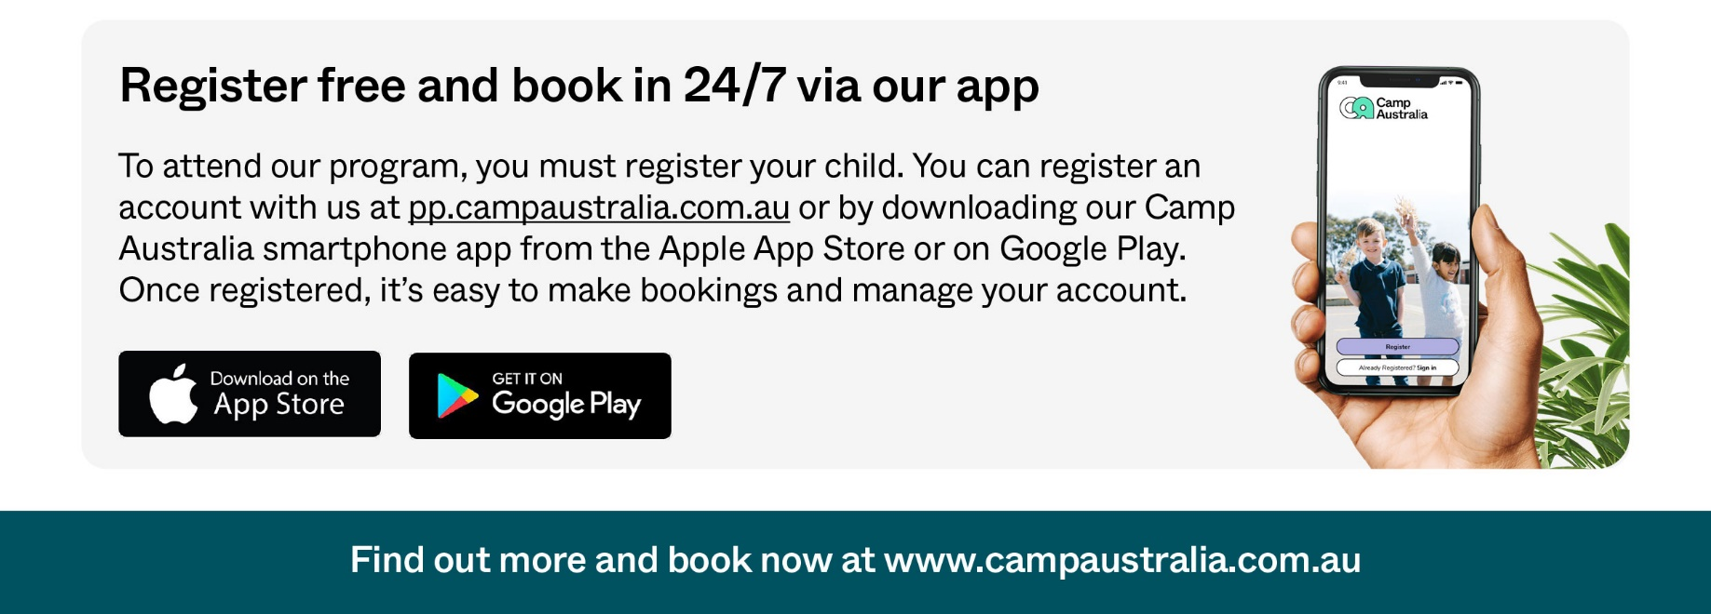](https://pp.campaustralia.com.au/)

**A message from your Coordinator**

Welcome to 2024, please register children to Oatlands Primary School OSHC, we are here to support the whole community.

We need your children registered to the service even if you need a once of care for your family. This is free to register , link below to complete the registration.

* Big Arts Friday
* Cricket
* Build and create

**Activities coming up**

Join in the fun of Outside School Hours Care activities and experiences with Your OSHC and Rocketeers.

**Make a booking**

Book now

**Oatlands Primary School OSHC**