THRIVE Launches into
Sport and Recreation

On May 22nd we celebrated the official launch of THRIVE into community sport and recreation. With funding from the South East Melbourne Primary Health Network and the Victorian State Government under the Suicide Prevention Place based Trials there are now 13 clubs that are adapting THRIVE to their setting. This work has been facilitated by a cross sectoral governance group made up of Langwarrin Positive Education Network, St Kilda Football Club, Frankston City Council, Peninsula Health, Primary Care Partnership and offers an innovative community approach to help all residents live happy and healthy lives.

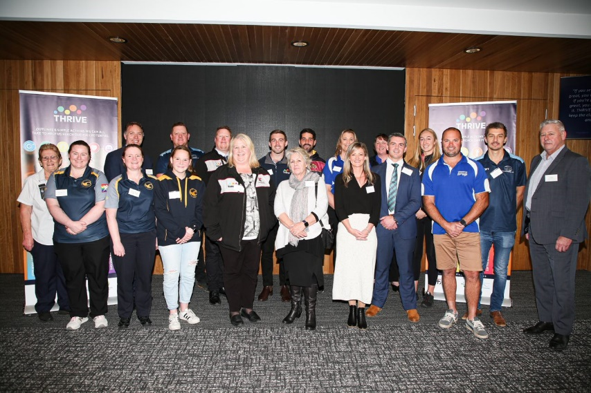
Schools and sports clubs come together to celebrate this community partnership.
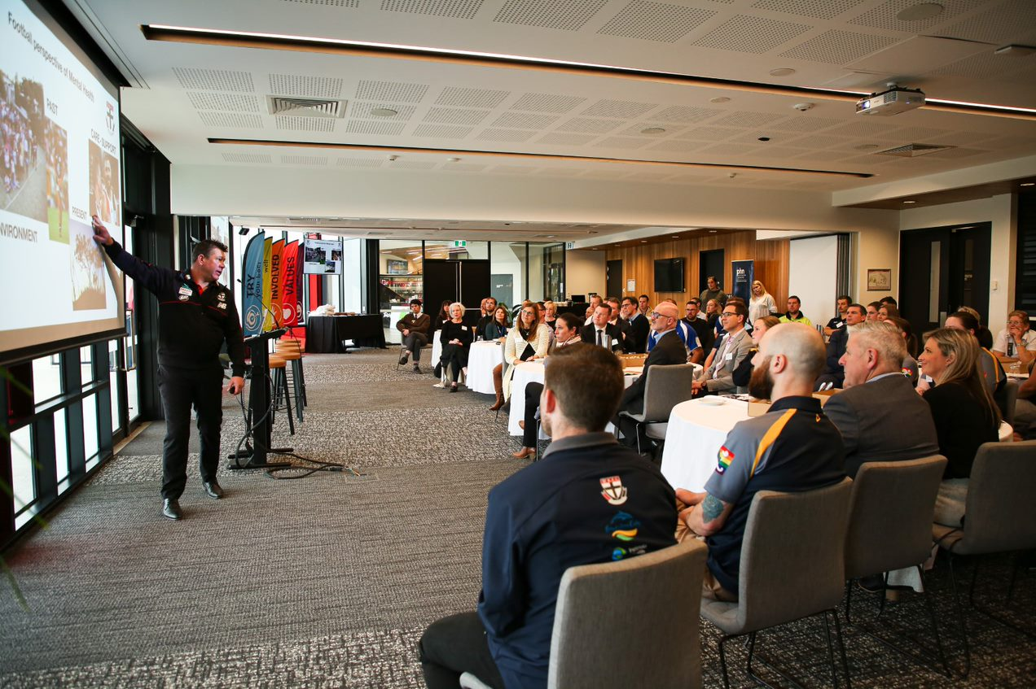
St Kilda Couch Brett Ratten speaking about the importance of mental health.

“Your strengths represent the way your brain is wired to perform at its best”
Buckingham & Clifton 2001
Character Strengths
Research in 2004 uncovered that we possess 24 character strengths. When practiced and developed these can lead to six universal virtues (wisdom, courage, humanity, justice, temperance, & transcendence). Whilst we have all 24, we are a unique combination of these strengths. Some of them will come more naturally to us than others. Our top strengths are often referred to as ‘signature strengths’. When we use our strengths in work, play and love we are more likely to achieve success and satisfaction. Character strengths can also play a critical role in relationships. When we appreciate character strengths in others this can help foster connection.
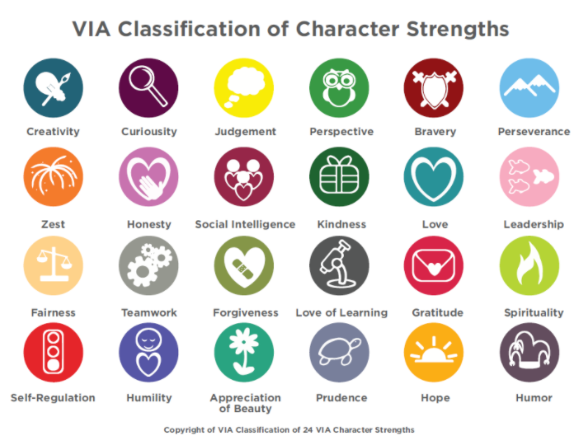
Tips
- Pick one strength you can develop. It might be one you want to use more consistently or one you really value.
- Think about how you can build a daily habit to develop this strength by creating a cue, a routine and a reward.
- Nominate a buddy. Tell someone about your goal and ask them for feedback and support to stick with this habit.
Resources
Book - Character strengths and Virtues: A handbook and classification. By Peterson and Seligman Website- https://www.viacharacter.org/

