
McCarthy Catholic College Netball Club
2025 Winter Season
Current Year 6 students: Information/Expressions of Interest
for to play for McCarthy in the 2025 Winter Season
We welcome all new players to MCC Netball Club for season 2025, especially our new year 7 players in 2025! To play netball for MCC we normally we ask players to organize their own team and submit the team nomination form early in the new year, however we understand this can be difficult for new year 7 players and teams, therefore the Committee do their best to assist these players/teams. Please note, you do not need to be enrolled at McCarthy High School to play netball for our club.
Please fill in the below information, return and we will provide you with all the information you need in the coming new year, including how to submit a team or how to submit a request to be placed into a team.
Don’t forget to join our Facebook page: MCC Netball Club Tamworth
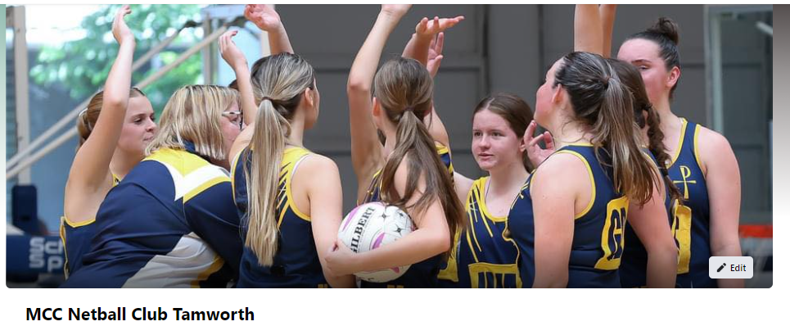

Return via email to: Amber.fitzgibbon@tafensw.edu.au
Player’s name:
Player’s parent/parents name:
Player’s date of birth:
Best contact phone number:
Best contact email:
Primary School attended:
Any additional information you would like to provide?

Amber Fitzgibbon, Secretary, McCarthy Catholic College Netball Club
Amber.fitzgibbon@tafensw.edu.au 0438687684

