5 *@(l©*

®rJLfGJ

WQ!J @ *©;::f2*

*[PB®* (?cl

**Colour in for your chance to WIN 1 of 80 Supercars themed kids stationery sets!**

bathurst.nsw.gov.au

-

.,..,

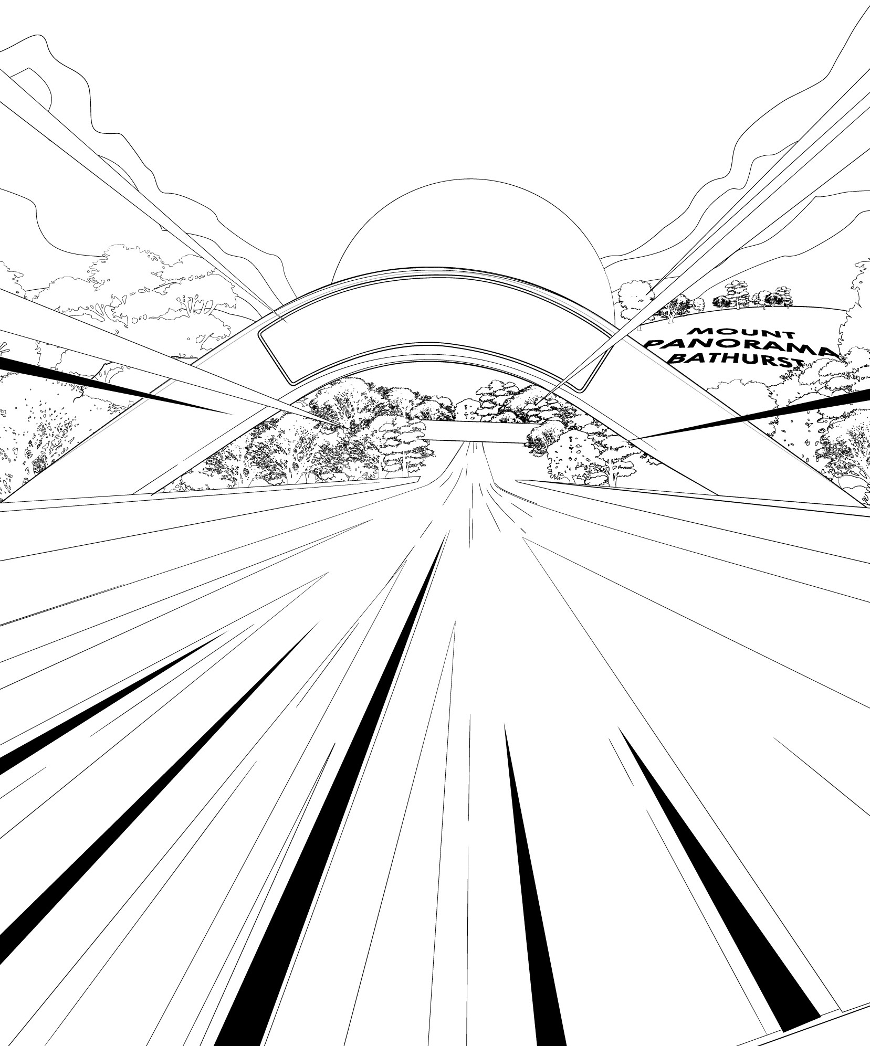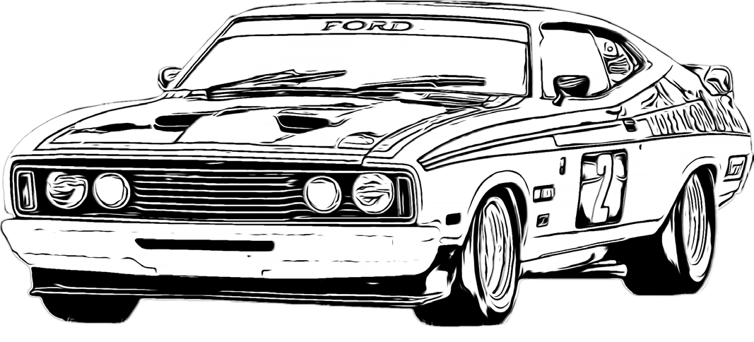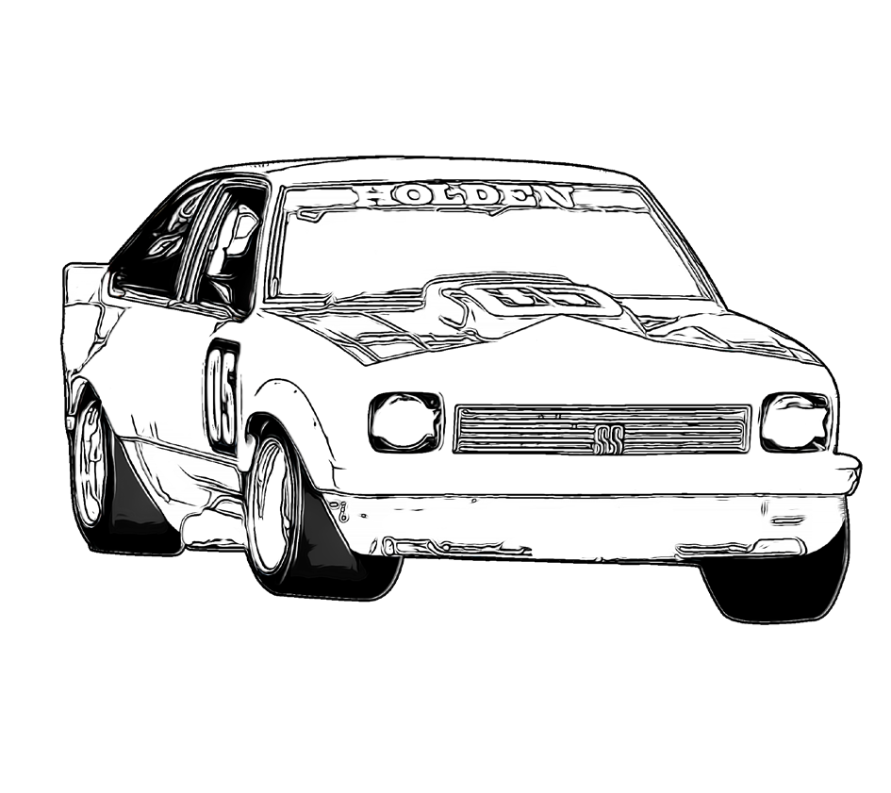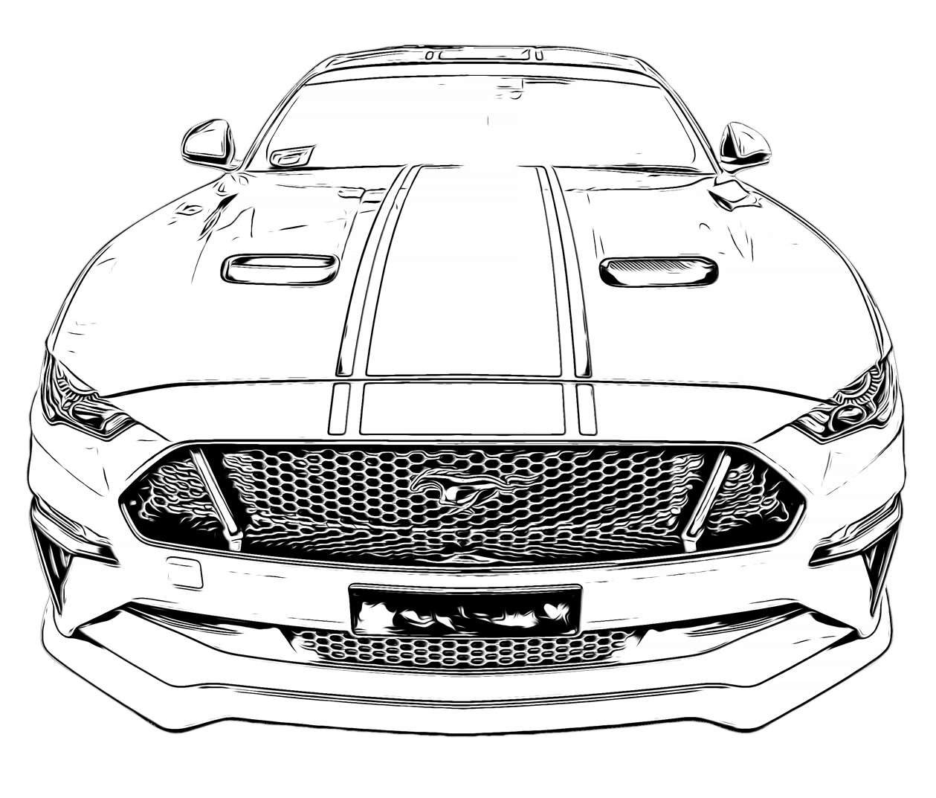

***SUPERCARS* /1**

*mMm.,.,•* B A TH U RST ..]

if- REGIONAL COUNCIL

------

***'15* - *'IS* OCT *2020***

***SUPERCARS.COM***

***#VAScBDBQ***



**CONTACT INFORMATION**

NAME:

AGE:

POSTAL ADDRESS:

STATE: POSTCODE:

PARENT’S NAME:

PARENT’S EMAIL ADDRESS:

# Email your completed entry to [events@bathurst.nsw.gov.au](mailto:events@bathurst.nsw.gov.au)

**by 5pm, Sunday 18 October 2020.**

