SAINT JOSEPH’S SCHOOL
Lunch order menu - term 3
Available Fridays

Sandwiches & Rolls
Cheese $2.00
Vegemite $2.00
Jam $2.00
Ham & Cheese $4.00
Ham, Cheese & Tomato $4.00
Cheese & Vegemite $4.00
Egg, Mayo & Lettuce $6.00
Ham & Salad $6.00
Roast Beef & Salad $6.00
Roast Chicken & Salad $6.00
* Please advise if you would like the sandwich toasted
* Available in white, wholemeal, or multigrain (White bread will be used unless specified)

Hot Food
Chicken nuggets (6) $4.50
Add chips $2.00

Roast roll – beef $7.50
Roast roll – chicken $7.50
Roast roll – lamb $8.00
Roast roll – pork $7.50
Add chips $2.00

Party Pie $2.00
Pie $4.50
Party Sausage Roll $2.00
Sausage Roll $4.50

Chips only $3.00

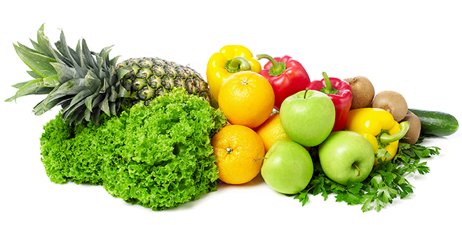

Lunch menu provided by:
Coffee Staines Café & Carvery
72 Ford Street, Beechworth, VIC, 3747
PH: 03 5752 5323
Current as at Term 3 2021

Drinks
Orange juice – 200ml $2.50
Apple & Blackcurrant - 200ml $2.50
Orange - 200ml $2.50
Orange & Mango - 200ml $2.50
Tropical - 200ml $2.50
Chocolate milk - 250ml $2.50
Strawberry milk - 250ml $2.50

Snacks
Muffin - assorted $3.00
Hedgehog slice $3.00

Apple – red $1.00
Apple – green $1.00
Banana $1.00
Grapes $1.00
Orange $1.00
Mixed Fruit salad cup $3.50

Carrot sticks $1.00
Carrot & Celery sticks $1.00
Snow peas $1.00
Mixed veggie cup $3.50

Yoghurt - vanilla $3.00

