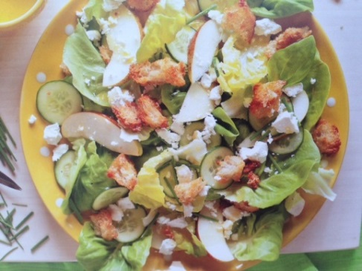


Pear and Lettuce Salad
Source – adapted
Harvest – lettuce, pear, cucumber, chives, lemon, garlic
Vocab Words – croutons, chives, Dijon,
Skills – grating, chopping/cutting, fry or bake, cut pears around stem
Equipment:  - Metric measuring cups and spoons  - Frying pan or lined baking tray  - Large bowls x 2  - Jar  - Serving Items – bowls and tongs | Ingredients:  - Bread, cut or torn into 2cm pieces, for croutons  - 2 tablespoon olive oil  - 2 tablespoons parmesan cheese, finely grated  - 1 lettuce – butter or cos, roughly chopped  - 1 cucumber, thinly sliced  - ¼ cup chives, finely chopped  - 2-3 firm ripe pears, cut around the stem, thinly sliced  - 100gm feta cheese Crumbled  Dressing:  - 1 teaspoon Dijon mustard  - 60ml olive oil  - ½ lemon, juiced  - 1 clove garlic, finely chopped  - 1 teaspoon caster sugar  - Salt and pepper, for seasoning
What to do:
- Wash all garden ingredients and prepare all ingredients based on instructions in the ‘Ingredients’ list.
- Place the bread in a large mixing bowl and add the oil and parmesan and fry in frying pan until crispy. (keep in mind they will become crunchier as they cool)
- Meanwhile, prepare the dressing by placing all ingredients in a jar and shaking to combine.
- Combine the lettuce, cucumber, chives and pears in a large mixing bowl and add dressing (just before serving) and gently mix to combine.
- Top with feta and croutons and serve.

