CAREER NEWS Friday 19 June

 Dates to Diarise in Term 2
- GAT – Tuesday 16 June
- Melbourne Careers Expo 2026 – 17 – 19 July

What can I do with an Arts Degree?
There is often the debate about the value of an Arts Degree and what kind of role an Arts Graduate could find in industry. The list of roles is quite varied, and includes -
- Teaching & educational administration
- International aid and trade agencies
- Arts production and management
- Public service and social welfare agencies
- General management and administration (local and global)
- Communications industry, publishing, media and public relations
- Tourism and hospitality
One of the very important things for students to note, is that an Arts’ student learns skills that are very transferrable in industry. These include communication skills, critical thinking and reading skills, analytical skills, and research skills.

 Studying Psychology at La Trobe University
Gain an understanding of the human mind and how it influences behaviour. You’ll develop analytical, research and communication skills while studying clinical and health psychology, developmental and social psychology, assessment, intervention and research.
La Trobe offers several degrees that allow students to study psychology. For example, the Bachelor of Arts offers a major in Psychological Sciences.

Students who are keen to enter a course with a greater focus on psychology, or to pursue a career as a psychologist might opt to enrol in one of two undergraduate degrees. Both the Bachelor of Psychological Science and Bachelor of Psychology (Honours) are accredited by the Australian Psychology Accreditation Council (APAC).**

** Professional registration with the Psychology Board of Australia will require an APAC-accredited fourth year and additional or ongoing requirements beyond the completion of the degree as well as an application to the professional body.

- Bachelor of Psychological Science
This is a 3-year degree that prepares students for a career as a professional psychologist, or in a psychology-related field across industries from clinical psychology to human services and marketing. Graduates of this course planning to continue on in further psychology-related studies will need to apply for an Honours year, such as the 1-year Bachelor of Psychological Science with Honours. A minimum WAM of 70 is required to be eligible for consideration.

- Bachelor of Psychology (Honours)
This is a 4-year degree that prepares students to become a professional psychologist, build a career in a psychology-related field or pursue research. Automatic progression to fourth year in this course requires a minimum weighted average mark (WAM) of 70%.

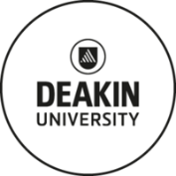Guaranteed ATARs for 2027 Entry
The Deakin Guaranteed ATAR provides access for more students, so you can secure a place in the course you want.
Deakin is providing lower upfront guaranteed ATARs for eligible students from under-represented cohorts at Deakin. So, this may mean students who:
- attend an under-represented school – see list here OR
- live or study in a regional or remote home or school location OR
- are of Indigenous Australian descent
This provides students with more certainty, reduces stress and gives them the best chance to get into the course they really want. Applications will be made through VTAC later in the year.
Find out more at Deakin Guaranteed ATAR.

 Overseas Volunteer Programs for High School Students
Students keen on finding out more about the two-week overseas programs on offer are invited to register for a webinar taking place on Tuesday 16 June 2026 from 6.00pm – 7.00pm (AEST).
Find out more at register at Volunteering & Internships for Teens
 Studying Psychology at Monash University
To practice as a psychologist, you must meet the requirements of the Psychology Board of Australia. This involves completing a minimum six-year sequence of study in psychology accredited by the Australian Psychology Accreditation Council.
Students undertake an initial undergraduate degree with a major in psychology (or graduate pathway), then a fourth year (Honours) in psychology to gain provisional registration. In order to become eligible to be a registered psychologist students undertake fifth and sixth (plus) years of study, whereas those seeking to develop research skills complete research training via a Doctor of Philosophy (PhD).
Students can still complete a standard Psychology major in other single and double degrees with Arts and Science → BUT they will need to be enrolled in one of the Monash UG degrees outlined below in order to complete the extended Psychology Major required by APAC.
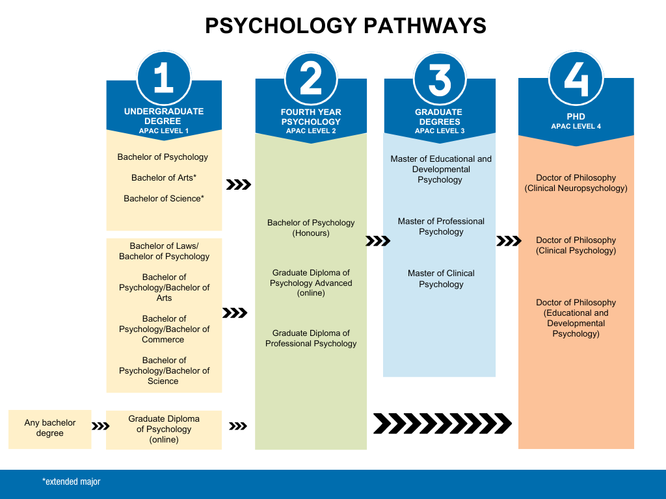

 Exercise Science & Sport Degrees in Victoria in 2026
Many of the courses listed below provide an accredited pathway for graduates to be eligible to register and practise as an Accredited Exercise Scientist with Exercise and Sports Science Australia (ESSA). These degrees are also often used as pathways to post-graduate study in courses such as the Master of Physiotherapy, Master of Clinical Exercise Physiology, Master of High Performance Sport, Graduate Diploma or Master of Applied Sport Science, Graduate Certificate of Strength and Conditioning, Graduate Certificate of Sport Performance, to name a few.
UNIVERSITY | COURSES | VCE PREREQUISITE SUBJECTS IN 2026 | ATAR 2026
ACU  M - Melbourne | Exercise & Sport Science | Units 3 and 4: a study score of at least 25 in English (EAL) or at least 25 in English other than EAL. | 59.50 (M)
DEAKIN  G – Waurn Ponds  M – Melbourne  # Sports Science School ranked 1st in the world  Note: New in 2026 - Bachelor of Exercise and Sport Science/Bachelor of Engineering (Honours) | Business (Sport Management) | Units 3 and 4: a study score of at least 25 in English (EAL) or at least 20 in English other than EAL. | 80.15 (M)
 | Exercise & Sport Science # | Units 3 and 4: a study score of at least 30 in English (EAL) or at least 25 in English other than EAL. | 62.55 (G)  70.05 (M)
 | Exercise & Sport Science (Adv) # |  | 75.40 (G)
 | Sport Development | Units 3 and 4: a study score of at least 25 in English (EAL) or at least 20 in English other than EAL. | 60.25 (M)
FEDERATION  B – Ballarat  Be – Berwick  Gi – Gippsland | Exercise & Sport Science | Units 3 and 4: a study score of at least 20 in any English; Units 1 and 2: satisfactory completion in two units (any study combination) of Maths: General Mathematics, Maths: Mathematical Methods or Maths: Specialist Mathematics or Units 3 and 4: any Mathematics. | 50.15 (B)  51.85 (Be)  52.00 (Gi)
FEDERATION  B – Ballarat  Be – Berwick  Gi – Gippsland | Sport, Physical and Outdoor Education |  | N/P (B)  50.05 (Be)  N/P (Gi)
LA TROBE  B – Bendigo  M - Melbourne | Sport and Exercise Science | Units 3 and 4: a study score of at least 25 in English (EAL) or at least 20 in English other than EAL; Units 3 and 4: a study score of at least 20 in one of Health and Human Development, any Mathematics or Physical Education, Biology, Chemistry, Physics or Psychology. | 61.80 (B)  65.45 (M)
LA TROBE  B – Bendigo  M - Melbourne | Sport and Recreation Management | Units 3 and 4: a study score of at least 25 in English (EAL) or at least 20 in English other than EAL. | 55.00 (M)
SWINBURNE  H – Hawthorn  Note: New in 2026 - Exercise and Sport Science/Physiotherapy* | Exercise and Sport Science | Units 3 and 4: a study score of at least 30 in English (EAL) or at least 25 in English other than EAL; Units 3 and 4: a study score of at least 20 in one of Maths: General Mathematics, Maths: Mathematical Methods or Maths: Specialist Mathematics | 61.30 (H)  80.20 (H) *
VIC UNI  F – Footscray  S.A. – St. Albans | Biomedical & Exercise Science | Units 3 and 4: a study score of at least 25 in English (EAL) or at least 20 in English other than EAL; Units 3 and 4: a study score of at least 20 in two of Biology, Chemistry, Health And Human Development, any Mathematics or Physical Education. | 57.30 (F)  L/N (S.A.)
VIC UNI  F – Footscray  S.A. – St. Albans | Exercise and Sport Science | Units 3 and 4: a study score of at least 25 in English (EAL) or at least 20 in English other than EAL. | N/P (F)
VIC UNI  F – Footscray  S.A. – St. Albans | Outdoor Leadership |  | N/P (F)
VIC UNI  F – Footscray  S.A. – St. Albans | Physical Education and Sport Science |  | N/P (F)
VIC UNI  F – Footscray  S.A. – St. Albans | Sport Management |  | N/P (C)
VIC UNI  F – Footscray  S.A. – St. Albans | Sport Science |  | N/P (F)
Snapshot of Monash University in 2026
- Named after engineer, military leader and public administrator Sir John Monash, Monash University was established in 1958.
- Monash University became a founding member of the Group of Eight universities in 1999.
- Monash ranks in the top 1% of world university rankings and ranks #36 globally in the 2026 QS World Rankings - Rankings. Notably, Pharmacy at Monash is ranked #4 in the QS World Subject Rankings in 2025.
- Monash has over 80,000 students, with an international presence in Malaysia, Indonesia, China, India (a research partnership), and Prato in Italy, besides its campuses in Australia - locations.
- Monash University is the only Victorian university to offer a Direct Entry medical program for students completing Year 12 as well as a Graduate Entry program leading to the same degree – Bachelor of Medical Science and Doctor of Medicine (MD).
- There are ten Monash Faculties offering hundreds of courses, be they single or double undergraduate degrees, or graduate qualifications up to a PhD.
- Monash has a number of student-run clubs and associations - a great way to get involved and meet people - Monash Clubs and Associations.
- Career Connect is the Career Centre available to all Monash students. Students can access the many services offered – be it for volunteering, part-time jobs, assistance with applying for work on graduation, etc.
- The Monash Study Abroad program assists students in studying overseas as part of their course. Monash has exchange/partnership agreements with more than 100 universities across 30 countries.
- Monash offers more than 200 different scholarships for new and current students, from course fee subsidies to travel allowances, and payments for accommodation costs - Scholarships.
- The Monash Guarantee is an alternative entry scheme for students to get into a Monash course even they do not reach the course’s clearly-in ATAR. Students may be eligible for the Monash Guarantee if they:
- have experienced financial disadvantage
- live in a low socio-economic area
- live or attend school in a regional or remote area
- are an Indigenous Australian
- attend a Monash under-represented school
- Monash University Accommodation assists students in finding accommodation on campus, and off campus.

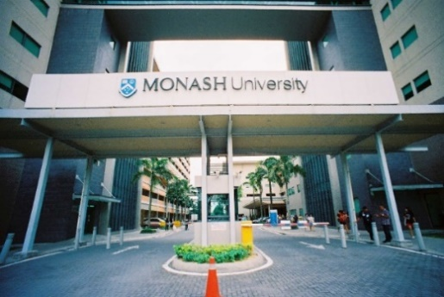
Snapshot of Monash University – Peninsula in 2026
- Monash University’s Peninsula Campus specialises in nursing, physiotherapy, paramedicine, occupational therapy, education, and business administration courses.
- There are approximately 4,000 students studying at the Peninsula Campus.
- The Peninsula campus has a very vibrant campus life and is connected to the Clayton Campus through shuttle buses that run between the campuses every day.
- There are three faculties offering courses at the Peninsula Campus: the Business Faculty, Education Faculty, and the Medicine, Nursing and Health Sciences Faculty.
- Courses offered at the Peninsula Campus include -

Business and Economics

Bachelor of Business Administration
Education
Bachelor of Education (Honours) in Early Childhood and Primary Education
Bachelor of Education (Honours) in Primary Education
Bachelor of Education (Honours) in Primary and Secondary Health and Physical Education
Bachelor of Education (Honours) in Secondary Health and Physical Education
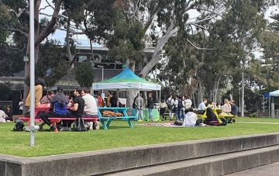
Medicine, Nursing and Health Sciences
Bachelor of Nursing *
Bachelor of Nursing and Midwifery (Honours)
Bachelor of Occupational Therapy (Honours)
Bachelor of Paramedicine
Bachelor of Physiotherapy (Honours)
Bachelor of Speech Pathology
* Also offered at the Clayton Campus

Monash University offers an excellent Diploma of Tertiary Studies (DoTS) pathway program into a few of its undergraduate degrees. The pathway programs offered at the Peninsula Campus are:
Diploma of Tertiary Studies – Business: Upon successful completion of the DoTS - Business stream students can apply to enter into the second year of the Bachelor of Business Administration (Peninsula) OR the Bachelor of Business (Caulfield) depending upon their mathematics preparation, and their average marks in the DoTS program.
Diploma of Tertiary Studies – Education: Upon successful completion of the DoTS - Education stream students can apply to enter into the second year of the Bachelor of Education (Honours) in several specialisations.
Diploma of Tertiary Studies – Nursing: Upon successful completion of the DoTS - Nursing stream students can apply to enter into the second year of the Bachelor of Nursing at the Peninsula Campus.
Browse and learn more about studying at the Monash University Peninsula Campus.

