
Teesdale Primary School Parents’ Club

Lunch Day

Last week of term 2
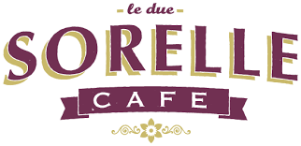

The Parents’ Club will be holding a ‘Lunch Order Day’ in the last week of term.
Tuesday to Thursday - date to be confirmed depending on catering numbers.
A lunch pack is on offer from Sorelle Café Bannockburn.
Cost $8.00 per lunch pack – includes one main meal and a choc chip cookie with M&M’s on top.
Please complete and return the order form by Friday 7th June 2024 with the correct money in a sealed plastic bag. CASH ONLY PLEASE.
One order form per student.

STRICTLY NO LATE ORDERS PLEASE

Name: ________________________ Home Group: _______

Please select option required:

Hot Dog and Cookie
Chicken nuggets and chips and Cookie

Ham salad wrap (lettuce tomato carrot cheese) and Cookie

GF Ham salad (lettuce tomato carrot cheese) sandwich and Biscuit

Vegetarian Wrap (lettuce tomato carrot cheese) and Cookie

Total Amount Enclosed: $8.00

Please note that the options cannot be customised as the lunch packs will be prepared by Sorelle Café and delivered to school in time for lunch at 11:25am.

