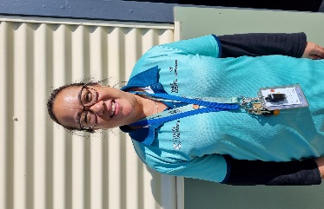](https://www.campaustralia.com.au/families/rocketeers)

Joshua Woods

Assistant Educator – Camp Australia Spring Gully Primary School OSHC

Hello, my name is Josh. I joined Camp Australia in Term 4 of 2024 and have spent my time working across Bendigo in multiple schools. A majority of that time however has been working here at Spring Gully Primary School where I have got to know many wonderful young people, and I look forward to meeting even more into 2025!

**Fun facts:**

* I love sports, especially soccer and have been playing locally all my life!
* My family has two golden retrievers named Nelja and Lumi.
* On the holidays I enjoy going camping with friends.
* I am currently studying to become a Primary School teacher and...
* One of my big inspirations for that is your very own Mr. Brett Parkes who was MY teacher when I was in Grade 6!

Michelle Man

Service Leader – Camp Australia Spring Gully Primary School OSHC

Hi, my name is Michelle, and I will be the new Service Leader for Camp Australia Spring Primary School OSHC as Term 1, 2025! I have been with Camp Australia since 2015, and I have been at another service in Werribee as a Service Leader.

I am excited to start this new adventure and getting to know all of you!

**Fun Facts:**

* I enjoy going to the beach, swimming in the salty waters because it’s great for my skin.
* I have a dog called Lily, she is a Staffy, and I try to walk her daily.
* My favorite food is Chicken Parma.
* My interest is to travel and explore different countries and their cultures. I have visited the Philippines, America, and Singapore.
* I enjoy watching comedy & romance movies.

at Camp Australia Spring Gully Primary School OSHC!

Meet the team