St Mary’s Ascot Vale

Term 4

A message from the team
Welcome back to Term 4! We’re so excited to see everyone’s smiling faces again after the break. It’s been a wonderful start to the new term, filled with laughter, teamwork, and creativity at our program.

These two weeks have been full of laughter and teamwork. Especially with our brand-new Gaga Ball Pit! The children absolutely love it. Some even became reporters, asking friends what they think about the new pit and how we could make it safer.

We’ve also been busy decorating our room. Children helped create colorful signs like “Breakfast Station” and “Wash Your Hands Capy clean,” featuring our cute capybara art!

And of course, plenty of arts and crafts time filled our afternoons with creativity and smiles. We’re off to a great start for Term 4!

Check out the fun!
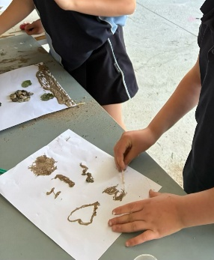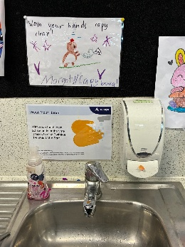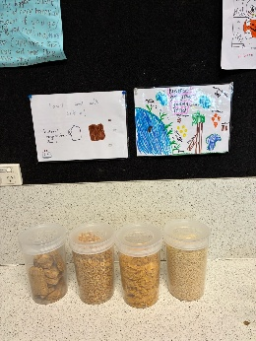

Important Dates
- Children’s week October 18–26, 2025
“Everyone should know about Children’s Rights”

Term Dates
October 6, 2025 - December 19, 2025

Projects we are working on
- Children’s Rights Poster Display
- Halloween art and craft

Make a booking!
Experience the fun of MACSEYE's OSHC program at St Mary’s Ascot Vale today!
Call our friendly team: 0493 136 327 or 1300 501 029
Visit us: 74 Roseberry St, Ascot Vale (7:00 am – 9:00 am & 2:30 pm -6:00 pm)
Email: enrolments@macseye.vic.edu.au | Website: www. macseye.vic.edu.au

