
Apple and Cinnamon Tart

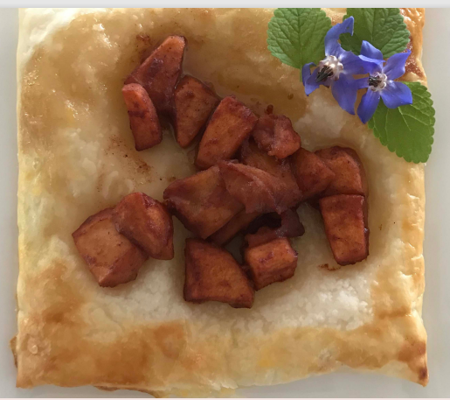

Fresh from the garden: Apples

 | Ingredients:  - 4 apples  - 2 teaspoons of cinnamon  - 2 teaspoons of maple syrup  - 4 tablespoons of water  - 1 egg  - 3 sheets of puff pastry
  Equipment:
  - Small saucepan
  - Chopping board
  - Knife
  - Wooden spoon
  - Metal spoon
  - Brush
  - Fork
  - Oven trays
  - Measuring spoons
  - Baking paper

What to do:

- Heat the oven to 180°C. Peel and dice the apples.

- Place a small saucepan on low heat, add water, apples, cinnamon and maple syrup. Cook, stirring regularly for 10 minutes or until the apples have softened. Add more water to the saucepan if needed.

- Remove from heat.

- Cut the pastry into 9 equal pieces. Score a 1 cm boarder around the edge of each pastry. Brush the edge with egg. Place the pastry onto a baking tray lined with baking paper.

- Scatter the apples in the middle of each pastry.

- Bake for 10 minutes or until the pastry is golden.

\

