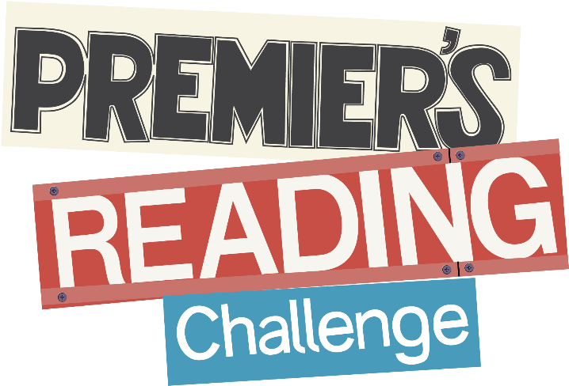

How to complete the Challenge
To complete the Premier’s Reading Challenge students need to read 12 books between week 1, term 1 and 3rd September 2021, term 3.
  - Reception to year 7: Students must read 12 books from the Premier’s Reading Challenge booklist and 4 personal choice books.
- Complete the Student Reading Record with the title and author for each book. A parent, caregiver, teacher or librarian must sign off on each book to verify it has been read.
- Pass on the completed Student Reading Record to the school’s Premier’s Reading Challenge coordinator or class teacher by the designated due date 3rd September 2021
- Receive an award in late November.

