http://www.sunsationalbodycare.com.au/

CLEAR SUNSCREEN SPF 50+
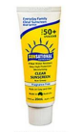 | 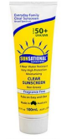 | 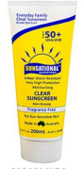 | 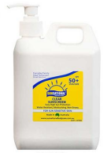 | SUNSATIONAL SUNSCREEN PRODUCTS ARE:  - Water resistant  - Quick drying  - Fragrance Free  - Titanium Dioxide Free  - Zinc Oxide Free  - PABA Free  - Nanoparticle Free  - Very High Sun Protection SPF 50+  - UVA/UVB Broad Spectrum  - Rubs on easy and clear  - Does not clog pores  - Does not sting eyes or run  - Non-greasy
Clear Sunscreen  20ml  $5 | Clear Sunscreen  100ml  $10 | Clear Sunscreen  200ml  $13 | Clear Sunscreen  1Ltr  $25

AFTER SUN CARE | HAND SANITISER | INSECT REPELLENT
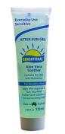 | 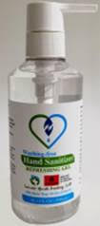 | 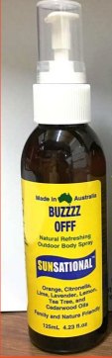 | BUZZOFF INSECT REPELLENT SPRAY  Enjoy the all-natural cooling and refreshing sensation of BuzzOff. The aroma that helps you enjoy the outdoors with this pure liquid Aloe Vera and organic alcohol that does not dry out your skin. Great to use at the beach, bushwalking, gardening, golf, sports, working and is safe for everyday use.  Ingredients: Purified Water, Liquid Aloe Vera, Solubiliser, Organic Alcohol and Essential oils. No Deet, safe around children and food.
After Sun Gel  125ml  $9 | Hand Sanitiser  300ml  $3 | Insect Repellent  125ml  $11

THANK YOU FOR SUPPORTING ONE OF THE LAST FUNDRAISING EVENTS FOR
MARLBOROUGH PRIMARY SCHOOL FOR 2021!
Order Form
Feel free to forward to family and friends to place an order.
All profits of this fundraiser will go towards our Playground Renewal Project.

Student Full Name or Family Name: _________________________________________________

Class: __________________________________________________________________________

Order Name (if different to the above): ______________________________________________

Contact Email or phone number: ____________________________________________________

Product Name | Size | Qty | Unit Price | Total
e.g. After Sun Gel | 125ml | 4 | $9 | $32
 |  |  | TOTAL

Please return this Order Form to the MPS Parents Association via email to marlborough.ps.pa@gmail.com along with payment by

Friday 15th October 2021

Items will be delivered to the school during Week 4 or 5 of Term 4 (pending restrictions).

Collection details will be communicated closer to the date.

Please indicate on your order form which payment method below you will be using.

PAYMENT METHODS:
Credit Card via OR  https://www.trybooking.com/BUMMI | Bank Transfer to:  Marlborough Primary School  BSB: 630 000  Account Number:138820683  Ref: Last name - Sunscreen

