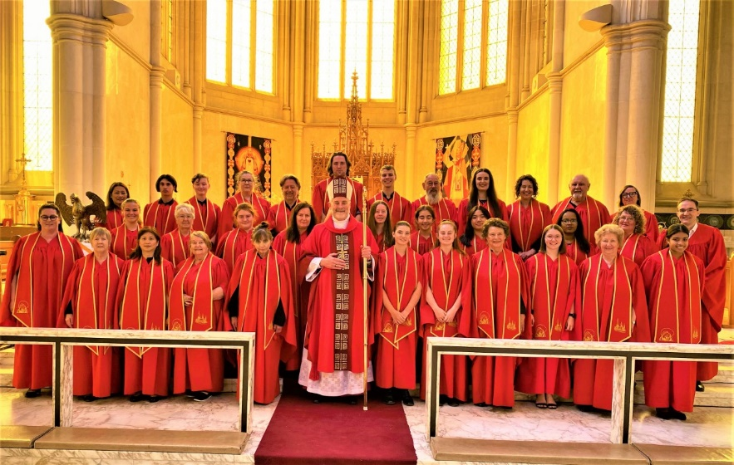

**SACRED HEART CATHEDRAL BENDIGO**

**CHOIR SCHOLARSHIPS (2025)**

The Sacred Heart Cathedral Choir in Bendigo is currently wishing to recruit new members from amongst students at local Catholic Schools and Colleges.

The mixed-voice Cathedral Choir (of sopranos, altos, tenors and basses) currently comprises 25 members, approximately one third of whom are on scholarship.

The scholarships, valued at $1,200 per year, offer a wonderful opportunity for students to contribute towards the liturgy at Sacred Heart Cathedral, and to further their musical education and appreciation. Scholarships are paid towards the end of each semester.

The Cathedral Choir sings music from the Church’s rich tradition of Gregorian chant and polyphony in Latin and English, plus traditional and contemporary hymnody and psalmody from Catholic and ecumenical sources.

Rehearsals are held in the Cathedral Choir Room, off Short Street, Bendigo, on Thursdays during school terms from 6-8pm (in Terms 1 and 4 due to extended preparations for Holy Week and Christmas) and from 6:30-8pm (in Terms 2 and 3), and on Sundays during Term from 9:45-10:40am in the Cathedral Choir Room, prior to the 11am Mass.

The Choir also sings at Christmas services and Easter ceremonies, and Diocesan celebrations (e.g. Chrism Mass on Tuesday of Holy Week and Ordination liturgies from time to time).

**Auditions will be held at the Cathedral Choir Room on Sundays from November - February, after the 11am Mass which interested singers are encouraged to attend. Audition bookings are required.**

Applicants are required to sing a number of items, including a familiar Christmas Carol (e.g. Silent Night) or Advance Australia Fair in addition to completing ear tests and a passage of sight-singing. 

Sight-singing ability is a distinct advantage. Interested applicants are invited to complete the audition form on the following pages.

**SACRED HEART CATHEDRAL BENDIGO  
CHOIR SCHOLARSHIPS**

**AUDITION APPLICATION FORM (2025)**

**STUDENT’S NAME: ________________________________________________________________**

**STUDENT’S AGE:___________________________________________________**

**NAME OF PARENTS:**

**________________________________________________________________**

**SIGNATURES OF PARENTAL CONSENT:_**

**____________________________________________________DATE: _______**

**____________________________________________________DATE: _______**

**HOME ADDRESS: ________________________________________________________________**

**PHONE/MOBILE NUMBERS: ________________________________________________________________**

**EMAILS: ________________________________________________________________**

**________________________________________________________________**

**STUDENT’S DATE OF BIRTH: _______________________________________________________________**

**STUDENT’S SCHOOL & YEAR LEVEL in 2021: _______________________________________________________________**

**STUDENT’S SCHOOL and YEAR LEVEL in 2022: ________________________________________________________________**

**SACRAMENTS RECEIVED BY STUDENT:**

**PARISH:_________________________________________________________**

**TOWN: _________________________________________________________**

**DATE: _______________________________ CELEBRANT:_________________**

**BAPTISM:________________________________________________________**

**CONFIRMATION: __________________________________________________**

**FIRST COMMUNION: _______________________________________________**

**MUSICAL INSTRUMENTS PLAYED? ________________________________________________________________**

**________________________________________________________________**

**AMEB MUSIC GRADES COMPLETED? ________________________________________**

**Please return this form - completed and signed - to**

**Dr Paul Taylor**

**Organist & Director of Music**

**Sacred Heart Cathedral**

**Bendigo VIC 3550**

**Email:**[**paul.taylor@sandhurst.catholic.org.au**](mailto:paul.taylor@sandhurst.catholic.org.au)

[**https://www.sandhurst.catholic.org.au/music/choir**](https://www.sandhurst.catholic.org.au/music/choir)

**Mob. 0400 830 929**