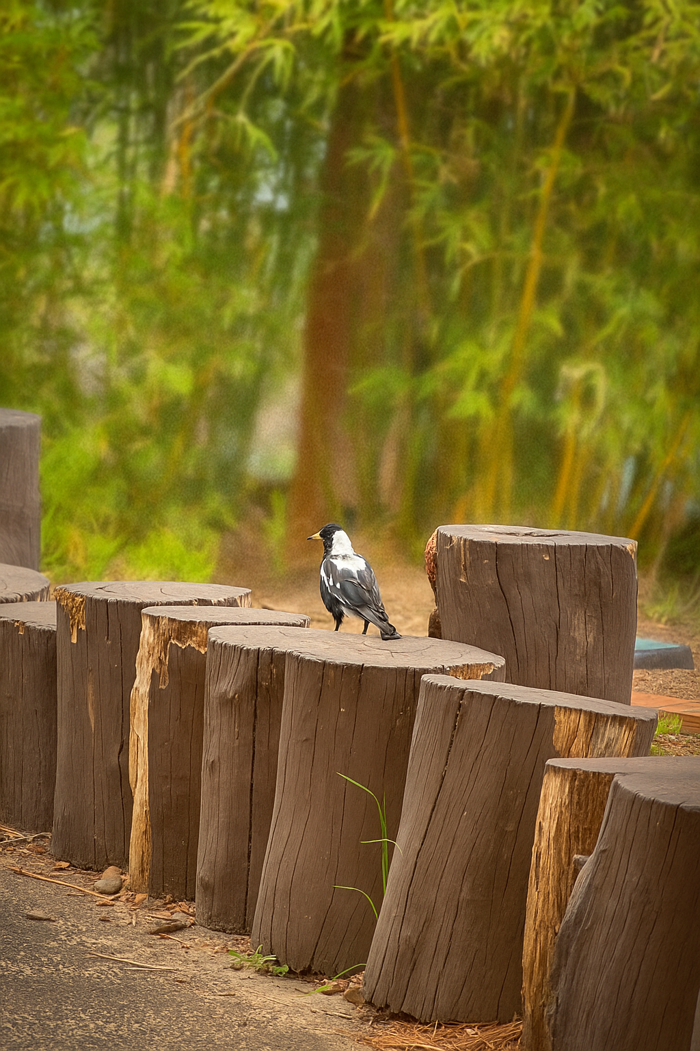
This picture shows a black and white magpie standing very close to some wooden stumps, and behind the stumps there are lots of tall bamboo plants that go out of the picture. The picture looks a bit like its in the bush or a path in the bush because of the stumps and the bamboo looks like small trees that have only just came out of the ground recently

