Service Name: Barwon Heads | Week Beginning: 14th to 18th November 2022 (Term 4. WEEK 7)
Community Involvement/ Service planned for the week:
- Following the schools’ Mental Health & well-being topic which is Fairness. Forgiveness means letting go of hard feelings like anger, sadness, or frustration that happen when you or someone else makes a mistake. It’s saying “Thank you” or “That’s okay” when someone apologizes and not staying upset about what they did.
- Doing the compost and completing the task of putting the chickens in their chicken coop.
- Talk to the parents about taking children to the library.
- Celebration of DAYS: 10-16 November International Week of Science and Peace, Saturday 19 November, World Toilet day, 18th November International Day of Islamic Art 18 November
Projects to be undertaken or planned:
- Enhance the new Junior Leadership Program and system in the coming weeks'
- Making our OSH newsletter with children
Team Goals for this Week:
- Talk with the children about the Junior Leadership Program, what is it? What have they been doing to participate? What would they like to change?
- Support children to make the OSH newsletter
Theme or Main Focus for this Week’s Planner: Tools and devices, create them and use them.
Learning Outcomes:
- 1.3 Children develop their sense of self-confidcence and autonomy by building and using tools
- 2.1 Children take action to assist other children to participate in social groups and experiences
- 3.2 Children manipulate equipment and manage tools with increasing competence and skill
- 4.1 Children participate in a variety of rich and meaningful inquiry-based experiences
- 5.3 Children engage with information and communication technology tools for designing, drawing, editing, reflecting and composing
School Holiday Program
We have an amazing School Holiday program coming up. Like all our holiday programs, we have an awesome time with the children, full of fun packed experiences that I am sure they will always remember. Please complete your booking forms as soon as possible and if you have any questions, come and speak to one of the staff at our program who will be happy to help.
Big Childcare Philosophy
Big Childcare is a leader in the out of school hour’s industry. Our team is professional, experienced, nurturing and committed to providing a supportive and transparent environment for families where their feedback and support is highly valued. We provide exceptional quality out of school hours care for school aged children which meets the health, safety and wellbeing needs of the children and families in the community. We believe in making our programs engaging, diverse, physically active and fun, where children’s learning can be scaffolded, so they can reach their full potential. Through these experiences’ children will develop a range of life long skills including building on their social and emotional capacity. Children are valued and respected as individual are central to our programs. The programs we offer are developed in conjunction with educators, schools the community, children and families. They are critically reflected upon and evaluated to ensure we are providing positive experiences that are age appropriate and extend every child.
We encourage all children and parents to provide us with feedback on the running of our service
All children are given the freedom to choose and change the activities they participate in

 | Monday | Tuesday | Wednesday | Thursday | Friday
Before Care  Creative Experiences | Creative Experiences  Hand signals device  People can use different system to communicate one of the is through hand signals. Learn some hand signals to communicate silently with others.  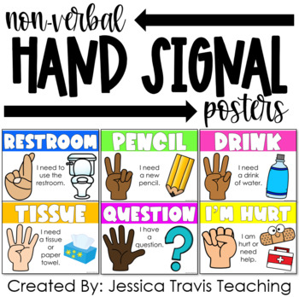  L/O: 1.3, 2.1, 4.1, 5.1  NQS: 1.2.1  Current Interest of:  Educator | Creative Experiences  Iron beads tools  Create a tool using the iron beads  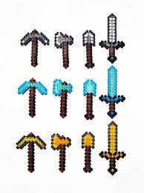  L/O: 1.3, 2.1, 4.1, 5.1  NQS: 1.2.1  Current interest of  3.11.22 Will and Max g. | Creative Experiences  Using different tools to paint  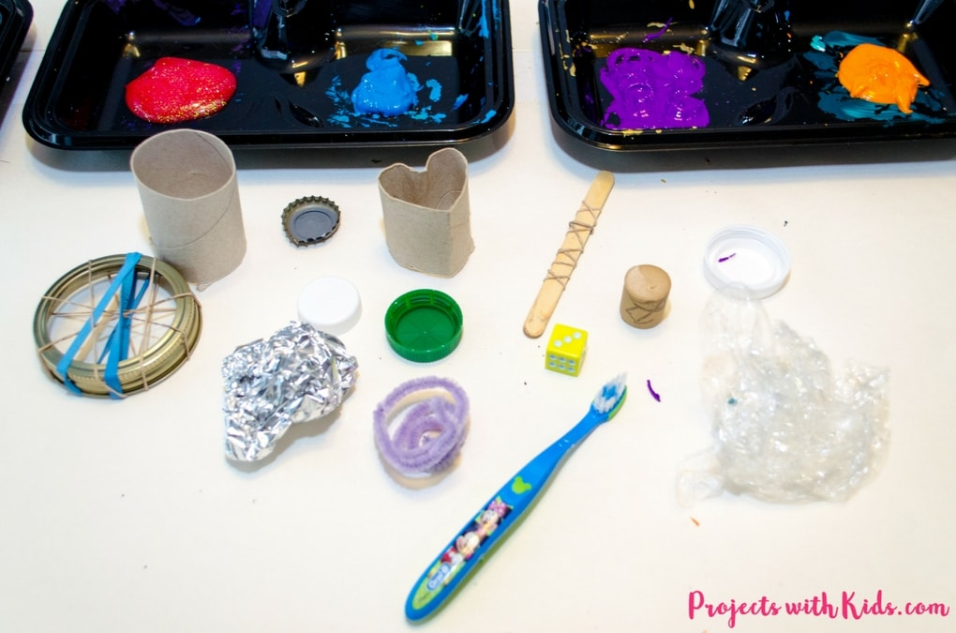  L/O: 1.3, 2.1, 4.1, 5.1  NQS: 1.2.1  Current interest of  2.11.22 Charlotte and Thom | Creative Experiences  Lego tools challenge  Build different tools with legos with 2 minutes time.  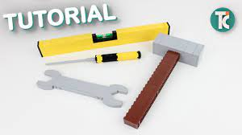  L/O: 1.1, 2.1, 4.4  NQS: 1.2.1  Current Interest of:  27.10.22 Thom | Creative Experiences  Origami Spaceship  How far can your spaceship fly? Made your own and have a go.  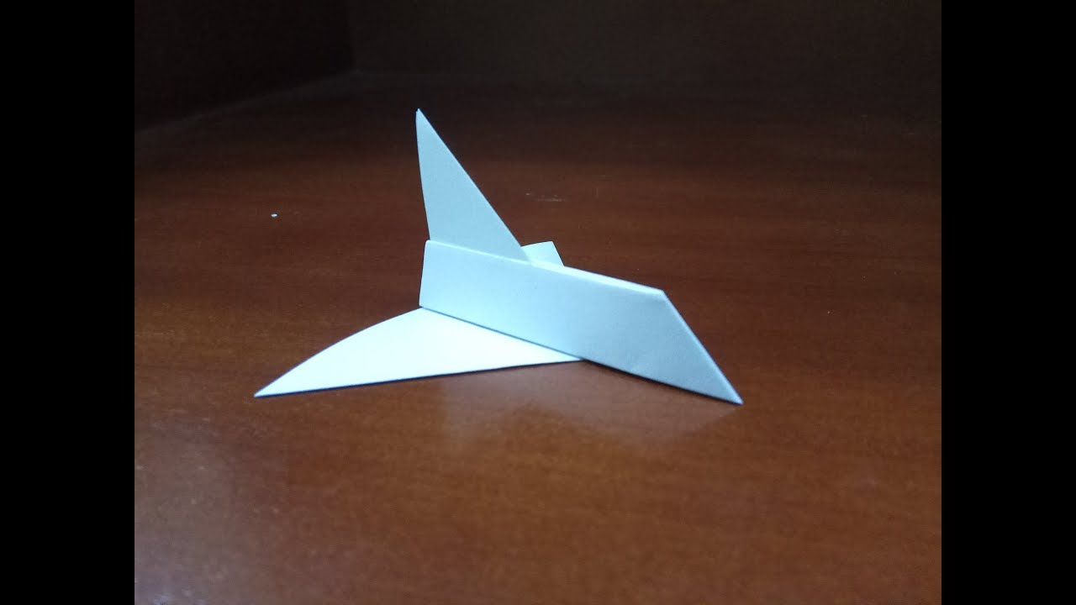  L/O: 1.2, 3.1, 4.3, 5.1  NQS: 1.2.1  Current Interest of:  25.10.22 Max

Before Care  Physical Experiences | Physical Experiences  Cricket  Coordinate your movements while hittin the ball with the bat or bowling the ball.  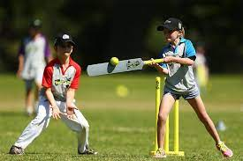  L/O: 3.2  NQS: 2.1.3  Current interest of  2.11.22 Will R, Will, Tarm and Maddison  1.11.22 Tharm (Learning Story) | Physical Experiences  Ball Line tiggy  Same rules as line tiggy but children will use their imagination and pretend to be in a milky way.  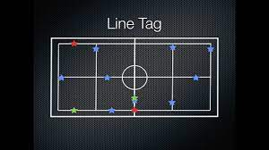  L/O: 3.2  NQS: 1.2.1  Current interest of  26.10.22 Goldic | Physical Experiences  Non- Elimination MUSICAL CHAIRS/Hoops  More than one participant can use a chair/hoop. So as hoops are removed, students aren't eliminated but more are forced to share the hoops that remain.  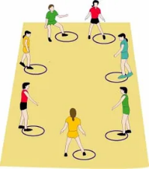  L/O: 3.2 NQS: 2.1.3 Current Interest of: 10/10/22 Dotty and Emma | Physical Experiences  Basquetball  Children will lead and agree fairly to the rules of the basketball game.  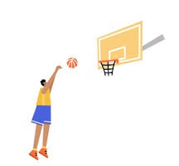  L/O: 3.2 NQS: 2.1.3  Current Interest of: 1.11.22 Tharm (Learning Story) and Wilson. | Physical Experiences  Dancing our favorite music  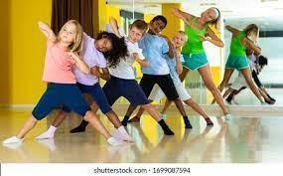  L/O: 3.2  NQS: 2.1.3  Current Interest of:  19.10.22 Peggy and Will.
Before Care Intentional Teaching or Discussion | Topic: Space  What is a tool? How do we use a tool? What tool would you like to create and how would you use it?  Tell me about a question that you would like to be ask.  Delivered by: Azucena  (*13.09.22 Will’s idea) | Topic: Space  What is a tool? How do we use a tool? What tool would you like to create and how would you use it?  Tell me about a question that you would like to be ask.  Delivered by: Azucena  (*13.09.22 Will’s idea) | Topic: Space  What is a tool? How do we use a tool? What tool would you like to create and how would you use it?  Tell me about a question that you would like to be ask.  Delivered by: Azucena  (*13.09.22 Will’s idea) | Topic: Space  What is a tool? How do we use a tool? What tool would you like to create and how would you use it?  Tell me about a question that you would like to be ask.  Delivered by: Azucena  (*13.09.22 Will’s idea) | Topic: Space  What is a tool? How do we use a tool? What tool would you like to create and how would you use it?  Tell me about a question that you would like to be ask.  Delivered by: Azucena  (*13.09.22 Will’s idea)
 | Monday | Tuesday | Wednesday | Thursday | Friday
After Care  Creative Experiences | Creative Experiences  Using different tools to paint  L/O: 1.3, 2.1, 4.1, 5.1  NQS: 1.2.1  Current interest of  2.11.22 Charlotte and Thom | Creative Experiences  Make an string telephone or a digital divise to play “The Office”.  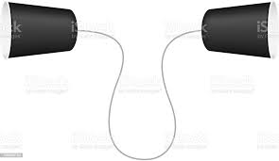  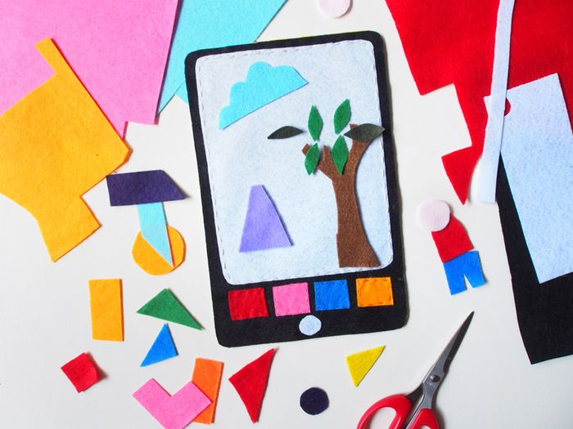  L/O: 1.1, 4.1, 5.3  NQS: 1.2.1  Current Interest of:  26.10.22 Emma and Charlotte | Creative Experience  Cardboad tools  Tools helps us to build different things. Create your own tools with cardboard.  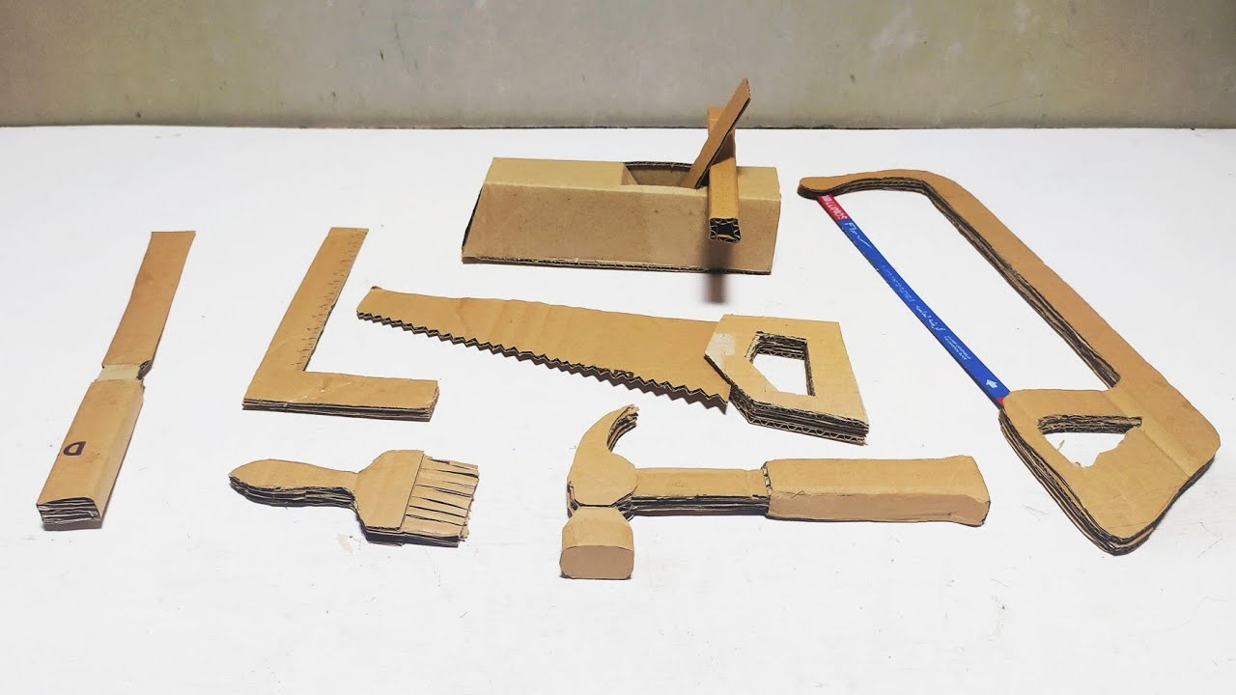  L/O: 1.1, 4.1, 5.3  NQS: 1.2.1  Current Interest of:  Visual Diary Week… Will C.  27.10.22 Thom (extension of lego tools) | Creative Experiences  Cooking Tool cookies  We will make a mixture of cookies for children and then they will have the chance to use it and create their favourite tool.  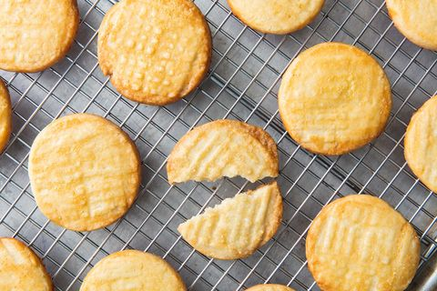  https://www.delish.com/cooking/recipe-ideas/a20138735/butter-cookies-recipe/  L/O: 1.3, 2.1, 4.1,  NQS: 1.2.1  Current Interest of: 3.11.22 Peggy | Creative Experiences  Iron beads tools  Create a tool using the iron beads  L/O: 1.3, 2.1, 4.1, 5.1  NQS: 1.2.1  Current interest of  3.11.22 Will and Max g.
After Care  Physical Experiences | Physical Experiences  Ball Line tiggy  Same rules as line tiggy but children will use their imagination and pretend to be in a milky way.  L/O: 3.2  NQS: 1.2.1  Current interest of  26.10.22 Goldic | Physical Experiences  GAGA BALL GAME  Using the Gaga pit outside, children will play a game of Gaga trying to get everyone out and become the winner.  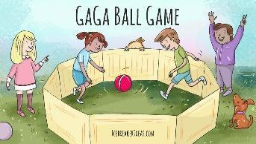  L/O: 3.2  NQS: 2.1.3  Current Interest of:  Max G. | Physical Experiences  Cricket  Coordinate your movements while hittin the ball with the bat or bowling the ball.  L/O: 3.2  NQS: 2.1.3  Current interest of  2.11.22 Will R, Will, Tarm and Maddison | Physical Experiences  Basquetball  Children will lead and agree to the rules of the basketball game.  L/O: 3.2 NQS: 2.1.3  Current Interest of: 12.10.22 Thom and Lola.  12.10.22 Brodhi | Physical Experiences  Non- Elimination MUSICAL CHAIRS/Hoops  More than one participant can use a chair/hoop. So as hoops are removed, students aren't eliminated but more are forced to share the hoops that remain.  L/O: 3.2 NQS: 2.1.3 Current Interest of: 10/10/22 Dotty and Emma
After Care Intentional Teaching or Discussion | Topic: Creativity  What is a tool? How do we use a tool? What tool would you like to create and how would you use it?  Tell me about a question that you would like to be ask.  Delivered by: Azucena  (*13.09.22 Will’s idea) | Topic: Creativity  What is a tool? How do we use a tool? What tool would you like to create and how would you use it?  Tell me about a question that you would like to be ask.  Delivered by: Azucena  (*13.09.22 Will’s idea) | opic: Creativity  What is a tool? How do we use a tool? What tool would you like to create and how would you use it?  Tell me about a question that you would like to be ask.  Delivered by: Azucena  (*13.09.22 Will’s idea) | Topic: Creativity  What is a tool? How do we use a tool? What tool would you like to create and how would you use it?  Tell me about a question that you would like to be ask.  Delivered by: Azucena  (*13.09.22 Will’s idea) | Topic: Creativity  What is a tool? How do we use a tool? What tool would you like to create and how would you use it?  Tell me about a question that you would like to be ask.  Delivered by: Azucena  (*13.09.22 Will’s idea)
10-16 November

International Week of Science and Peace
The annual observance of the International Week of Science and Peace is making an important contribution to the promotion of peace. The Week encourages greater academic exchanges on a subject of universal importance while also generating greater awareness of the relationship of science and peace among the general public. Based on observances of Science and Peace Week to date, it may be expected that participation each year will increase, contributing to greater international understanding and opportunities for co-operation in the applications of science for the promotion of peace throughout the year.
Saturday 19 November
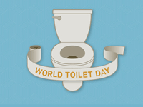

World Toilet Day
Organisation: World Toilet Organisation
World Toilet Organisation created World Toilet Day (WTD) to raise global awareness of the struggle 2.6 billion face every day without access to proper, clean sanitation. WTD also brings to the forefront the health, emotional and psychological consequences the poor endure as a result of inadequate sanitation.
National/State: International

International Day of Islamic Art
18 November
In 2019, UNESCO proclaimed this day to raise awareness to past and contemporary artistic expressions of Islam and the contribution of culture through Islamic Art to civilisation. It encourages worldwide appreciation for Islamic art in all its forms, such as glass, metalwork, pottery, jewellery and textiles.
These representations of Islamic art greatly influenced and formed part of the architectural style of the many lands of Islam with the tile and ceramic mosaics, intricate woodwork, stone and stucco carving and sumptuous hangings. The arts of Islam also feature calligraphy prominently throughout scrollwork, arabesques, geometric motifs and interlace patterns.

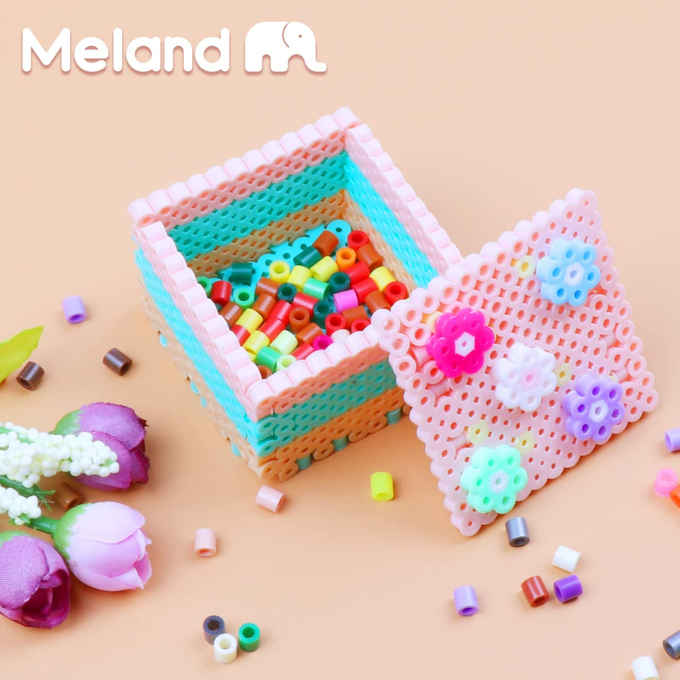

A device is any piece of equipment made for a particular purpose, especially a mechanical or electrical one while tool is (senseid)a mechanical device intended to make a task easier.

As a verb tool is to work on or shape with tools, eg, hand-tooled leather .

A tool, an instrument for making material changes on other objects, as by cutting, shearing, striking, rubbing, grinding, squeezing, measuring, or other processes.

