Gallipoli
Who?
In the battle of Gallipoli New Zealand troops along with Australia, Great Britain, Ireland, France, India and last but not least newfoundland fought in Gallipoli.
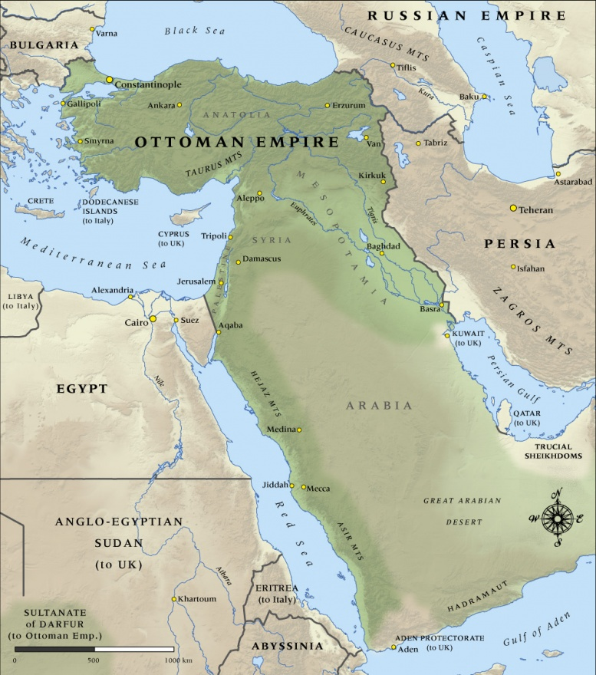
When?
This battle started in 1915 on the 19 of February and ended on the 9 January 1916.

Why? / What?
Gallipoli was intended to force Germanys ally, Turkey out of the war.

Where?
Gallipoli was fought in Ottoman Turkey.

Facts.
The allies underestimated their enemies.
130, 000 people died by the time that the war had ended.

