


Learn To Read

A
Parent’s Guide
ST PHILOMENA'S PRIMARY SCHOOL MOREE



St Philomena’s School Moree
55 Boston Street
PO Box 669
MOREE NSW 2400
Ph 02 6752 1577
moradmin@arm.catholic.edu.au

Dear Parents

We are pleased to share with you this parent guide to the teaching of reading. It has been compiled by the staff of St Nicholas Catholic School, Tamworth. We acknowledge the hours of work that went into the creation of the guide and thank them for their willingness to share it with fellow schools of the Armidale Diocese.

This parent guide has been produced to assist parents and teachers with the task of teaching our children to read. Its aim is to create a more consistent approach to our children’s learning in the classroom and at home.

The strategies outlined help the children to master the five big ideas to learning to read:

- Phonemic Awareness (what a child hears and the sounds they use to say a word)
- Phonics (different letters and combinations of letters make different sounds)
- Fluency (the speed and accuracy with which a child reads a text)
- Comprehension (understanding what has been read)
- Vocabulary (oral language and developing a broader knowledge of words)

We hope you may find this guide to be a useful resource.

Yours faithfully,



Karen Jagers
Principal

Phonemic
Awareness





WHAT IS PHONEMIC AWARENESS?

- First of all, Phonemic awareness is not phonics!
- Phonemic awareness is the ability to hear, identify, and manipulate individual sounds (phonemes) in spoken words.
- Children who are phonemically aware can perform phonemic awareness tasks in the absence of printed words.
- Before children learn to read print, they need to become more aware of how the sounds in words work.
- They must understand that words are made up of speech sounds, or phonemes (the smallest parts of sound in a spoken word that make a difference in a word's meaning).

WHY IS IT IMPORTANT?

- Phonemic awareness improves students’ word attack, reading and comprehension.
- It helps students learn to spell.
- This is a major contributing factor to overall phonological awareness (the ability to perceive and manipulate spoken words).

READ THESE SOUNDS

m | b | x
t | n | qu
s | k | y
f | r | a
d | w | e
g | j | i
l | p | o
h | v | u
c | z

  - It is ESSENTIAL that teachers and parents are modelling the correct pronunciation of phonemes / sounds.
  - Only using the most common form or sound. eg. /c/ as in /cat/, not the ‘ss’ sound in ‘face’ or the beginning of ‘circus’. We start with only basic sounds first.
  - Ensure that we are not adding a sound. eg. M, not ‘mu’ nor ‘fer instead of ‘f’; ‘p’ not ‘per’.

OTHER SOUNDS/LETTER COMBINATIONS

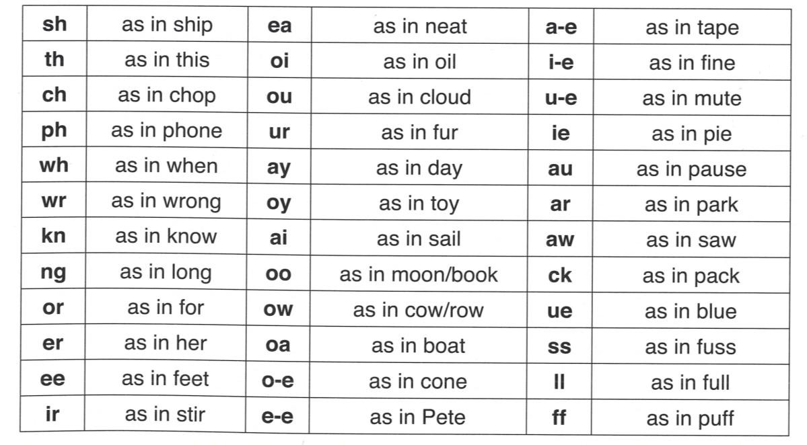

PRONOUNCING THE SOUNDS

    - Some sounds (phonemes) are voiced (b in bat) while others are unvoiced (p in pat)
    - Some sounds have stops eg. t, c, b, g
    - Others are continuous eg. f, s, m, v
    - Ensure that we are not adding a vowel sound on to consonants. eg. ‘p’, not ‘per’, or ‘M’, not ‘mu’
    - Sounds people often make mistakes with are: b, d, f, l, m, n, p, t, y

TEACHING PHONEMIC AWARENESS

- Taught through oral activities
- Use Model, Lead, Test process
- Blending & segmenting
- Beginning, medial, end sounds

Model – Lead – Test reflects modelled, guided, independent
- Model – adult does it
- Lead – child does it with the adult
- Test – child does it on their own
Example:
“mat – listen to me sound it out - /mmm/ /aaaa/ /t/” (MODEL) “ Do it with me - /mmm/ /aaaa/ /t/” (LEAD) “Now do it on your own” - (child says “/mmm/ /aaaa/ /t/”) (TEST )

This happens numerous times in a lesson, not just once.

ORAL BLENDING
The ability “to combine the sounds represented by letters to pronounce a word ... or sounding out (Harris & Hodges 1995)
- Explain – taking sounds and blending them together to make a word
- Demonstrate blending: I can slowly go /c/, /aaaaa/, /t/, cat – what word? Child responds: cat
- Then demonstrate doing it more quickly: c-a-t-cat – what word?:
- Quickly sound out words (rag, dip, run, dog, sit, mat, hit, etc) and have child blend them in their head, only saying the whole word.

ORAL SEGMENTING
  - Breaking words down into their individual sounds / phonemes
  - Whole word learners can find this tricky
  - Reverse of the oral blending.
  - Demonstrate using fingers to segment the sounds in a word (put one finger up for each sound going from left to right from the child’s perspective), then brushing fingers across to blend and say the whole word.
  - Have child use left hand. Start with thumb. That way they are reading left to right – makes it easier for writing (of course, reverse this for lefties!)

WORD STRETCHING
  - Combines blending and segmenting
  - Draw out the sounds and then blend the sounds together quickly
  - Imagine you are pulling a piece of elastic as you slowly sound the word out, but it springs back into a ‘clap’ as you blend to phonemes together and say the word at the end
  - Start with hands together. Slowly pull apart as you sound out each sound. Hands get further apart for each sound.
  - After sounding out the words, pretend to release the elastic and bring hands together in a clap as you say the blended word.

  - /d/ - /ooooooo/ - /g/ - ‘dog!’
Hands together - pull & stretch - stretch more - stretch more - ‘release’ & clap

Phonics



WHAT IS PHONICS?

    - Linking sounds to letters and letter combinations i.e moving from the oral (sound) of words to print
    - Variety of activities used
    - Applies to both reading and spelling

INTRODUCING SOUNDS (Suggested order)

    - One suggested sequence for introduction of sounds (based on Australian research – Macquarie University):
m, a, s, t, i
f, d, r, o, g
l, u, h, c, b
e, n, k, v, p j, z, w
q, x, y
C, K, O, P, S, U, V, W, X, Y, Z T, L, M, F, D
N, I, R, A, H
G, B, J, E, Qu
sh, ck wh, ng ch, th …

Sounds can be introduced in groups.

      - Step 1: Phonemic awareness – can children recognise and identify orally?
      - Step 2: Phonic matching – can children match phoneme (sound) with corresponding grapheme (letter/s)?
      - Step 3: Use these sounds to create cv (consonant vowel) , vc (vowel consonant) = at and cvc (consonant – vowel- consonant) words = cat.
- This way children are able to create simple words early on, rather than only having one sound introduced each week.
- NB: Need to cover capital letters – don’t assume children know them, or will make the connection between lower and upper case letters.
E.g. For some children ‘the’ and The’ are two different words.

MAKING WORDS

- Introduces students to word reading
- Provides a clear link between sound and symbol
- Highlights the importance of a sound in a word

STRATEGY
MAKE LETTER BOXES (as below)

and LETTER TILES

ch | o | p

  - Children use letter boxes and letter tiles to create decodable words
  - This reinforces the sound / grapheme correspondence
  - Remember, one sound, but some sounds might have more than one letter in the box

WORD TRANSFORMATIONS

r | i | p

ch | i | p

    - Start with the word ‘rip’
    - If we change /r/ to /ch/
    - What word?
    - We could go on to say, change the /p/ to /n/. What word? Etc.
    - Here we just change one letter at a time – this reinforces commonalities and differences between words.

WORD LADDERS

    - Good extension for older or more capable children
    - Children have to see if they can get from a starting word to target words by changing only one sound at a time

To change:
cat ➔ rob chain ➔ rush

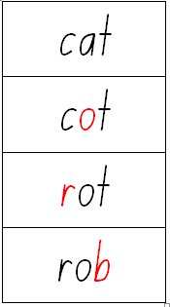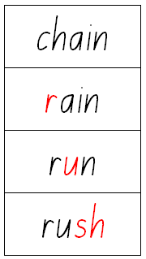

Let’s try: crush ➔ fleck
Who can do it in the fewest moves?

Supported
Reading



WHAT IS IT?

- Supported reading is a cross between Shared and Guided reading – when a child is reading themselves with the guidance of an instructor/adult
- Used for children in the early years of reading development
- Links vocabulary knowledge , comprehension and fluency( which includes punctuation)
- Links isolated reading skills to the text in a book form

WHY IS SUPPORTED READING SO CRITICAL?

  - Allows for generalisation of skills already explicitly taught in the classroom
  - Provides children with access to meaningful text and the time to make connections
  - Promotes development of fluency, comprehension and vocabulary skills
  - Ensures that children experience an integrated approach to literacy instruction

BOOK SELECTION

For beginner readers books need to be phonic based with a limited number of high frequency irregular sight words. They may seem boring to us but they build confidence in our students.

WHAT TO DO EACH READING SESSION

During the reading session ask the child to:
    - Introduce the book (new book)
    - Read title aloud
    - Discuss characters
    - Set the scene
    - Make connections

During the reading session when the child is continuing or rereading a book:

    - Ask 2-3 questions about the story so far
    - Recap and predict

During the reading session:
    - Write a few unfamiliar words on a sheet of paper- These may need highlighting in the session. (No more than 6 words)
    - Ask students to try to read the words
    - Discuss the meaning of the words
    - Provide help if they are unable to do so

During the reading session:
    - As an instructor, read aloud to model fluency and expression at times.
    - Encourage the child to follow along with their finger in early years
    - Ask brief questions every two or three pages to check for understanding
    - Point out any problematic vocabulary words when encountered in the text
    - Children have opportunities to read sentences aloud, either individually or with their instructor
    - NB: The tutor takes a turn every now and then – two fold purpose:
    - gives the children a good model
    - gives the children a break from reading

Support child by:
    - Encouraging them to work out words independently when errors are made
    - Promote self-monitoring and use of independent strategies
    - Use Pause, Prompt, Praise.
    - Remember to use Model, Lead, Test (as outlined in the Phonemic Awareness section) if child is having difficulty

CONCLUDING A SESSION

    - Recap the story through 5 ‘WH’ questions
Who, What, When, Where, Why, Which, How

Pause, Prompt
and Praise



WHAT IS IT?

      - Pause, Prompt, Praise (the 3Ps)
      - A technique to support students with individual reading
      - Used by teachers, EAs, classroom volunteers, parents

PAUSE

When a child makes an error when reading, or does not know a word, the instructor should pause (5 seconds) to give the child time to self correct.
If they are still unsuccessful the instructor will provide a series of prompts.

PROMPT

Give a general phonic prompt
Ask the child to look at the incorrectly read, or unknown, word more carefully
If error does not make sense: point this out, and then ask the child to look more carefully at the word
If the child says nothing, ask them to go back to the beginning of the sentence and re-read

Give a specific phonic prompt
Draw child’s attention to the specific part of the word that is read incorrectly.
  - ‘cat’ (child says cot) – remember ‘a’ says /a/

After second prompt
If child fails to correct their error after the second prompt, then you simply give them the word.
Say, “the word is...”

PRAISE

Praise the child when there is evidence of:
    - Self-correcting
    - Sounding out a word
    - Correcting after a prompt
    - Reading a sentence, paragraph or page correctly
    - Reading carefully and with expression
    - Following along with their finger

Story Book
Reading



      - The adult reads to the child
      - Provides good modelling of expression and fluency
      - One book over 3 sessions at different times e.g. successive nights
      - Only need take 7-10 minutes
      - Positive experience – everyone loves a story
      - Child should be comfortable

BOOK SELECTION

      - Use quality books
      - No need to worry about reading ability, as it is the adult who is reading
      - Need to ensure that it contains vocabulary that will challenge
      - Be mindful of the interests of the child

INTERACTIVE STORY BOOK READING

FIRST READ THROUGH
INTRODUCING THE BOOK
Ask 1 or 2 questions about: (take 2-3 minutes)
      - Difficult words in the title
      - Illustrations on the front cover
      - What might happen in the story
      - A connection between the story and the child’s own knowledge / experience

READING THE BOOK
- Read the book from beginning to end
- Briefly pause to explain the meaning of difficult words, but don’t go into great detail or ask questions

SUMMARY & REVIEW
Use the prompts:
- What happened in the beginning of the story?
- What happened in the middle of the story?
- What happened at the end of the story?

SECOND READ THROUGH
- Recap and re-read the book
- Ask one question every page or every couple of pages
~ Prepare questions beforehand
~ Put them on a sticky note and attached to relevant page of book for ease of reference
~ Questions should be a combination of:
  - Literal (What is on the page?)
  - Inferential (Reading between the lines)
  - Evaluative (What do you think?)
  - Vocabulary (What does that word mean?)

- At least 5 questions should focus on asking the children the meaning of difficult words.
- Provide child-friendly definitions or synonyms for words that students do not know.

~ Child friendly definitions:
  - Reside – live in
  - Detest – hate
  - Amusing – making us laugh
  - Grin – a big smile
~ Synonyms:
  - ‘I am going to tell you a word for “amusing” that means the same thing.
  - The word is “funny”. You could say “amusing” or “funny”; they mean the same thing.’

- Expanding on child’s responses using the PEACH strategy
~ Prompt with a question to the child
~ Evaluate the child’s response. Limited response? (yes, no)
~ Add a prompt, add information (rephrase the child’s answer in more detail)
~ CHeck to see that the child can answer the question in more detail

When questioning we need to do more than scratch the surface. We need to get children to
- expand on their responses if their initial response is limited
- have high expectations of children, but provide scaffolding to help them reach these

AN EXAMPLE OF PEACH STRATEGY
using the book The Gruffalo’ by Julia Donaldson

(Adult) “Why do you think the Gruffalo said ‘Astounding’?” (Prompt)

(Child) “He was surprised.” (Evaluate)

(Adult) “Yes, that’s right, ‘astounding’ means ‘very surprising’.” (Add)

(Adult) “Why was the Gruffalo surprised?”
(Child) “The Gruffalo was surprised that the owl was so
scared of a little mouse.” (Check)

THIRD READ THROUGH
VOCABULARY REVIEW
- Recap the story
- Select three to five words that were the focus in Session 2
- Use sticky notes to find the pages where each word was used in context
- Ask an individual student to tell the group what the word means
- Model a sentence using the target word
e.g. There were too many vegetables in the stew.
- Ask individual students to put the target word into a sentence of their own.
- Guide student through the whole sentence.
- Ask the student to repeat the sentence.
e.g. I do not like peas in my stew.

SUGGESTED READING LIST FOR STORY BOOK READING

FOX, Mem | Wombat Divine Possum Magic The Magic Hat Koala Lou
FRENCH, Jackie | Dairy of a Wombat
GLEESON, Libby | Uncle David
HILTON, Nette | The Smallest Bilby and the Midnight Star
HORNSEY, Chris | Why Do I Have to Eat Off the Floor?
JENSEN, Kiersten | Possum in the House
KERR, Judith | The Tiger Who Came to Tea
KNOWLES, Sheena | Edward the Emu Edwina the Emu
LESTER, Alison | Ernie Dances to the Didgeridoo
LIPPO, Agnes | The Kangaroo and the Porpoise: An Aboriginal Story
MCALISTER, Angela & FUGE, Charles | Found You, Little Wombat!
MONKS, Lydia | Aaaarrgghh! Spider!
MUNSCH, Robert | The Paperbag Princess
MURPHY, Jill | On the Way Home
NICOLL, Helen | Meg and Mog
NILAND, Deborah | Annie to the Rescue
PARK, Ruth | When the Wind Changed
PATERSON, A.B.  (retold by Dawn McMillan) | Mulga Bill’s Bicycle
PENKOWSKIM, Jan | Meg & Mog

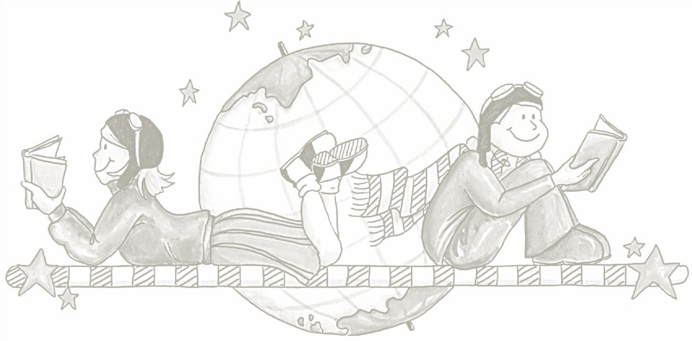
ALLEN, Pamela | My Cat Maisie Who Sank the Boat Belinda  Bertie and the Bear  I Wish I Had a Pirate Suit Alexander’s Outing  Mr McGee and the Biting Flea
ANDREDE, Giles | Giraffes Can’t Dance
BAKER, Jeannie | Where the Forest Meets the Sea Millicent
BROWNE, Anthony | Silly Billy Gorilla Changes
CLEMENT, Rod | Olga the Brolga
COOK, Kaz | The Terrible Underpants
CRONIN, Doreen | Cleck, Clack, Moo: Cows That Type Giggle, Giggle, Quack
CROSER, Josephine | Crunch the Crocodile
DODD, Lynley | Slinky Malinki
DONALDSON, Julia | The Snail and the Whale The Gruffalo
EDWARDS, Hazel | There’s a Hippopotamus on Our Roof Eating Cake  My Hippopotamus is on Our Caravan Roof Getting Sunburnt
FALCONER, Ian | Olivia
FLACK, Margorie | The Story About Ping
FOX, Lee | Ella Kazoo Will Not Brush Her Hair
SENDAK, Maurice | Where the Wild Things Are?
SEUSS, Dr | The Cat in the Hat
SHANNON, David | Duck on a Bike
SILVERSTEIN, Shel | The Giving Tree
SIMMONS, Jane | The Ebb and Flo Series
THOMAS, Valarie | Winnie at the Seaside
VAUGHAN, Marcia K. | Wombat Stew
WHYBROW, Ian Harry | Harry and the Bucketful of Dinosaurs
WILD, Margaret | Little Humpty

Games

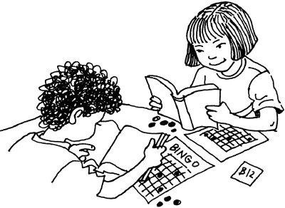

The following is a selection of games which are can be played to support phonic and phonemic awareness.
- I Spy
- Beginning Sound Snap
- Guess a Word
- Segmenting Speed Game
- Bingo
These games can all be adjusted for a variety of student ability groups and Stage levels.

I SPY
I spy with my little eye something:
- beginning with ’A’ (letter name)
- beginning with /a/ (sound)
- ending in /sh/
- that ends in ‘men’
Instructors can adapt to emphasise whatever they wish to emphasise.

BEGINNING SOUND SNAP
- Instructor calls out 2 words . If both words start with the same sound , eg dip and dog, ship and sheep etc. child claps and says SNAP!
- Make sure there are a mixture of examples, some of which don’t start with the same sounds.
- Can be used with same end sounds/ medial sounds/ blends of 2 sounds etc.
- Have a go.

GUESS A WORD
- Guessing a word from the oral clues given.
- Eg. I’m thinking of a word with 3 sounds. It begins with the sound
/c/ and ends with the sound /t/ and it purrs.
- I’m thinking of a word with 5 sounds. The second sound is /ur/ and the last sound is /n/. I hang in houses to provide privacy. (Stage2/3 example)
- Provide phonemic clues and contextual clue/s for each word.
- Sound boxes can be used- demonstrate
You will need to say that /n/ means the sound NOT the letter name

SEGMENTING SPEED GAME
- “I’ll say a word. Let’s take it in turns to say the next sound in the word. “
- Instructor keeps going through the list.
~ Eg. Cat-/c/ /a/ /t/, print /p/ /r/ /i/ /n/ /t/,
~ wrote-/r/ /o/ /t/, book- /b/ /oo/ /k/,
~ handbag-/h/ /a/ /n/ /d/ /b/ /a/ /g/,
~ provide- /p/ /r/ /o/ /v/ /i/ /d/
~ sing- /s/i/ng/
- Time the activity. Do again and retime to beat the clock. Instructor needs to have a list of words ready to use.

BINGO
Single sounds, digraphs,(sh, ck, wh, etc.),common letter combinations, sight word recognition, bossy “e” words etc.
Need a different bingo board depending on sounds being used for game Children can make their own Bingo boards . Eg. using their spelling list

A Word
About Sight Words

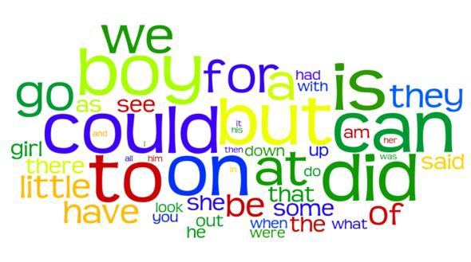

WHAT ARE THEY?

Sight words are those regular and irregular high frequency words used in English that cannot be sounded out using phonic or decoding techniques
Example: /said/ /could/. Children need to learn these words as whole words and must learn to spell them by using their letter names (not sounds). Sight words are usually introduced to children in sets of five words.
Please Note: When spelling a word with a double letter in it e.g. little – do not use the term ‘double l’ – instead you must spell the word as ‘l-i-t-t-l-e’.

200 IMPORTANT WORDS TO READ AND SPELL

a | and | he | I | in | is | it
of | that | to | the | was
all | as | at | be | but | are | for
had | have | him | his | not | on | one
said | so | they | we | with | you
about | an | back | been | before | big | by
call | came | can | come | could | did | do
down | first | from | get | go | has | her
here | if | into | just | like | little | look
made | make | more | me | much | must | my
no | new | now | off | old | only | or
our | other | out | over | right | see | she
some | their | them | then | there | this | two
up | want | well | went | were | what | when
where | which | who | will | your
after | again | always | am | another | any | ask
away | bad | because | best | bird | black | blue
boy | bring | day | dog | don’t | cat | every
far | fast | father | fell | find | five | fly
four | found | gave | girl | give | going | good
got | green | hand | have | head | home | house
how | jump | keep | know | last | left | less
let | live | long | man | many | may | men
mother | Mr | once | open | own | play | put
ran | read | red | room | round | run | sat
saw | school | should | sing | sit | soon | step
take | tell | than | these | thing | think | three
time | too | tree | under | us | use | very
walk | white | why | wish | work | would | year
help | say

References:
Diocesan Learning Enhancement Strategy – Catholic Schools Office Armidale MiniLit – Meeting Initial Needs In Literacy
Early Intervention Program (Strategies for Reading)

