Woolbrook Excursion
By Lindsay Ham
Yesterday we went to Woolbrook. I loved playing T ball, I loved cheering my friends on when they were running from base to base.
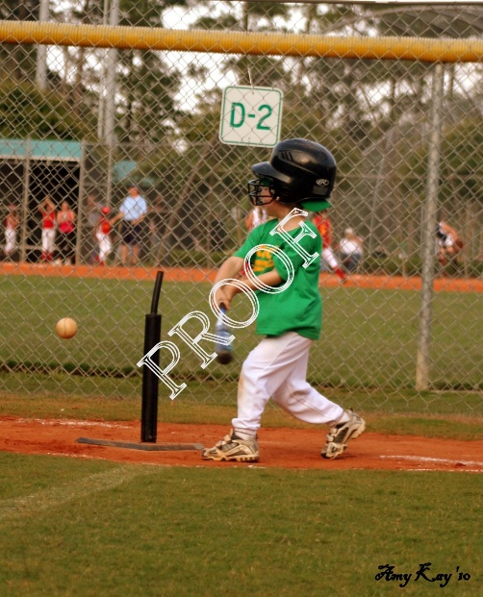
This Photo by Unknown Author is licensed under CC BY-NC-ND

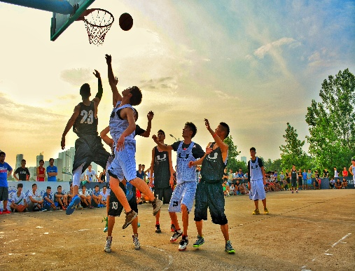
After T ball I played basketball. We got smashed but we weren’t playing to win, we were playing to have fun.

Woolbrook is a very nice school.


Thank you Mrs wall for organising the excursion.
This Photo by Unknown Author is licensed under CC BY-SA

