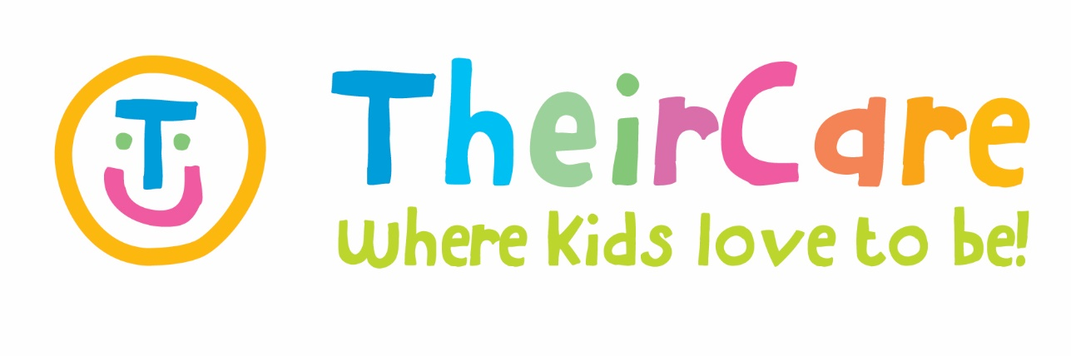

#### Newsletter Term 1 Week 4 2022

***St Marys Primary School St Kilda***

**Theatre – Week 2**

Theircare brought the ‘Theatre’ to the service to motivate children to show their skills with performance activities, combining also construction games, mindfulness activities, dancing, singing and craft related to the week topic such as making puppets, mask making and craft made dresses.

We enjoyed of good weather and we spent part of ASC in the playground discovering, playing tagging and soccer.

As part of the compliance activities, during this week TheirCare staff checked and updated medical documents, enrolments, and wall displays. Also, we did our first drill evaluation of the term, which was a Lockdown drill and our children shown there are prepared for this kind of situations.

**Lego Master - Week 3**

Our children has shown a passion for Lego and this week the activities were focusing on Lego building, challenges, science experiments making a Lego volcano, and STEM activities using Lego pieces such as creating a Lego boat and car. The boys love to play together with Lego and Jenga making towers, building houses and mazes, trying it with water and small balls. As part of craft, we did bubble wrap painting and our children decided to do some San Valentines cards for their love ones. As child initiative, our children shown interest for calligraphy and drawing making their names using bubble letter; role play and mask making.

The outside activities were related to discover insects and worms in the playground, created castles in the sandpit and playing tag.

Also, we did a cooking activity making yummy fairy bread due to our children love it!

**Photo Gallery**

|  |  |  |  |  |
| --- | --- | --- | --- | --- |
| Contact Service | Contact Head Office | Times |  |  |
| Phone: 0475 577 404 | Phone: 1300 072 410 | Before School: 7:00am – 8:45am |  |  |
| Email: stmarysstkilda@theircare.com.au | Email: info@theircare.com.au | After School: 3:30pm – 6:00pm |  |  |