Press Release: Diamond Valley Singers
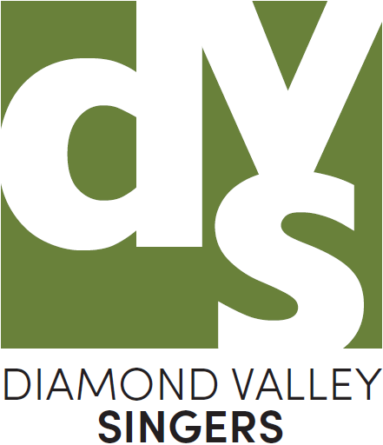
Present
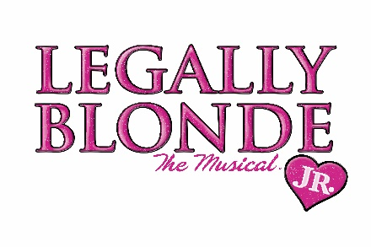
LBJ Synopsis:

Come and join the Diamond Valley Singers Youth production for the 8-performance season of “Legally Blonde Jr.”

Based on the award-winning Broadway musical and the smash hit motion picture, Legally Blonde JR. is a fabulously fun journey of self-empowerment and expanding horizons. The show's instantly recognizable songs are filled with humour, wit and sass — leaving cast members and audiences alike seeing pink!
Legally Blonde JR. follows the transformation of Elle Woods as she tackles stereotypes, snobbery and scandal in pursuit of her dreams. When Elle's boyfriend, Warner, dumps her and heads to Harvard, claiming she's not "serious" enough, Elle takes matters into her own hands, crafting a showy song-and-dance personal essay and charming her way into law school. Befriending classmate, Emmett, and spunky hairdresser, Paulette, along the way, Elle finds that books and looks aren't mutually exclusive. As Elle begins outsmarting her peers, she realizes that law may be her natural calling after all.

From our Director, Scott Patton: “I am excited to be directing Legally Blonde JR. for DVS. I have previously performed in Broadway productions with DVS and have now come full circle. I am really honoured to be moving into a creative role with this wonderful company.”

“Acting locally and thinking Globally” Diamond Valley Singers will donate proceeds from the performances to International Needs Australia and Open House in Macleod.

Try booking ticket link: Book Here

Web Site: www.dvsingers.org

Further information, contact: Malcolm Wilton: 0435 763 215

