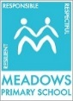
Child Safe Code of Conduct Policy

MEADOWS PRIMARY SCHOOL
RESPONSIBLE RESPECTFUL RESILIENT

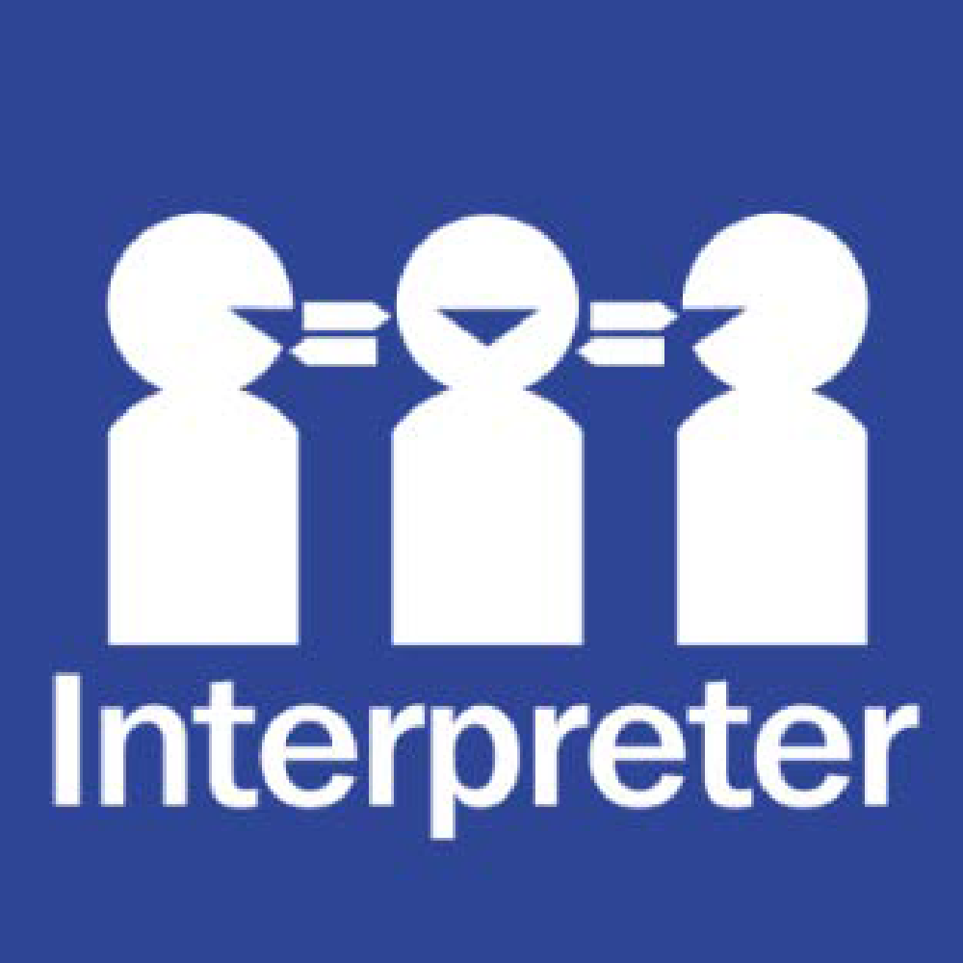
Help for non-English speakers
If you need help to understand this policy, please contact Meadows Primary School on 9466 1322 or 9466 1810.

Purpose
Our Child Safety Code of Conduct sets out the expected behaviour of adults with children and young people in our school.
All Meadows Primary School staff, volunteers, contractors, service providers, school council members and any other adult involved in child-connected work must follow the Child Safety Code of Conduct.
The Child Safety Code of Conduct applies to all physical and online environments used by students. It also applies during or outside of school hours and in other locations provided by the school for student use (for example, a school camp).

Acceptable behaviours
As Meadows Primary School, staff, volunteers, contractors, and any other member of our school community involved in child-connected work, we are responsible for supporting and promoting the safety of children by:
- upholding our Meadows Primary School commitment to child safety at all times and adhering to our Child Safety and Wellbeing Policy
- treating students and families in our school community with respect in our school environment and outside our school environment as part of normal social and community activities
- listening and responding to the views and concerns of students, particularly if they disclose that they or another child or student has been abused or are worried about their safety or the safety of another child or student
- promoting the cultural safety, participation and empowerment of Aboriginal students, students with culturally and/or linguistically diverse backgrounds, students with a disability, international students, students who are unable to live at home and lesbian, gay, bisexual, transgender and intersex (LQBTIQ+) students
- ensuring, as far as practicable, that adults are not alone with a student – one-to-one interactions between an adult and a student are to be in an open space or in line of sight of another adult.
- reporting any allegations of child abuse or other child safety concerns to the School Principal and or Assistant Principal.
- understanding and complying with all reporting and disclosure obligations (including mandatory reporting) in line with our child safety responding and reporting policy and procedures and the PROTECT Four Critical Actions.
- if child abuse is suspected, ensuring as quickly as possible that the student(s) are safe and protected from harm.

Unacceptable behaviours
As Meadows Primary School, staff, volunteers, contractors and any other member of our school community involved in child-connected work we must not:
- ignore or disregard any concerns, suspicions or disclosures of child abuse or harm
- develop a relationship with any student that could be seen as favouritism or amount to ‘grooming’ behaviour (for example, by offering gifts)
- display behaviours or engage with students in ways that are not justified by the educational or professional context
- ignore an adult’s overly familiar or inappropriate behaviour towards a student
- discuss intimate topics or use sexualised language, except when needed to deliver the school curriculum or professional guidance
- treat a child or student unfavourably because of their disability, age, gender, race, culture, vulnerability, sexuality or ethnicity
- communicate directly with a student through personal or private contact channels (including by social media, email, instant messaging, texting etc) except where that communication is reasonable in all the circumstances, related to schoolwork or extra-curricular activities or where there is a safety concern or other urgent matter
- photograph or video a child or student in a school environment except in accordance with the Photographing, Filming and Recording Students policy or where required for duty of care purposes
- consume alcohol against school policy or take illicit drugs in the school environment or at school events where students are present
- have contact with any student outside of school hours except when needed to deliver the school curriculum or professional guidance and parental permission has been sought.

Breaches to the Child Safety Code of Conduct
All Meadows Primary School staff, volunteers, contractors and any other member of the school community involved in child-connected work who breach this Child Safety Code of Conduct may be subject to disciplinary procedures in accordance with their employment agreement or relevant industrial instrument, professional code or terms of engagement.
In instances where a reportable allegation has been made, the matter will be managed in accordance with the Department of Education and Training Reportable Conduct Scheme Policy and may be subject to referral to Victoria Police.
All breaches and suspected breaches of the Meadows Primary School Child Safety Code of Conduct must be reported to the Principal and Assistant Principal on 9309 2573.
If the breach or suspected breach relates to the principal, contact the Senior Education Improvement Leader or the Regional Office on 1300 338 691 nwvr@education.vic.gov.au .

Approval and review
Created date | June 2025
Consultation | School community via newsletter and website 13 June 2025  Sought feedback from School Council 12 June 2025
Endorsed by | Principal - June 2025  School Council - June 2025
Next review date | June 2027
Responsibility | Principal Class

I have read and acknowledged this Code of Conduct and will abide by it at all times. I also acknowledge my responsibility to report any breaches of this code to the principal, leadership staff members and the Child Safety Officer. Options for reporting include an email to the school’s email account: meadows.ps@education.vic.gov.au

Name: ____________________________________________

Signature: ____________________________________________ Date: ______\______\______

