
28/11/2025

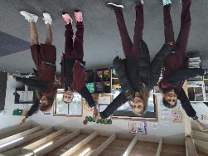
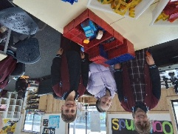


Christma
Only three weeks to go until we say goodbye to Camp Australia at Oatlands Primary School!
Join us on Thursday, 18th December for a fun-filled afternoon:
- 1:30 PM onwards – Splash into exciting water activities
- Followed by our Crazy Hair Party and heartfelt goodbyes
- From 4:00 PM – Parents are warmly invited to join the festivities
We’re hoping some of our past staff will pop in too, so we can all share memories and celebrate together with our amazing families and children.
From all of us, thank you for the incredible journey from 2012 to 2025. It’s been an absolute privilege caring for your children and being part of this community.
Wishing you all a Merry Christmas and Happy Holidays!

- Cup and saucer creation
- Christmas Tree
- Shortbread Biscuits
- Christmas Globes
Activities coming up
Join in the fun of Outside School Hours Care activities and experiences with Your OSHC and Rocketeers.
Make a booking
Book now
Oatlands Primary School OSHC

