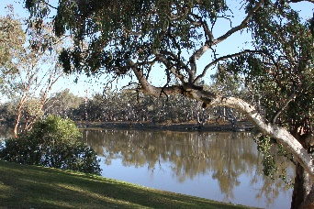

District 9510
Sunraysia Rotary River Health Scholarship
Application form
Applicant’s Family name First Name
Other names
Date of birth
Gender
Normal home address
Phone number(s) Landline Mobile
Email:
Eligibility Applicant must be citizen or permanent residents of Australia, whose normal home address is in the Mildura area.
Applicant must be enrolled in Year 12 in a Mildura school or be enrolled in a first-year tertiary course
1.1 Name of Yr12 Secondary College
OR
1.2 Name of First Year Tertiary course

Name of Rotary Club willing to endorse the application for consideration
Rotary Club of
Indicate below your current subject interests and further Tertiary intentions.
Write up to 250 words, briefly describing your interest in river health issues and how your proposed studies are relevant to the intent of the scholarship (To aid future development of improving the health of the rivers in the Murray Darling Basin)

Applications to be sent to the Rotary Club of Red Cliffs email address:
For further information Phone 0428 165 355


