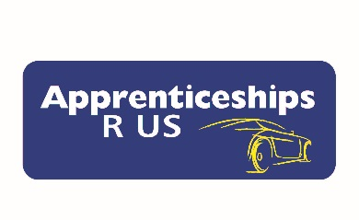
PLEASE COMPLETE THE DETAILS BELOW AND FAX OR EMAIL IT BACK TO US WE WILL CALL YOU BACK TO ARRANGE A TIME AND DATE TO BE INTERVIEWED FOR AN APPRENTICESHIP.
Expression of Interest
Fax back to: (02) 9687 3069 or Email: to
mwentworth@apprus.com.au
Candidate Summary Information –
School Name :

Student Name :
1st Year Apprenticeship or Traineeship : (circle one)
Light Vehicle – Heavy Vehicle – Panel Beating – Spray Painting – Auto Electrical - Parts

Licence: (circle one)
No Licence | Learners | Provisional 1 | Provisional 2 | Full Licence

Contact Details –
Address:
Email:
Mobile:

PLEASE HAVE THE STUDENT COMPLETE THE INFORMATION ABOVE AND A TEAM MEMBER WILL CONTACT THEM BACK. THIS EXPRESSION OF INTEREST FORM NEEDS TO BE FAXED TO (02) 9687 3069.

