**CAREER NEWS** **Friday 11 September**

 **Dates to Diarise in Term 3**

* **Year 12 VTAC timely applications** – throughout August and September
* **VTAC SEAS and Scholarship applications** open August and September

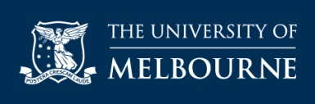 **Diploma in General Studies (DiGS)**

*The Diploma in General Studies (DiGS) gives students a sample of various University of Melbourne degrees and provides a pathway to further tertiary study.*Open to domestic students, this one-year course provides students with the opportunity to study a wide range of subjects from Science, Commerce, Design and Agriculture - providing some students with guaranteed entry into a University of Melbourne degree based on their weighted average mark. ***DiGS*** provides a pathway to one of the following University of Melbourne bachelor’s degrees:

* Bachelor of Agriculture
* Bachelor of Biomedicine
* Bachelor of Commerce
* Bachelor of Design
* Bachelor of Science.

**Find out more at** [**Diploma in General Studies (DiGS)**](https://study.unimelb.edu.au/find/courses/undergraduate/diploma-in-general-studies/)

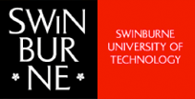 **News from Swinburne University**

* **Upcoming Virtual Events**

***A Flying Start:*** find out what the future looks like for aviation in the wake of 2020. Join the host and panel as they discuss the resilience of aviation, strategies being employed by industry leaders, and stay for the Q&A.   
 **Date:** Thursday 17 September 2020, from 4.00pm – 5.00pm. Register [here](https://www.swinburne.edu.au/choose/events/flying-start)

***Ask Me Anything (AMA) Week:*** participants get the chance to pitch their hard-hitting questions to course experts, student ambassadors and also academics – about courses, careers, entry requirements, and lots more.

**Date:** Monday 14 – Friday 18 September 2020, from 10.00am – 6.00pm.   
Save the date [here](https://www.swinburne.edu.au/choose/?seid=em%7Ccpn%7Ccp%7Ccps%7CcpSep20%7C1&deliveryName=DM9933#events)

* **Nursing at Swinburne**

Students considering studying the Bachelor of Nursing are encouraged to watch a recording of a recent nursing webinar - [Bachelor of Nursing Webinar](https://www.youtube.com/watch?v=uwlrJuZ5nwY&feature=youtu.be&seid=em%7Ccpn%7Ccp%7Ccps%7CcpSep20%7C1&deliveryName=DM9933)

**News from the University of Sydney**

* **The Future Leaders Scheme**

Academic or school leadership can help guarantee a place at the University of Sydney. The***Future Leaders Scheme***, open to Dux students and school captains in Australia, requires a principal’s nomination and an ATAR of at least 65 or above.   
For a list of courses participating in the Futures Leaders Scheme, browse the following PDF - [Future Leaders Scheme Courses 2021](https://www.sydney.edu.au/content/dam/corporate/documents/study/how-to-apply/admission-pathways/future-leaders-scheme-courses.pdf).

[**Future Leaders Scheme nominations**](https://www.sydney.edu.au/study/how-to-apply/undergraduate/admission-pathways.html#Futureleadersscheme) **have opened and close on 13 November 2020.**

* **Academic Excellence Scheme**

*The Academic Excellence Scheme recognises high performance in English and mathematics by applying adjustment factors to boost your selection rank.*

The ***Academic Excellence Scheme*** was introduced this year recognising domestic students who achieve high performance in higher levels of English and mathematics by applying adjustment factors to boost their selection rank for eligible courses. A student's ATAR will not change, however, their selection rank can increase for particular courses based on these subject-related adjustment factors.

**Find out more at** [**Academic Excellence Scheme**](https://sydney.edu.au/study/how-to-apply/admission-pathways/academic-excellence-scheme.html)

cid:449235102@16032009-17DC **News from Victoria University**

* **Important changes to Bachelor of Nursing at VU**

*Victoria University is introducing the CASPer test (domestic students only) and an ATAR to the applications process for the Bachelor of Nursing for 2021 entry.*  
CASPer is a scenario-based test, designed to grade the ‘soft skills’ of applicants – their strengths and suitability for the profession. While VU is the first university in Australia to introduce CASPer for nursing, it is following the success of universities in Canada and the US which use a similar test for pre-nursing students.

Students are also reminded that besides the CASPer test, they must also meet the VCE requirements of: Units 1 and 2: satisfactory completion in two units (any study combination) of any Mathematics or Units 3 and 4: any Mathematics; Units 3 and 4: a study score of at least 30 in English (EAL) or at least 25 in English other than EAL.

**Browse** [**CASPer**](https://takecasper.com/) **and also** [**Preparing for CASPer**](https://takecasper.com/test-prep/) **and book a test at** [**CASPer Test - Dates and Times**](https://takecasper.com/dates-times/)**. Find out more about nursing at VU by browsing** [**Bachelor of Nursing at VU**](https://www.vu.edu.au/courses/bachelor-of-nursing-hbnb)**.**

* ***New* Courses in 2021**

**Bachelor of Applied Movement Sciences/Master of Physiotherapy**

This *new* 4.5-year dual degree will prepare students to become a physiotherapist and use rehabilitation, injury prevention and exercise to improve people’s quality of life. This course prepares work-ready graduates through clinical placements in public hospitals, private health, sports, aged and community care, paediatrics, heart and lung disease and stroke with a person centred focus on mental health and wellness as well as cultural diversity and Indigenous health.

**Admission criteria:**

Units 3 and 4: a study score of at least 30 in English (EAL) or at least 25 in English other than EAL; Units 3 and 4: a study score of at least 25 in one of Biology, Chemistry, Maths: Mathematical Methods, Maths: Specialist Mathematics or Physics.   
An ATAR is also considered as part of selection.

**Note:** Students keen on finding out more are invited to participate in a webinar and meet the Course Director, Professor Rebecca Lane.

**Date:** Thursday 17September 2020

**Time:** 5.30pm

**For registrations please** [**click here**](https://victoriauniversity.zoom.us/webinar/register/WN_uUQT-2I0TTSh-pxCskUWOQ)

**Bachelor of Nutritional Science/Master of Dietetics**This *new* dual degree will give students the food-related knowledge and clinical skills needed to work in private practice, care settings and public programs. Students will become adept at delivering strategies that help people and populations make better food choices to prevent and manage disease and illness.

**Admission criteria:**

Units 3 and 4: a study score of at least 30 in English (EAL) or at least 25 in English other than EAL; Units 3 and 4: a study score of at least 25 in one of Biology, Chemistry, Physics, Health & Human Development, Mathematics (any) or Physical Education.   
An ATAR is also considered as part of selection.

**Note:** Students keen on finding out more are invited to participate in a webinar and meet with the Future Students team and Dr. Helen McCarthy.

**Date:** Tuesday 22 September 2020

**Time:** 5.30pm

**For registrations please** [**click here**](https://victoriauniversity.zoom.us/webinar/register/WN_TkDj2CeVQo6Z8yaxbx-0pg)

** Snapshot of Charles Sturt University (CSU) in 2020**

* The history of Charles Sturt University dates back to 1895 but CSU was formally incorporated on 19 July 1989 and is one of Australia's newer universities
* Charles Sturt University has three Faculties which comprise of several Schools and centres for specific areas of study and research –

[Faculty of Arts and Education](https://about.csu.edu.au/our-university/organisational-structure/faculties-and-schools#FAE)

[Faculty of Business, Justice and Behavioural Sciences](https://about.csu.edu.au/our-university/organisational-structure/faculties-and-schools#FBJBS)

[Faculty of Science](https://about.csu.edu.au/our-university/organisational-structure/faculties-and-schools#FS)

* CSU has campuses in a number of [locations](https://about.csu.edu.au/locations) and also has various campuses that offer specialist courses, such as *theology, education, Terrorism & Security Studies,* and *policing*. These include [Canberra](https://about.csu.edu.au/locations/campuses/canberra), [Goulburn](https://about.csu.edu.au/locations/campuses/goulburn), [Manly](https://about.csu.edu.au/locations/campuses/manly), and [Parramatta](https://about.csu.edu.au/locations/campuses/parramatta)
* CSU also has four [Study Centres](https://about.csu.edu.au/locations/study-centres) in Brisbane, Melbourne, Sydney, and Wangaratta
* CSU offers a range of [accommodation](https://accommodation.csu.edu.au/home) options to students across six campuses
* CSU offers a broad range of [courses](https://futurestudents.csu.edu.au/courses) including postgraduate studies
* Some courses that may be of particular interest include –
* [Bachelor of Communication - Radio](https://futurestudents.csu.edu.au/courses/communication-creative/bachelor-communication-radio)
* [Bachelor of Dental Science](https://futurestudents.csu.edu.au/courses/medical-science/bachelor-dental-science)
* [Bachelor of Pharmacy](https://futurestudents.csu.edu.au/courses/allied-health-pharmacy/bachelor-pharmacy)
* [Bachelor of Physiotherapy](https://futurestudents.csu.edu.au/courses/allied-health-pharmacy/bachelor-physiotherapy)
* [Bachelor of Veterinary Biology / Bachelor of Veterinary Science](https://futurestudents.csu.edu.au/courses/animal-vet-sciences/bachelor-veterinary-biology-bachelor-veterinary-science)
* [Master of Terrorism and Security Studies](https://study.csu.edu.au/courses/police-security-emergency/master-terrorism-security-studies)

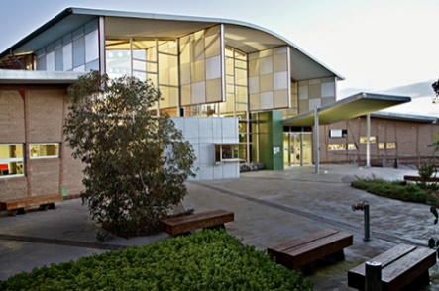 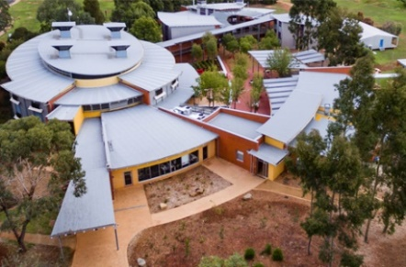 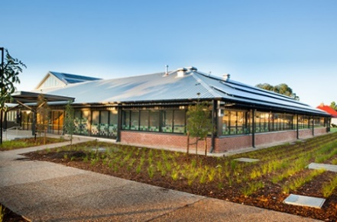

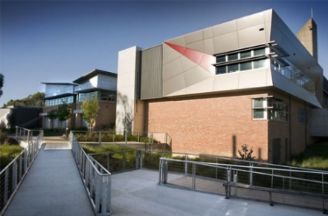 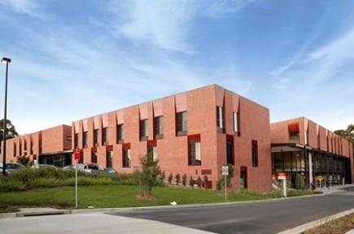 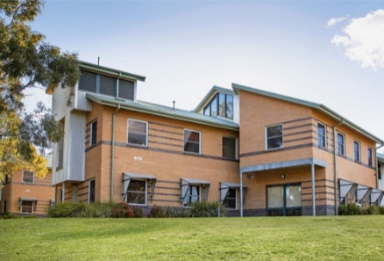

** Media, Communication & Journalism Degrees in Victoria in 2020**Many universities in Victoria offer ***advertising, media, media & communication, and/or journalism*** degrees, and many of these are listed below. These areas of interest are often also offered as majors in Arts degrees. **For a comprehensive list of all courses (including double-degree options) visit** [**VTAC**](http://www.vtac.edu.au/)**.**

|  |  |  |  |
| --- | --- | --- | --- |
| **INSTITUTION** | **COURSE NAME** | **MAJOR STUDIES IN 2020** | **ATAR 2020** |
| **DEAKIN**  M – Melbourne GW – Geelong W’ Ponds | Communication  (Advertising) | Account management, Account planning, Advertising and society, Art direction, Brand communication futures, Brand narratives, Branded content, Campaign planning, Client relationships, Consumer personas, Copywriting, Creative process, Digital disruption, Global advertising, Internship, Media management, Social media for brands, Strategic communication, Transmedia storytelling. | **60.05 (M)** |
| Communication  (Digital Media) | Digital and social media, Gamified media, Media and cultural industries, Media genre and cultural representation, Media policy regulation and censorship in global contexts, Quantified media. | **61.20 (M) 55.50 (GW)** |
| Communication  (Journalism) | Broadcast journalism, Local and international news, Multiplatform journalism, Newsroom production, Online journalism, Print journalism, Professional journalism practice. | **61.40 (M) 58.50 (GW)** |
| Communication (Public Relations) | Campaigns and event management, Ethical communication, Marketing communication, Media and communication, Media relations, Professional writing, Public affairs, Public relations, Public relations management, Social media, Strategic communication. | **60.50 (M) 56.40 (GW)** |
| **LA TROBE**  M - Melbourne | Media & Communication (Journalism) | Journalism | **56.70 (M)** |
| Media & Communication (Media Industries) | Media industries, Media production. | **56.45 (M)** |
| Media & Communication  (Public Relations) | Public relations, Strategic communication. | **56.60 (M)** |
| Media & Communication (Sports Journalism) | Journalism (Sport) | **66.50 (M)** |
| **MONASH**  Ca – Caulfield | Media Communication | Journalism, Media, Public relations, Screen. | **80.40 (Ca)** |
| **RMIT**  C – City  R.C. – Range of Criteria  for selection | Communication  (Advertising) | Advertising, Advertising Briefs, Advertising Campaigns, Advertising Communication, Advertising Concept Development, Advertising Marketing, Advertising Production, Advertising Research, Advertising Strategy, Communications, Concept Development, Consumer Behaviour, E-marketing, E-media, Marketing, Marketing Research, Media Planning, Media Strategy. | **R.C. (C)** Entry based on selection kit, and folio presentation |
| Communication  (Journalism) | Broadcast journalism, Data journalism, Digital journalism, Journalism, Journalism culture, Journalism ethics, Journalism foundations, Journalism history, Journalism innovation, Journalism law, Journalism practice, Literary journalism, Newsroom practice, Newsroom sociology, Online journalism, Photojournalism, Political journalism, Print journalism, Radio Journalism, TV journalism. | **78.15 (C)** |
| Communication  (Media) | Asian media and culture, Broadcast media production, Cinema, Communication, Film production, Internet and multimedia, Literature, Live media, Media, Media industries, New media, Online media production, Politics and economies, Popular culture, Radio production, Social media production, Video production. | **78.05 (C)** |
| Communication  (Prof. Communication) | Advertising, Asian studies, Cinema studies, Communication, Journalism, Literature, Media production, Politics, Popular culture, Public relations. | **80.05 (C)** |
| **SWINBURNE**  H – Hawthorn   * Professional Degree | Communication Design | 20th century design, Brand and identity design, Communication design strategy, Concepts and narratives, Design for production, Design research, Digital design, Graphic design, Information design, Methods of investigation, Packaging design, Photography for design, Publication design, Typography, Visual communication, Web design. | **82.100 (H)** |
| Media & Communication | Advertising, Cinema and screen studies, Creative writing and literature, Digital advertising technology, Games and interactivity, Journalism, Media industries, Professional Writing and Editing, Public relations, Social media. | **60.95 (H) 80.15 (H) \*** |
| **VICTORIA**  FP – Footscray Park | Screen Media | Screen media. | **n/a (FP)** |

** Medical Imaging Courses in Victoria in 2020***Medical imaging technologists operate X-ray and other imaging equipment, such as MRI and Ultrasound, to produce radiographic images which are used in the diagnosis and subsequent management of disease or injury.* Below are links to the specialised medical imaging areas, some of which are detailed in the *Good Universities Guide*: [Nuclear Medicine Technologist](https://www.gooduniversitiesguide.com.au/careers-guide/browse/nuclear-medicine-technologist), [Medical Imaging Technology](https://www.gooduniversitiesguide.com.au/careers-guide/browse/medical-imaging-technologist), and a useful links - [So, you want to be a Sonographer?](http://www.sdms.org/learning/resources/educational/so-you-want-to-be-a-sonographer), and [Medical Imaging and Radiation Sciences at Monash](https://www.monash.edu/medicine/spahc/radiography/geninfo)   
**In Victoria students can study specific medical imaging courses (also known as medical radiography or medical radiations or sonography) at the following universities:**

|  |  |  |  |
| --- | --- | --- | --- |
| **INSTITUTION** | **COURSE** | **VCE PREREQUISITES** | **2020 ATAR** |
| **CQU** M - Melbourne Campus | [Medical Sonography](https://www.cqu.edu.au/courses/study-areas/health/undergraduate/bachelor-of-medical-sonography-and-graduate-diploma-of-medical-sonography) | Year 12 English | 80.15 (M) |
| **Deakin University**  G - Geelong Waurn Ponds Campus | [Medical Imaging](http://www.deakin.edu.au/course/bachelor-medical-imaging) | Units 3 and 4: a study score of at least 30 in English (EAL) or at least 25 in English other than EAL; Units 3 and 4: a study score of at least 25 in one of Biology, Chemistry or Physics; Units 3 and 4: a study score of at least 22 in one of Maths: Mathematical Methods or Maths: Specialist Mathematics or at least 30 in Maths: Further Mathematics. | 88.45 (G) |
| **Monash University**    C – Clayton Campus  *This course is primarily at Clayton with some first year-level units only available at Caulfield. | [Radiography and Medical Imaging](https://www.monash.edu/study/courses/find-a-course/2019/radiography-and-medical-imaging-m3006) | Units 3 and 4: a study score of at least 35 in English (EAL) or at least 30 in English other than EAL; Units 3 and 4: a study score of at least 25 in one of Biology or Physics; Units 3 and 4: a study score of at least 25 in one of Maths: Mathematical Methods or Maths: Specialist Mathematics. | 97.10 (C) |
| [Radiation Sciences](https://www.monash.edu/study/courses/find-a-course/2019/radiation-sciences-m2013#overview-1) | Units 3 and 4: a study score of at least 30 in English (EAL) or at least 25 in English other than EAL; Units 3 and 4: a study score of at least 30 in Maths: Further Mathematics or at least 25 in Maths: Mathematical Methods or at least 25 in Maths: Specialist Mathematics. | 87.95 (C) * |
| [Radiation Sciences (Informatics)](https://www.monash.edu/study/courses/find-a-course/2020/radiation-sciences-m2017?domestic=true#overview-1,Radiation_sciences_informatics) | Units 3 and 4: a study score of at least 30 in English (EAL) or at least 25 in English other than EAL; Units 3 and 4: a study score of at least 30 in Maths: Further Mathematics or at least 25 in Maths: Mathematical Methods or at least 25 in Maths: Specialist Mathematics. | n/a (C) * |
| **RMIT University**  B – Bundoora Campus | [Medical Radiations (Radiography)](https://www.rmit.edu.au/study-with-us/levels-of-study/undergraduate-study/bachelor-degrees/bp321) | Units 1 and 2: satisfactory completion in one of Biology or Chemistry or Units 3 and 4: one of Biology or Chemistry; Units 3 and 4: a study score of at least 30 in English (EAL) or at least 25 in English other than EAL; Units 3 and 4: a study score of at least 20 in one of Maths: Mathematical Methods or Maths: Specialist Mathematics. | 94.45 (B) |
| [Medical Radiations (Nuclear Medicine)](https://www.rmit.edu.au/study-with-us/levels-of-study/undergraduate-study/bachelor-degrees/bp321) | Units 3 and 4: a study score of at least 30 in English (EAL) or at least 25 in English other than EAL; Units 3 and 4: a study score of at least 20 in one of Maths: Mathematical Methods or Maths: Specialist Mathematics; Units 3 and 4: a study score of at least 20 in Chemistry. | 83.25 (B) |
| [Medical Radiations (Radiation Therapy)](https://www.rmit.edu.au/study-with-us/levels-of-study/undergraduate-study/bachelor-degrees/bp321) | Units 3 and 4: a study score of at least 30 in English (EAL) or at least 25 in English other than EAL; Units 1 and 2: satisfactory completion in one of Biology or Chemistry or Units 3 and 4: one of Biology or Chemistry; Units 3 and 4: a study score of at least 20 in one of Maths: Mathematical Methods or Maths: Specialist Mathematics. | 88.20 (B) |