Sandringham College
Presents
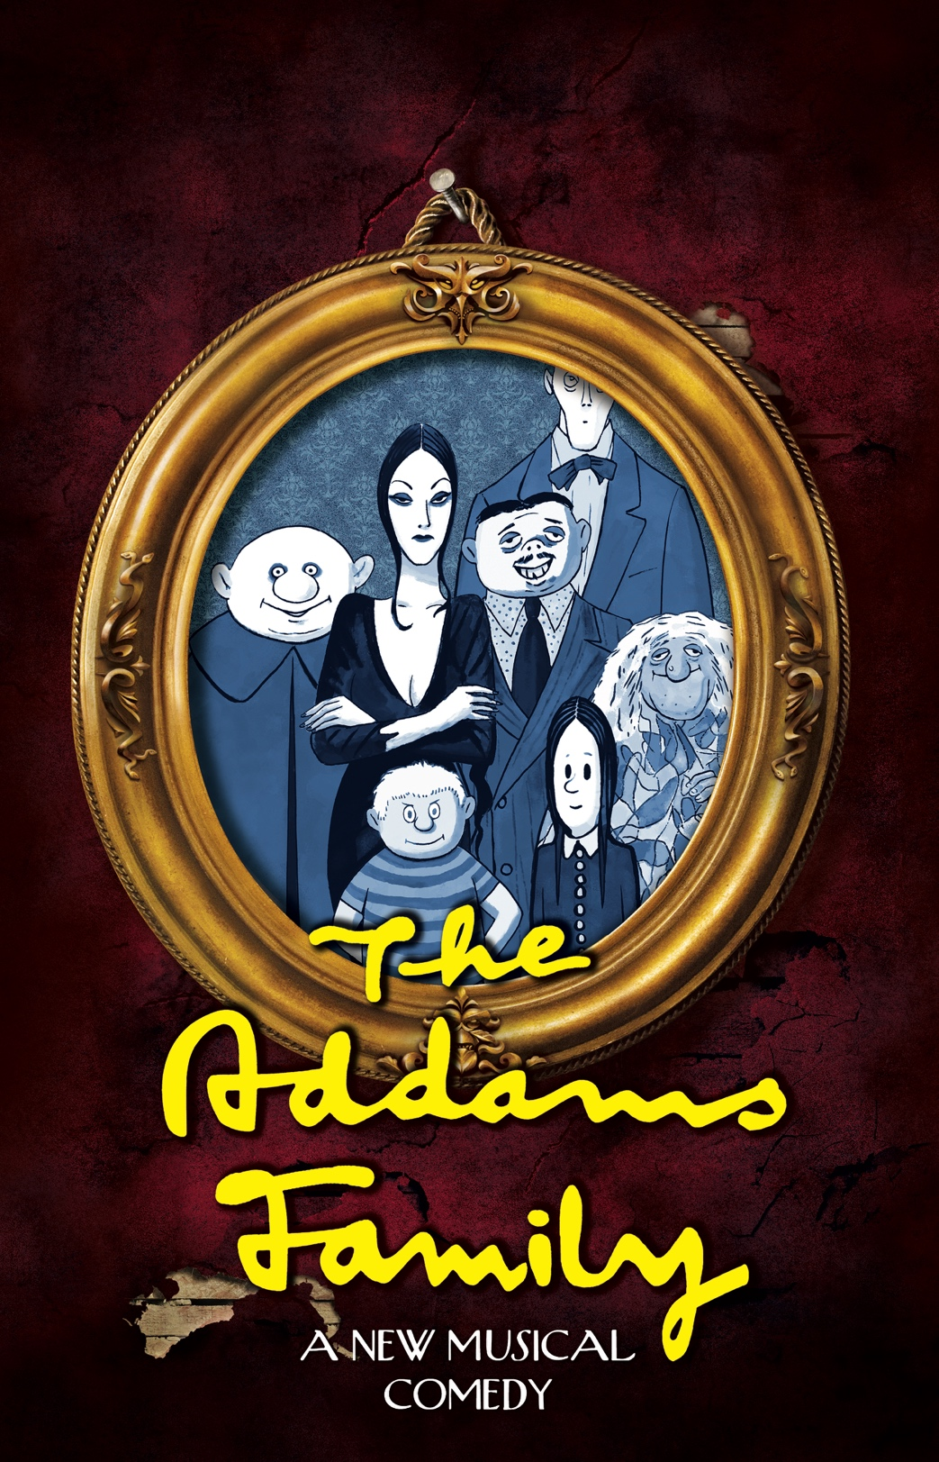
Audition Pack
Information about the 2022 Sandringham College Production:

The Addams Family: A New Musical Comedy

Participating in a school musical is an exciting and enriching opportunity; students will socialize with new people from various year levels, learn new skills, increase their confidence, contribute creatively to the shaping of the production and benefit from being an integral part of the rich performing arts community within this college.

The Sandringham College production provides opportunities for students to build and apply practical performance skills, backstage production role skills, and teamwork. While striving for performance excellence, we prioritize learning experiences, respectful relationships and skill development for all participants committed to working together on the production.

Students will be selected based on their audition and on their ability to be a positive representative for the school, based on the recommendation of their year level co-ordinator / student manager.

Audition Timeline

1. | Audition Booklets out to students  Compass News feed and Hard copies through P.Arts Staff | Term 1 – Week 10
2. | Students to fill out the following form to audition | Friday 29th April
3. | Auditions  Holloway - Theatre  Junior students: 3.30pm - 5.00pm approximately  Senior students: 5.00pm - 6.30pm approximately  Senior students - please bring appropriate study materials or a book, so you can work quietly in the library / use your time productively, as you will not be completing an audition until 4:30pm or later. | Monday 2nd May  3:30pm – 6:30pm
4. | Call-backs  Holloway - Theatre | Thursday 5th May  3:30pm – 6:00pm
5. | Release of Casting  Compass News feed | Friday 6th May  EOD (End of Day)

WHERE?

These will ALL be held at Holloway Campus. Students at the Bluff Road campus should make their way to the senior campus straight after school and report to the Foyer of the Theatre to register in groups of 6 – ideally 3 boys and 3 girls.
The singing audition will take place in Room 024 – the music room.
The acting and dance auditions will take place in room 0DTH – The Holloway Theatre.
The groups of 6 students will complete their singing auditions separately and their acting and dance auditions together.
Vocal Auditions

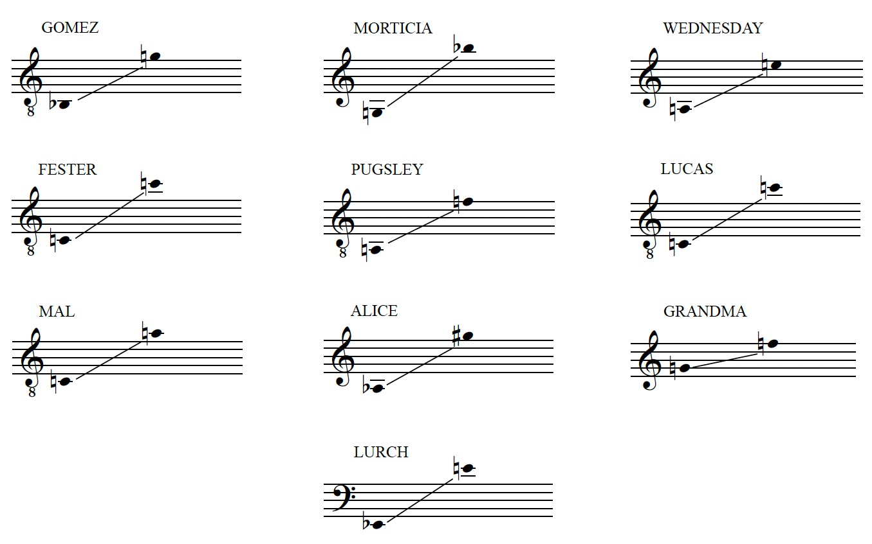

Notes:
- Students should note the above ranges and when auditioning for The Addams Family.
- High Male vocals are in the Tenor clef and should be sung 1 octave lower than written.
- 20 bars (Approximately 1 minute) of a music theatre style song in the style of The Addams Family.

Female Lead voice: Wednesday – One Normal Night Bar 1 – 55
Example track: https://www.youtube.com/watch?v=HiHZ0dPYY7A
Practise backing track: https://www.youtube.com/watch?v=qzSNmtKY-r0

Male Lead voice: Lucas – One Normal Night Bar 70 – 92
Example track: https://www.youtube.com/watch?v=HiHZ0dPYY7A
Practise backing track: https://www.youtube.com/watch?v=qzSNmtKY-r0

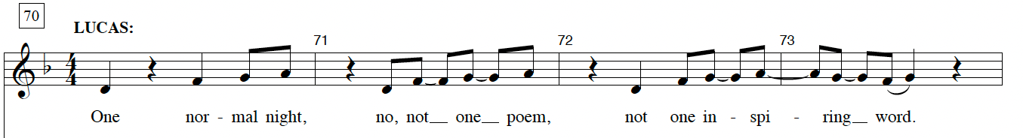
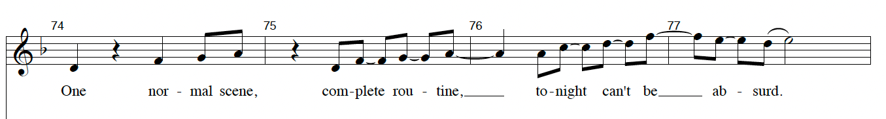
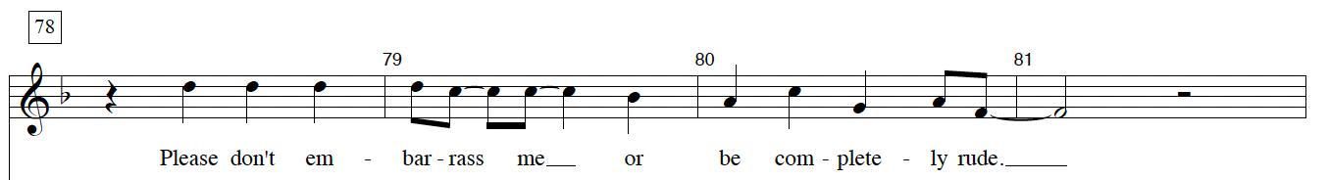
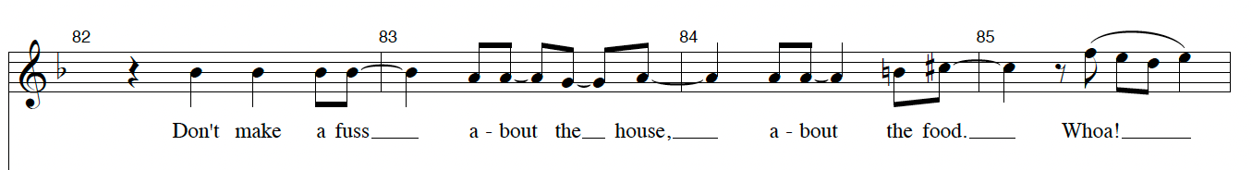
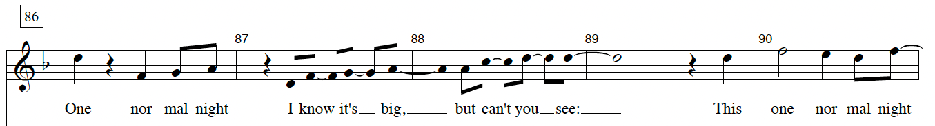
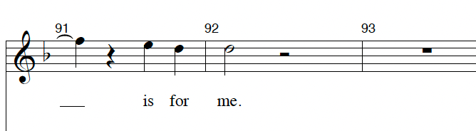

Acting

You are required to create two frozen images based on prompts given to you in the audition room. You do not need to prepare anything for this. In the frozen images, we are looking for your ability to use acting skills (facial expressions, physicality, gestures etc.) your use of space and your ability to make creative choices.

You will also deliver the following lines in a clear acting voice (projection, tone, clearly speech)
Be familiar with the lines but you do not need to memorise them – although you can if you would like. Read from a paper script, not a laptop screen or phone. Show us your own interpretation of a ‘quirky’ character. This character functions like a narrator, so storytelling, speaking to the audience and using vocal expression is important.

Uncle Fester:
Little Wednesday Addams - that charming, irrepressible bundle of malice who would poison her own brother just for a ride in the ambulance - has grown up and found love.

Dance

HOW TO LEARN
Students auditioning for the musical will need to be learn the dance audition phrase via videos which will be on compass as part of the audition pack.

Students will be required to learn and practice the dance choreography over the holiday period using the videos supplied to prepare for the audition.

Each year in the musical we have a specialised dance group, these performers are featured in dance breaks throughout the musicals pieces and support the ensemble in routines. We will be auditioning those who are interested in being part of the specialised dance group in term 2, which consists of approximately 10 dancers from any year level. If you are interested, please contact Miss Slingsby.

Remember, when performing in a musical all members of the cast will be required to perform movement sequences. Therefore, it is important to present your skills in the audition to show your ability and to show your willingness as a performer. We know not everyone will be confident with dancing, but we do ask you all to give it your best go.

HOW TO PRESENT FOR DANCE IN THE AUDITION
Students will be called for a group dance audition. Please warm up and stretch before you perform for the auditioning panel.

You can practice with your peers as a group and will all present to the panel as the same time.

Students will need to bring:
- A change of clothes for dancing e.g., sports uniform, leggings, t-shirt, track pants, dance attire (if you have it). Clothing must align with the school policy, e.g., no mid-drift tops. Please present professionally for the audition.
- Bring a bottle of water to ensure you hydrate before and after the audition.
- Shoes must be worn in the dance auditions. dance shoes, sneakers or runners are fine
- Neat presentation is important for viewing your performance ability and skills, this includes tying your hair back if it long so that we can see your face.
- Warm clothing such as a jacket should be brought to wear before and after the audition.

What are we looking for in the DANCE auditions?

- Ability to learn and retain choreography
- Execution of technique and physical skills
- Spatial awareness and ability to perform within a group
- Timing, accuracy of movement and performance qualities
- Energy, enthusiasm, and positive attitudes

Other Frequently Asked Questions

Do you have a particular person in mind for a specific role?
No. We want to see the skills everyone has before we decide on any casting

Is there anything I can do to impress in an audition?
Yes.
- Be prepared. Taking the time to learn lyrics or dance steps or familiarise yourself with the script is a great start.

- Be brave in your choices and, also, make eye contact with us. It is the best way to show confidence on stage. You’ll need to make eye contact with the audience after all!

- Listen to instructions rather than chat to your friends once you’re in the room. This shows us that you’ll be delightful to work with, that you’ll listen to your choreographer, vocal coach, director, stage manager etc. and help us produce a truly amazing show.

- Be polite and kind and proactive. These are just generally useful human skills anyway but especially desirable when you’re working on a production!

Will you choose all Year 12s for LEADS?
No. As above, we do not have specific people or year levels allocated for certain roles. That being said, we will often cast more experienced students in key roles and will cast in such a way that the ages of the characters make sense on stage.

Does it matter about hair colour or other aspects of physical appearance?
We always try to cast blind. This is an industry term that means that hair colour, eye colour, skin colour, gender identification etc. doesn’t matter – what matters is the talent of the performer and the suitability for the role. This means the ability to SING in the vocal range, the ability to execute CHOREOGRAPHY required by the character, and the ability to ACT as the character is implied in the script becomes key to our decision making.

What roles are available?
Main roles include: Morticia, Gomez, Pugsley, Wednesday, Lucas, Mal, Alice, Lurch, Uncle Fester, Grandma and there are some featured chorus roles too with spoken or sung dialogue.
The ensemble of ancestors have lots of stage time as they sing, dance and act in lots of scenes in the graveyard, Addams Family house, central park etc.

General Concerns such as “I dislike auditions a lot.” Or “I get nervous.” Or “I don’t audition well.” Or “I suffer from Anxiety.” Or “I can’t sing/dance.”
What should I do?

- Breathe. Taking a moment for some deep calming breaths before auditions has been proven to be really helpful. Deep breaths slow your heart rate and calm your mind. Incidentally, this also prepares your voice for speaking clearly and singing. If you can couple that with a sentence in your mind that can reassure you – a mantra of sorts – that’s even better as it allows your brain to focus and block out inner negativity.
- Nobody really LOVES auditions. Everyone is in the same boat but facing our fears is actually something really important to do in life. It’s courageous. Remind yourself of this!
- We already know that not everyone is a triple threat (singer, dancer and actor all rolled into one!) and we don’t expect you to be. We are just interested in what skills you do have. If you do not feel like you are the strongest dancer, that’s fine – just give it a red hot go. If you don’t think you’re a singer, just try and pitch the song the best you can. If acting isn’t your strongest suit, show us what you can do in the other areas. See a reoccurring theme, here? J
- Be logical. What’s the worst that can happen?
- Remember that your audition panel are teaching staff who are on your side. We want to support you and celebrate your skills. That’s why we are there in the first place! It’s not judgemental – it’s about finding out where best to put you in the cast to showcase what you can do.

What is the process for Call backs?
Call-back auditions (for lead roles) will be held on Thursday 5th May 3.30pm - 6pm in the College Theatre, Holloway Rd. Further information about these will be given in Term 2.
When will we find out if I am in the cast?
The cast list will be announced on Friday 6th May at the end of the day. It will be published on Compass.

I still have a question. Who do I speak to?
You are encouraged to contact the Director, Laura Washington. However, you can contact any of the Production Team. These are: Prue Slingsby (Choreography) Tim Clifton or Luke Devenish (Band / Music related questions) Fiona Bechtold and Heather Fehring (production managers / administrative-related questions) via email.

