Level 5 Homework Matrix
Homework tasks should ideally be completed with adult supervision. The Homework Matrix for each level will be available in the Connect newsletter once a fortnight. Tasks will be completed in student homework books and handed in to the teacher, to be signed, two weeks later on a Friday morning (even weeks). Teachers will sign homework books.

L5/6 – Reading + 8 tasks/fortnight
Reading (compulsory)  Read for: minutes every day.  Record the title of your book and the pages read in your diary. Ask an adult to sign your diary.   | Writing (grammar)  Write a recount of our camp experience to Sovereign Hill.  What was your highlight ?  What was your lowlight ?  What made you laugh? | Physical Education Challenge  thletics Practice  Go for a run at home with a parent or guardian. Alternate between jogging and sprinting. Remember to learn forward, use your pumping arms and drive your knees when you sprint. | Gratitude  Pick 3 people you are grateful for  this month. Make sure you explain  why you picked each person.
Spelling:  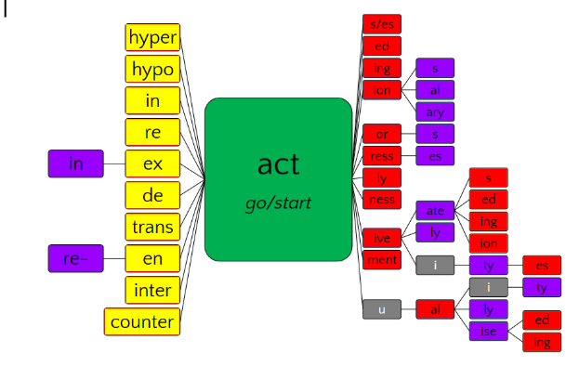 | Maths  World Cup Rich Task - Measurement ⚽  Perimeter and area of a field  According to FIFA regulations, a World Cup soccer field should have a length of 105m and width of 68m.  - Calculate the perimeter  - Calculate the area  - If fencing costs $45 per meter, how much would it cost to fence the entire field?  - If grass costs $12 per m², how much would it cost to re-lay grass on the field? | Art Challenge  Select a colour and draw 3 objects. Explore tone by showing light and dark variations of that colour.  Create a portrait focusing on proportion, detail and expression. Consider personality and mood | Mindfulness  Lay in a quiet room of the house or  somewhere comfortable outside  e.g. on the grass for a few minutes.  Take a moment to just stop and  listen to all the sounds around you.
Handwriting  Tell your family all about the four S’s we learnt in camp and demonstrate. | Maths Skills/Fluency  Practice your 6 times tables.  Challenge: See if you can skip count by  6’s go right past 100. | Science Challenge  Does anyone in your family wear glasses? If so, are they short sighted or long sighted? Can you explain how their glasses work?  (Ask a teacher if no one at home wears glasses).  Can you show your parents or guardians one of our refraction experiments? | Emotional Literacy  Create a feelings collage using  magazines, coloured paper or art  supplies. Find pictures  representing different emotions to  create a collage that visually  portrays your feelings.
Maths  World Cup Rich Task - Decimals ⚽  The Group Stage ticket costs _____ (choose your own decimal number). Choose a decimal with tenths, hundredths or thousandths to make your riddle easier or harder.  Can you work out the price of each ticket?  - 🏟️ Round of 16 = 1 tenth more  - 🥉 Quarter Final = 20 tenths more  - 🥈 Semi Final = 5 hundredths less  - 🏆 Final = Double the Group Stage price  Challenge:  - Rename each ticket cost once. (eg. $1.95 = one dollar and ninety five hundredths = one hundred and ninety five hundredths)  - Create one extra clue for a partner to solve. | Online Platforms  - Read a book on Wushka  - Complete tasks on Mathletics  - Play a game on Maths frame  - Listen to a story on Storybox | Mandarin Challenge  Write 6 sentences using:  会 huì (could), 不会 bú huì (couldn’t), 但是 dànshì (but), 也 yě (also) | Empathy  Think about 3 ways in which you  can brighten someone’s day this  week or ways in which you can  cheer someone up if you notice  they’re sad.

