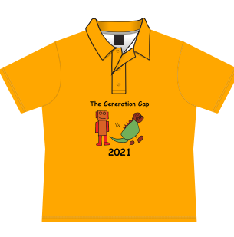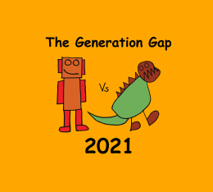

**2021 School Production**

“The Generation Gap”

**Polo Shirts**

April, 2021

Dear Parents,

‘The Generation Gap’ Polo Shirts are now available to order. Student polos are in the school gold and have Felix Lim’s winning design pictured on the front. Sizes available for order are 8 /10 /12 /14 & 16 or adult sizes ‘small’, ‘medium’, ‘large’, ‘extra large’ The cost will be $32 per polo (up to size 16) or $35 for the adult sizes. Payment must be received with the order form. These polos are approved to be worn as school uniform. Adult/Staff Member/Backstage Crew tops are also available in black. Adult sizes are ‘Small’, ‘Medium’, ‘Large’ and ‘Extra Large’. These cost $35 each

Orders need to be submitted to the office no later than Friday 7th May, 2021. **LATE ORDERS WILL NOT BE ACCEPTED.**

Sincerely,

*The Production Fundraising Team*

…………………✄…………………………………………………………………………………

***Orders must be submitted to the school office with payment no later than 4pm, Friday 7th May***

**2021 School Production** *‘The Generation Gap”* **Polo Shirts**

Person Placing Order: _____________________________

Contact Number: _________________________________

Child’s Name: _________________________ Grade: _________

|  |  |  |  |
| --- | --- | --- | --- |
| **POLO SHIRT** | **QUANTITY** | **COST** | **TOTAL** |
| SIZE 8 |  | @ $32 each |  |
| SIZE 10 |  | @ $32 each |  |
| SIZE 12 |  | @ $32 each |  |
| SIZE 14 |  | @ $32 each |  |
| SIZE 16 |  | @ $32 each |  |
| ADULT: SM, M, L, XL (Please circle) |  | @ $35 each |  |
| Staff/Crew Black Polo  ADULT: SM, M, L, XL (Please circle) |  | @ $35 each |  |
|  |  | **TOTAL COST** |  |