[](https://play.google.com/store/apps/details?id=au.com.campaustralia.parent)[](https://apps.apple.com/app/apple-store/id1529575453?pt=120333103&ct=edmbookings&mt=8)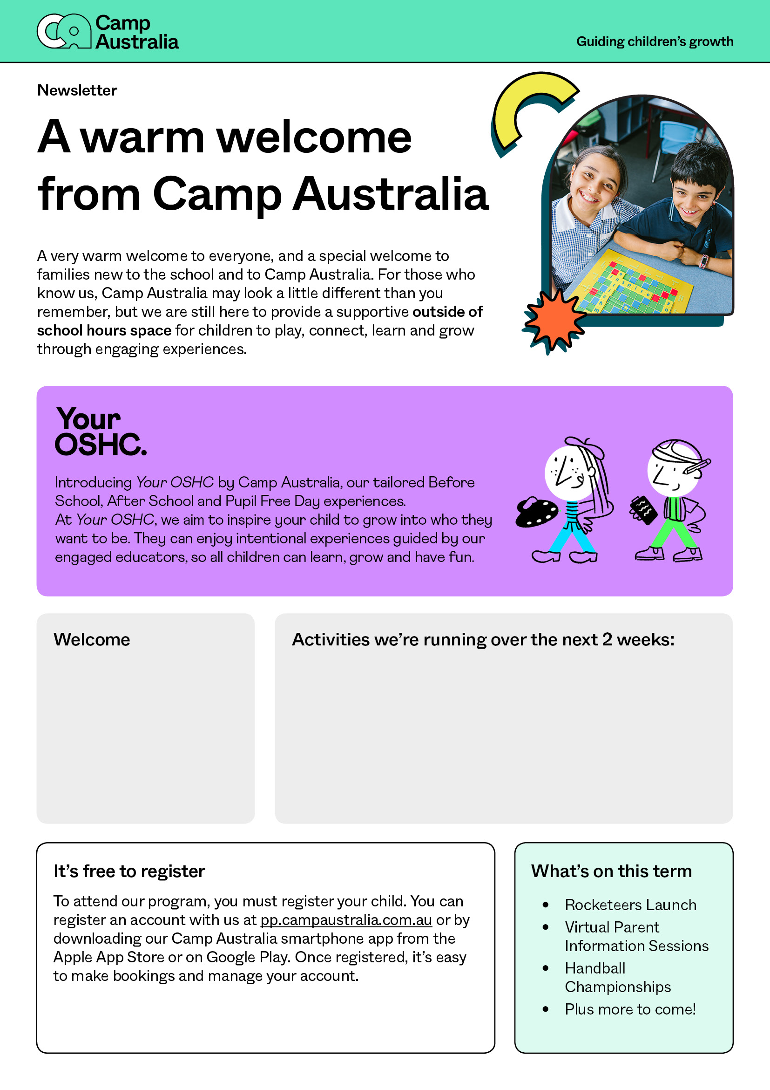

Write some highlight activities you’ll be running over the next two weeks.

Write a welcome note to your families here.