

Melbourne's Biggest Careers & Education Expo


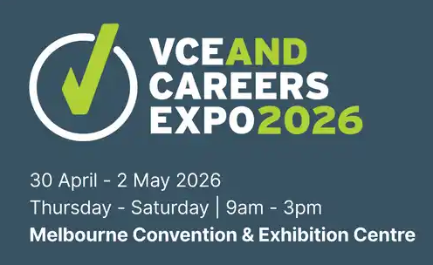 | For 34 years we’ve connected over 1 million Australians with study, training and career opportunities.  

 | March 19 to 21, 2026 - Entry’s Free - Melbourne Showgrounds  Registrations Now Open

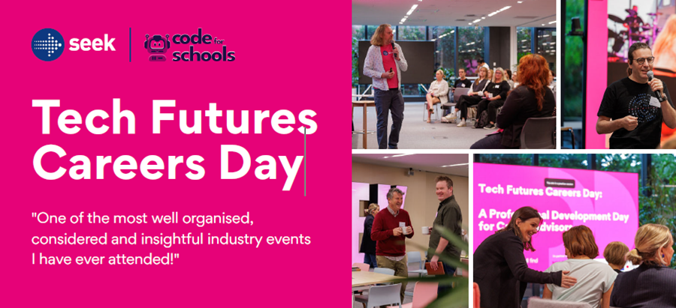

Thu 26 March: 9am-3pm  SEEK HQ, Cremorne, Vic  Cost: FREE  Morning Tea & Lunch provided  Join the myfuture team for a day of unprecedented industry access and firsthand insights into the dynamic world of tech careers, and careers empowered by technology – to explore real-world environments, diverse roles, and expanding opportunities. | Spend the day on-site at SEEK’s stunning Melbourne HQ and gain actionable strategies and resources to support young people in navigating the rapidly evolving world of tech-enabled careers. Ideal for anyone responsible for guiding pathways, shaping curriculum, or leading school strategy in the context of a changing world of work.  

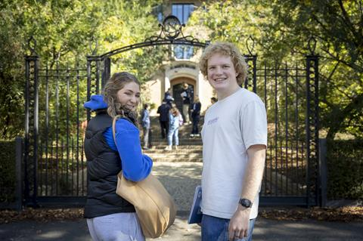   | Uni Melb Residential Colleges Open House Saturday 16 May  The 10 University of Melbourne Residential Colleges are again holding their annual Open House event of tours for future students and their families on the afternoon of Saturday 16 May.

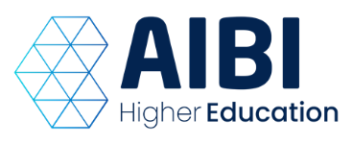 | Future of Work 2030:  AI, Automation & Digital Business Careers

Join AIBI Senior Lecturer Dr Maryam Shahbazi for an insightful webinar exploring how technology is transforming careers in business. Designed for careers advisors and students, this session will provide valuable insights into emerging opportunities in artificial intelligence, digital transformation, and the evolving digital economy.
Date: Wed 15 April 2026, 1:00pm – 1:45 pm

 | 



