New era of BASEBALL?
Mickey mouse has recently been drafted into the MLB, the team he is drafted in is the most famous and the most magnificent team… the New York Yankees! Their team is so excited to have Mickey because no one knows about this but the Mouse is an experienced baseball player. And he was picked up by his chauffeur yesterday evening to go to NYC.
Mickey mouse drafted into the MLB is the latest and most shocking news, Mickey was inspired by two spectacular baseball players, Babe Ruth and Jackie Robinson. And looks like we have quotes from Babe Ruth because he is so amazed by the Mouse, “You know it’s really amazing to have such an amazing baseball player”.

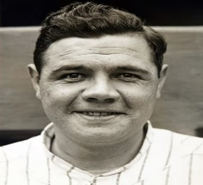
Since Mickey didn’t have a hobby he decided to try baseball, and after a few hours it became his dream come true, Mickey Mouse saw the movement of baseball stars and he thought it was magnificent.
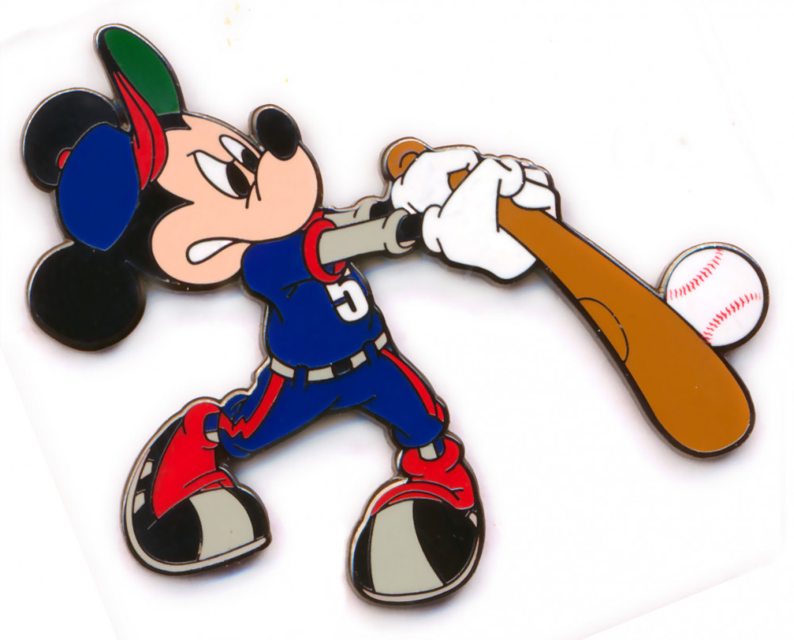
Hope for the best to mickey and do you think this could be a new era of baseball?

Mickey practising for the big game

