Siena College Uniform for Sale

Blazer size 15 - as new $150, Winter skirt size 10W $60
Pullover size 14 $30. Polar fleece vest - 2 x size 16 $25
3 summer dresses - size 2x8W, 10W $40. School bag $30
2 long sleeve blouse - size $15 each. 1 long sleeve rugby top - size S $30
Sports spray jacket - 2 x size S $40. Sports tee size C14 $25
2 x sports shorts, 1 with 2 pockets size M $20,
1 with zip pocket and inner size 10A $30. Lab coat $25
Singlet with velcro / Netball sports top size M $25
Tracksuit pants size 32/S $25. Sports cap $6. School scarf $15

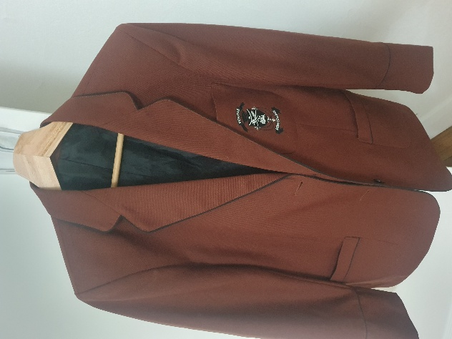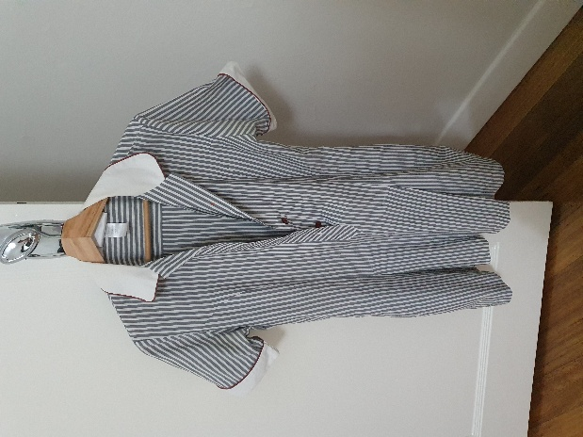
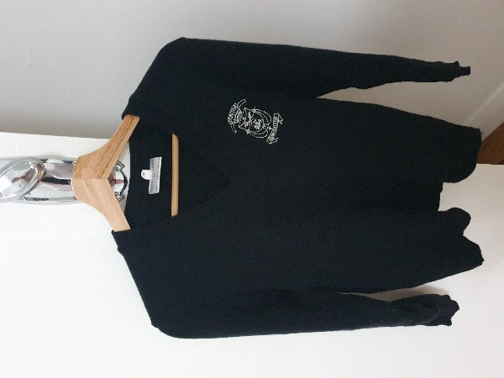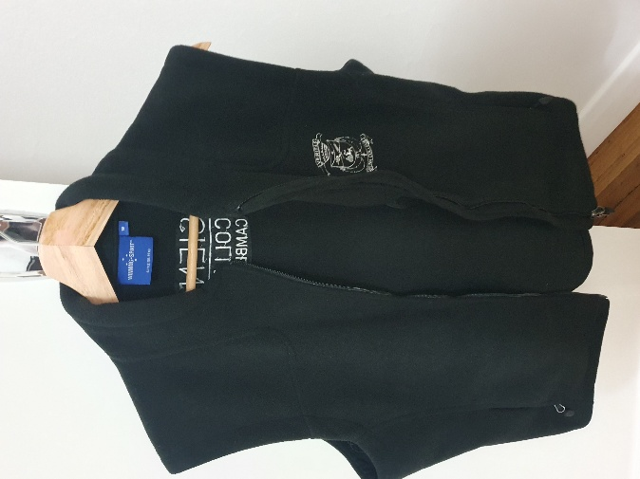
Contact Olga on 0419330101

