

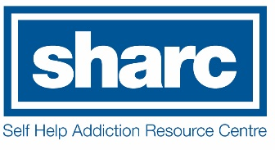

For Bookings please…

Ring: Helpline 1300 660 068

Email Angela: [aireland@sharc.org.au](mailto:aireland@sharc.org.au)

**Knowledge is Power**

**Where: 399 Wyndham Street, Shepparton Vic 3630**

**When: Over 3 weeks on Wednesday 14th 21st & 28th November 2018**

**Time: 1 - 3-30 pm**

**Who: Primary Care Connect**

**We have an education program for you**.

The family and friends impacted by someone’s gambling

**We provide helpful strategies and information that can bring about change**

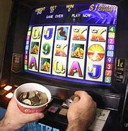



**You are not alone**