School Principal | Anthony Hyde
OSHClub Coordinator | Milan Bulic
OSHClub Educator(s) | Julie Ann Thomas, Teale Manzella, Maddison Spry.
OSHClub Regional Operations Manager | Amanda Bell.
OSHClub Partnership Manager | Sheryl Haskell
Corpus Christi OSHClub
TErm 2 REPORT, 2021

What have we been up to this Term?
Term Two at Corpus Christi OSHClub has been absolutely superb, and supremely enjoyable.
Despite facing a myriad of uncertainties due to the ongoing pandemic, we have had the opportunity to observe and see the children develop some amazing character attributes and traits. We have seen the children develop their sense of courage, show perseverance, develop mental strength and resilience in the face of adversity. This has been demonstrated through their ability to problem solve at OSHClub, navigate situations on their own and make decisions during games and times of play.
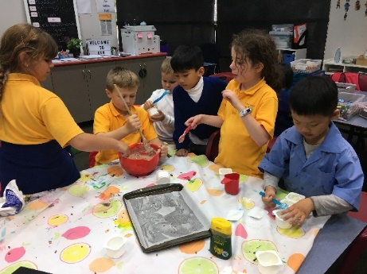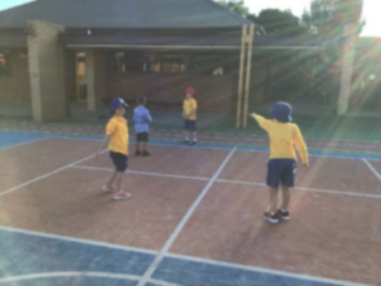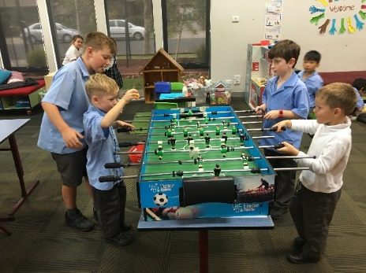
This has been amazing to see and has allowed for the staff at Corpus Christi OSHClub to continually focus upon developing and refining the program throughout the term. It has also allowed for the staff at OSHClub to also focus upon continuing to rebuild the community links and ties to the school community (children and families), to further develop their rapport, friendships and lines of communication between the staff at OSHC and the staff (Administration, Teachers and Learning Support Workers) at the school and to continue to rebuild our presence within the school community.
By doing this we have been able to increase the attendance of children throughout the term. This has been because we have been open to and available for school tours (have met and welcomed prospective parents into the program), answering emails and inquiries from prospective families and those who have newly enrolled into the program, via completing newsletters which are sent out through the school newsletter and kidsoft, and through collecting preps during the drop off and pick up collection times.
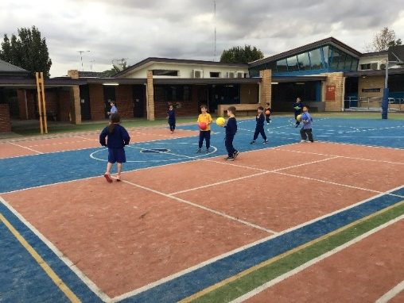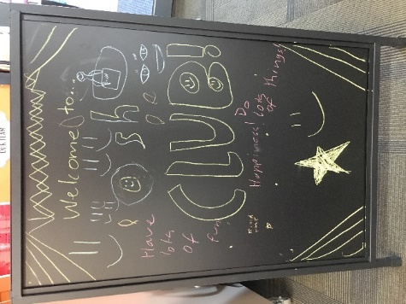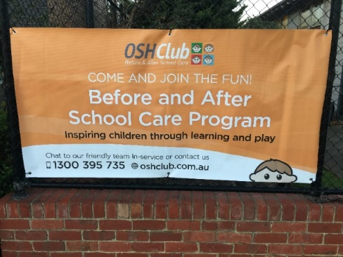
This term, we discovered that the school implements a sustainability program which focuses upon reducing waste and paper recycling. We also found out that the school implements a PBIS program within the school and this is done through the implementation of Classroom DOJO points. We are currently in discussions with the school about how we can participate and contribute to these programs.
We have moved around playspaces (put the home corner near the windows, created a reading area/circle time seating area). We have also redecorated the walls and added colour to them, moved around feature pieces and signage and ensured that the room appears to be more kid friendly and child like. This has all been influenced by our discussions with the children and families who engage within the program.
Hence, our activity engagement and overall attendance at OSHClub has improved as we are getting more children than ever. This has been partly due to the staff at the service implementing the new clubs which consistent of Junior Master Chef, STEM Club, Creative Club and Sustainability Club.
Our biggest hit has been the implementation of the Junior Master Chef club where we have explored our prowess for cooking. The children have helped make or attempted to make Jelly (Mango/Grape/Lime flavours) with chocolate on the side, have endeavoured to make choc chip cookies, pancakes and other dishes. Whilst some of them did not work, they have had fun none the less by participating within the process.
We have also explored our innate sense of creativity through our creative club. We have been focusing on the Harry Potter book series throughout this term and have just begun listening to the Audiobooks. The kids have loved doing this and they have begun exploring their artistic selves through the creation of wands, lego panoramas, acting out different scenes from the books and movies, and drawing pictures of their favourite moments from the book.
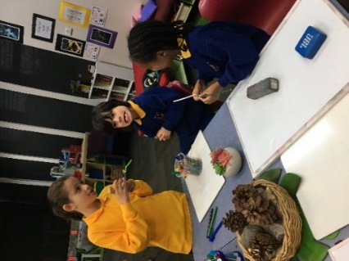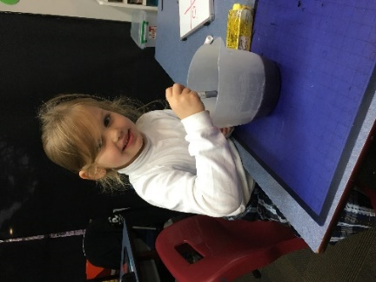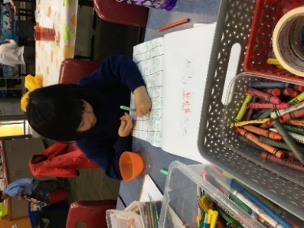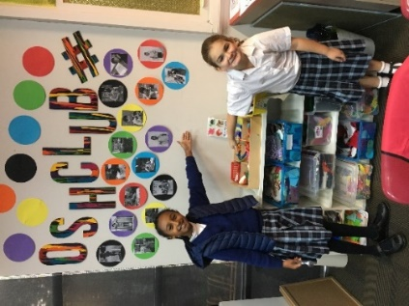
We have also been fortunate as well to implement a Sports Club (off shoot of the STEM Club) where the children have been participating within their favourite games. The most requested game so far has been Dodgeball (everyone’s favourite) which has been followed by Zombie Tag and Zombies Attack, Forty Forty Homebase, Toilet Tag, Keepings Off and so much more. We have found that sport has been a great way for children of all ages to develop friendships with one another and further strengthen already existing bonds.

National Quality Standard assessment and rating reports
Our service at Corpus Christi OSHClub was last assessed in May 2019. We received a rating of Meeting within the National Quality Framework.

Waiting Lists
We have no waiting list at this service.

Policy updates
At OSHClub, we aspire to be recognised as a national market leader that has a focus on excellence, aligned to the industry endorsed frameworks provided by the Australian Children’s Education & Care Quality Authority.
As part of our ongoing internal improvement processes, we have recently reviewed our Policies and Procedures in order to align them to the National Quality Standard (NQS). Our new Operational Policies are now divided into seven sections, as per the seven Quality Areas of the NQS. There will be minimal impact to Service activities unless there are practices that improve the safety and quality of care through learnings and best practices from the industry.
The new Policies have been made available for parents/guardians through our on-line portal. Rollout of the new Policies and Procedures commenced on Monday 7th June, with a gradual transition to support parents/guardians and our staff in familiarising with the new Policies and Procedures.

Formal complaints
Complaint | Action taken to resolve | Timeframe for resolution
None | N/A | N/A

Incidents
Incident |  | Action taken to resolve | Timeframe for resolution
None | N/A |  | N/A

Breaches or non-compliances
Breach/non-compliance | Action taken to resolve | Timeframe for resolution
None | N/A | N/A

Attendances
