Spicy Indian Rice

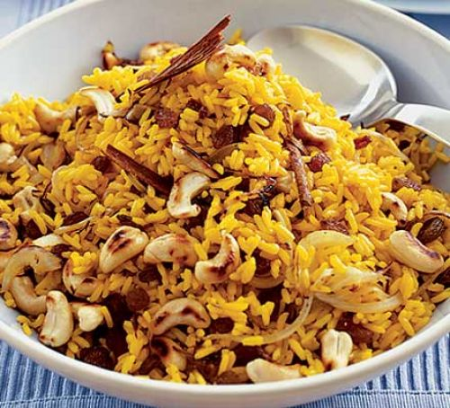


Recipe source: BBC Goodfood by Sarah Buenfeld.

Sara Buenfeld’s delicious spicy rice is perfect served with your favourite curry.

Equipment: | Ingredients:  - 1 cup of long grain rice  - 2 onions, sliced  - 2 tbsp sunflower oil  - 1/2 tsp turmeric  - 1 cinnamon stick  - 6 cardamom pods  - 1 tsp cumin seeds  - Large handful of sultanas and roasted cashew nuts (we are not using the cashew nuts at Skye Primary School).
  - Fry Pan
  - Wooden spoon
  - Saucepan
  - Measuring spoons
  - Measuring cups
  - Slotted spoon
  - Sieve
  - Knife
  - Chopping Board

What to do:
- Fry the onions in the sunflower oil in a large frying pan for 10-12 minutes until golden.
- Fill a roomy saucepan with water, bring to the boil and tip in a heaped teaspoon of salt - the water will bubble furiously. Add turmeric and the cinnamon stick to the water.
- Pour in the rice, stir once and return to the boil, then turn the heat down a little so that the water is boiling steadily, but not vigorously. Boil uncovered, without stirring (this makes for sticky rice) for 10 minutes. Lift some out with a slotted spoon and nibble a grain or two. If they're too crunchy, cook for another minute and taste again. They should be tender but with a little bite.
- Drain the rice into a large sieve and rinse by pouring over very hot water.
- Stir the crushed seeds of the cardamom pods into the onions with the cumin seeds and fry briefly.
- Toss in a large handful of sultanas and roasted cashew nuts (we are not using nuts), then the hot drained rice. This is great with curry and will also give an exotic edge to grilled meat or fish.

