

Artificial Intelligence Student Use
This document outlines the College’s expectations regarding student access to and use of artificial intelligence technologies within learning environments. It establishes a framework for limited, guided, and purposeful use of AI that prioritises authentic learning, human relationships, student wellbeing, and responsible digital citizenship.
This document should be read in conjunction with other relevant College policies and procedures including, but not limited to:
- EREA AI Governance Policy
- Privacy Policy
- Student Duty of Care Policies and Procedures
- Intellectual Property Policy and Procedures
- EREA Cyber Security Policy

Rationale
“Schools are not called to follow the pace of the digital world, but to offer that which the digital sphere by itself cannot provide, namely a shared time for learning and developing trustworthy relationships.”

Pope Leo XIV, Magnifica Humanitas: On Safeguarding the Human Person in the Time of Artificial Intelligence (Vatican City: Vatican Press, 2026).
Artificial Intelligence is increasingly embedded in the learning, social, and personal lives of young people. Research and polling indicate that many young people are now regularly engaging with AI for study support, personal advice, and wellbeing-related conversations. Schools therefore have a responsibility not only to teach AI literacy, but also to provide safeguards that support student wellbeing, privacy, critical thinking, and ethical decision-making.
The College recognises that AI is neither inherently positive nor negative; rather, its educational value depends on how it is used. Consistent with Catholic understandings of human dignity and the common good, AI should remain a tool that strengthens human learning, relationships, and flourishing rather than replacing them. Technologies should serve people, not diminish agency, truth, or authentic human connection.
Accordingly, the College adopts a limited-source approach to AI use that prioritises:
- Human dignity and authentic relationships
- Student wellbeing and safeguarding
- Truth, critical thinking, and verification
- Privacy and data protection
- Equity of access
- Responsible digital citizenship
- Human oversight in all learning processes

Limited Source Approach
Students may only use the school’s AI Co-Pilot Platform as accessible through their school Microsoft account and under the guidance and supervision of their teacher in line with the College’s Artificial Intelligence Framework.
The limited source approach:
- AI systems licensed, approved, or endorsed by the College
- AI functionality embedded within approved College software ecosystems
- AI tools only when explicitly authorised by classroom teachers for defined learning activities
- AI sources listed within assessment notifications or course materials
- AI tools reviewed against College privacy, child safety, and educational criteria
Students must not access or use:
- Public generative AI platforms not approved by the College
- AI systems requiring students to upload personal information or create unauthorised accounts
- AI platforms that collect, retain, or train models using student information without approval
- AI tools that replace required thinking, drafting, or problem-solving processes

The College reserves the right to block, remove, or restrict technologies where concerns arise regarding educational value, student wellbeing, privacy, or safety.

College’s Artificial Intelligence Framework for Learning

The College uses an AI Task Scale to provide clear guidance regarding appropriate AI use in class tasks and assessments, ensuring technology supports learning while maintaining student ownership, critical thinking, authentic demonstration of understanding, and human oversight. The Assessment Scale is published in the College Diary and displayed in classrooms across the College to support students in understanding if, when, and how AI may be used within their learning as directed by their teacher. This framework supports the College’s limited and guided approach to AI use, ensuring technology strengthens learning processes and human agency rather than replacing them.
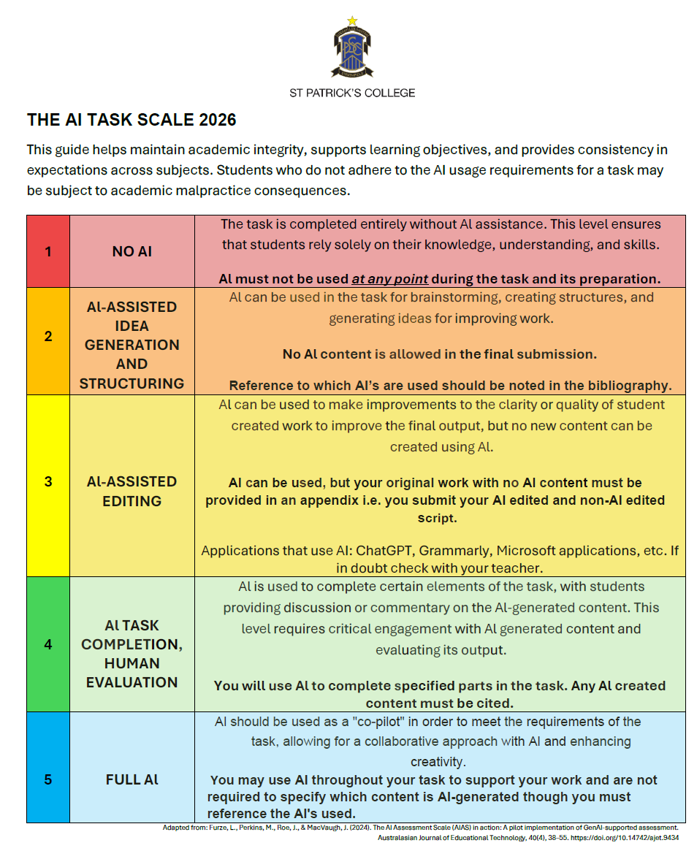

Accessing Additional Artificial Intelligence Platforms for Student Use
“As we adopt AI, we must ensure that our schools serve an integral education that supports every dimension of the person. This means supporting our teachers to engage with these tools positively and confidently, and helping students to use them responsibly rather than passively succumbing to their influence.”
Dallas McInerney CEO Catholic Schools NSW, Magnifica Humanitas –
On Safeguarding the Human Person in the Time of Artificial Intelligence, 28 May 2026.
The College recognises that artificial intelligence technologies evolve rapidly and that new tools may offer educational benefits. As such, additional AI platforms or applications may be considered for student use through a formal approval process.
Requests for approval must demonstrate educational value and will be reviewed against criteria including:
- Alignment with curriculum and learning outcomes
- Student age appropriateness and safeguarding considerations
- Privacy, confidentiality, and data security requirements
- Compliance with College policies and relevant legislation
- Risks relating to bias, misinformation, or inappropriate content generation
- The extent to which human oversight remains central to the learning process
Protecting student privacy and confidentiality remains paramount. Students and staff must not upload personal information, identifiable student data, confidential College information, assessment materials, photographs, or sensitive wellbeing information into unapproved AI systems. Any approved tool must demonstrate appropriate protections for data collection, storage, sharing, and retention.
Following review, approved tools may be assigned a traffic-light classification to guide student use:
- Green: Approved for general educational use within defined learning contexts
- Amber: Approved for limited, guided, or teacher-directed use only
- Red: Not approved for student use due to concerns relating to privacy, safety, educational value, reliability, or student wellbeing
Approval decisions may involve consultation with College leadership, ICT staff, learning leaders, and wellbeing personnel. Approved tools may be subject to ongoing review and may be removed if privacy, safety, or educational concerns emerge.
