**CAREER NEWS** **Friday 13 September**

** Dates to Diarise in Term 3**

* **Year 12 VTAC timely applications** – throughout August and September
* **VTAC SEAS and Scholarship applications** – throughout August and September

  **Reminder: VTAC 2025 Upcoming Key Dates** 

|  |  |
| --- | --- |
| **Timely applications through VTAC** | Monday 30 September 2024 |
| **SEAS applications close** | Friday 11 October 2024 |
| **Scholarships through VTAC close** | Friday 11 October 2024 |

Also, students applying for courses that have **essential requirements** (i.e., submitting a folio, a pre-selection kit, arranging an interview, etc.) are reminded that failure to meet the deadline date for these means students may no longer be eligible for selection into their desired course.

Students eligible to apply for **SEAS** are also encouraged to apply for **VTAC Scholarships**.

**The VTAC website is** [**www.vtac.edu.au**](http://www.vtac.edu.au)

 **September Campus Tours**

*Did you miss out on attending the recent Open Day?* La Trobe will be hosting ***September Campus Tours*** for students who would like to see the Bundoora Campus, get a feel for the campus vibe, check out the facilities and see what it's like to study at La Trobe. Tours will depart at 10.00am and 12.00pm and take around 45 minutes.  
  
**Dates:** Tuesday 24 September OR Wednesday 25 September 2024

**Times:** 10.00am OR 12.00pm

**Venue:** La Trobe University, Jenny Graves Building in Bundoora

**Registrations are essential, so book a spot** [**here**](https://www.eventbrite.com.au/e/september-campus-tours-tickets-939095940237?cid=edm%3Aacs%3Anan%3Ainf&deliveryName=DM65662)**.**

**Experience Day at Federation University**

*Join us at Federation University’s Walk, Talk and Experience Days at the Berwick, Gippsland*

*and Mt Helen campuses.*   
Students can explore possible careers through a wide range of interactive workshops and information sessions, hear from Fed Uni’s current students, and explore the campuses.   
  
Sessions will be focused on:

• Health and Wellbeing

• Education and Community

• Innovation, Science and Sustainability

Register for Berwick: Wednesday 25 September - 10.30am – 12.00pm at [Berwick Experience Day](https://events.federation.edu.au/event/sessions?id=Experience_Day_-_Berwick1451952073)

Register for Mt Helen: Thursday 3 October - 10.30am – 12.00pm at [Mt. Helen Campus](https://events.federation.edu.au/event/sessions?id=Experience_Fed_2024_-_Mt_Helen877784197)

 **School Holiday Program**

*Get ready for our School Holiday Program this October!* *Step into the shoes of an event manager and discover what it’s like to work behind the scenes and front of house in the dynamic hotel and hospitality industry.*  
This will be a fun-filled day of hands-on workshops in hospitality, events, and hotel management. Students will get to explore the campus and discover all the exciting opportunities Angliss has to offer. This program is open to Year 9 – 12 students, and students can choose a morning or afternoon session.

**Date:** Wednesday 2 October 2024

**Time:** 9.30am – 1.00pm OR 12.00pm- 3.30pm  
**Location:** William Angliss Institute, 555 La Trobe Street in Melbourne

**Cost:**  $15.00  
  
**Registration is essential, and a minimum of 48 hours’ notice must be given for cancelling a booking. Book a spot at** [**School Holiday Program**](https://www.angliss.edu.au/events-hub/school-holiday-program/)**.**

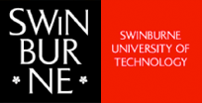 **News from Swinburne University**

* **A Day in the Life of a Swinburne Student**

During the September holidays Swinburne will be hosting school students who might have missed their Open Day, or just want to get an idea of what university is really like.   
  
With **nine different study areas** to choose from, hands-on workshops, informative presentations and more, students can get a firsthand glimpse of what their Uni experience might be like – including engineering, science, media, education, creative, business, law, health and psychology.

**Date:** Tuesday 24 OR Wednesday 25 OR Thursday 26 September 2024

**Location:** Advanced Technologies Centre, [Hawthorn campus](https://t.mail.swinburne.edu.au/r/?id=h436384a,7fbeb17,7fbeb20&e=c2VpZD1jaF9lbSU3Q2NhbXBfY3Bud3MlN0NzcmNfY3AlN0NhdWRfY3BzJTdDY3JlX2NwYXVnMjQlN0NuYQ&s=jmcAw8kMx3Andps8inNEa9f2qmiBGCSHITypuA0faUk)

**Registration is essential so book a spot** [**here**](https://www.swinburne.edu.au/collaboration-partnerships/school-programs/workshop-events/immersion-days/)**.**

* ***New* Bachelor’s Degrees in 2025**

Swinburne is proud to announce three *new* bachelor’s degrees for 2025. All three degrees are available to apply for via VTAC and available via the Early Entry Program.

* **Bachelor of Design (Fashion)**

Focusing on digital solutions, novel fabrics and ethical practices, the [Bachelor of Design (Fashion)](https://www.swinburne.edu.au/course/undergraduate/bachelor-of-design-fashion/) will foster the innovation needed to transform the fashion industry. Students will graduate with the industry exposure and skills to enter this exciting and creative field and will become frontrunners in its sustainable and tech-forward future. Entry for the Bachelor of Design (Fashion) is by folio, not by ATAR score.

* **Bachelor of Biomedical Science**

Through hands-on, tech-focused learning and industry experience, the [Bachelor of Biomedical Science](https://www.swinburne.edu.au/course/undergraduate/bachelor-of-biomedical-science/) immerses students in this critical arena of healthcare. With access to cutting edge equipment, including virtual reality and digital dissection, students will graduate ready for the biomedical workforce, or for postgraduate physiotherapy, occupational therapy and medicine. An ATAR of 60.00 will guarantee an offer.

* **Bachelor of Nutrition**

Lab-based study meets progressive food trend analysis in the [Bachelor of Nutrition](https://www.swinburne.edu.au/course/undergraduate/bachelor-of-nutrition/). In this always-evolving field, students will examine the science of nutrition and uncover new ideas in the relationship between food and human health, with pathways into industry or postgraduate dietetics. An ATAR of 60.00 will guarantee an offer.

 **Diploma of Nursing Pathway**After successful completion of the ***Diploma of Nursing*** – which is currently a FREE TAFE course – students may have the option of applying to universities and being granted up to 12 months credit towards most 3-year Bachelor of Nursing qualifications. Box Hill Institute has specific articulation arrangements with *ACU, Deakin and La Trobe* Universities.

**Find out more about the Diploma of Nursing at** [**Diploma of Nursing at Box Hill Institute**](https://www.boxhill.edu.au/courses/diploma-of-nursing-hc543-d/)**.**

**Richmond Institute Information Sessions**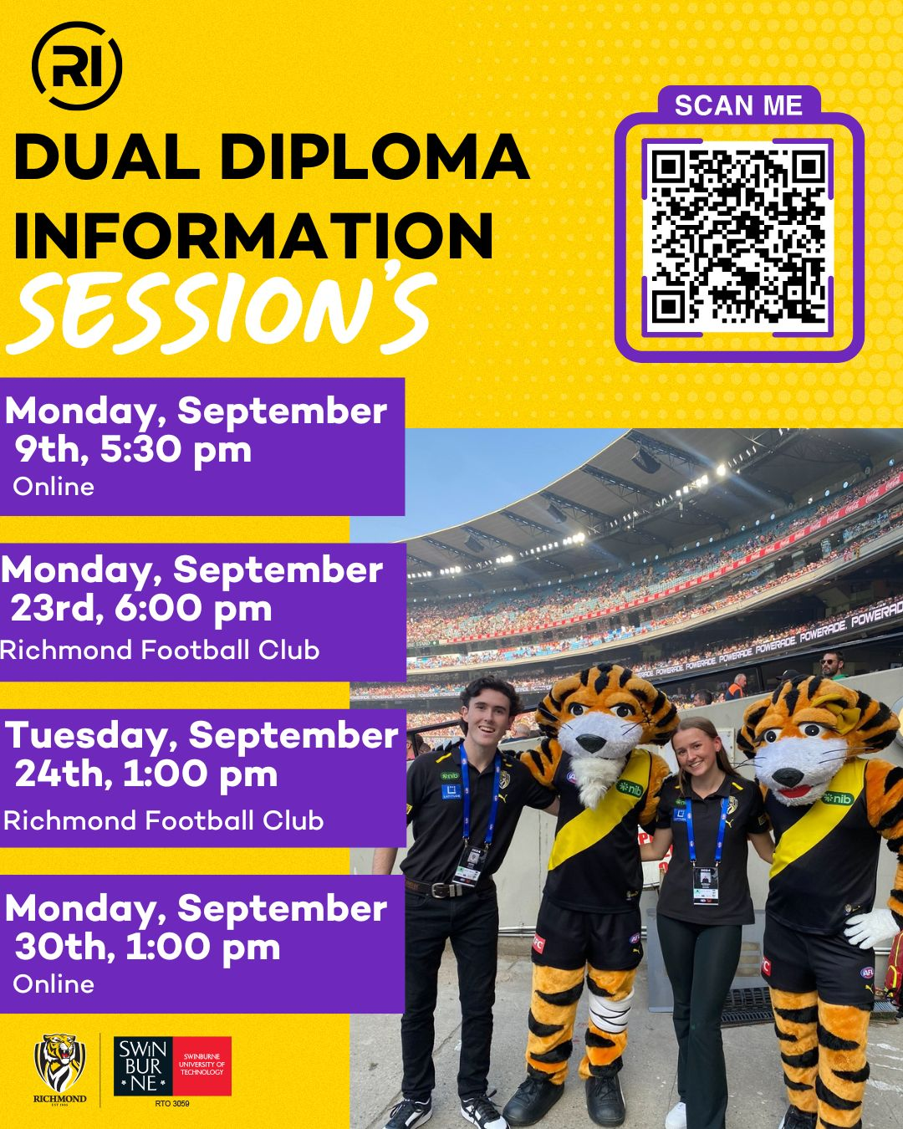

******Health Science Degrees in Victoria in 2024***Are your strengths in health? Are you interested in how the body works?*   
Below is a list of a number of health science degrees offered at Victorian Universities that lead to very diverse career opportunities. For a comprehensive list of health sciences courses, including double degrees, on offer at both TAFEs and universities, visit [**VTAC**](http://www.vtac.edu.au/).

|  |  |  |  |
| --- | --- | --- | --- |
| **INSTITUTION** | **COURSE** | **VCE PREREQUISITES** | **MAJOR STUDIES IN 2024** |
| **DEAKIN** | [Health Sciences](http://www.deakin.edu.au/course/bachelor-health-sciences) | Units 3 and 4: a study score of at least 30 in English (EAL) or at least 25 in English other than EAL. | Disability and inclusion, Environmental health, Exercise science, Family, society and health, Food studies, Health promotion, Health, nature and sustainability, Medical biotechnology, Nutrition, Physical activity and health, Psychological science, Psychology for allied health, Public Health. |
| **LA TROBE** | [Health Sciences](https://www.latrobe.edu.au/courses/bachelor-of-health-sciences) | Units 3 and 4: a study score of at least 25 in English (EAL) or at least 20 in English other than EAL. | Environmental health, Health promotion, Health, wellbeing and performance, Human physiological sciences, Medical and exercise science, Psychological science, Public health, Rehabilitation counselling. |
| **MONASH** | [Health Sciences](https://www.monash.edu/study/courses/find-a-course/2019/health-sciences-m2014) | Units 3 and 4: a study score of at least 27 in English (EAL) or at least 25 in English other than EAL. | Anatomy, Biostatistics, Epidemiology, Forensic medicine, Global Health, Health and Human Development, Health promotion, Health sciences, Healthcare, Human health, Physiology, Public health, Social sciences. |
| **RMIT** | [Health Sciences (Associate Degree)](https://www.rmit.edu.au/study-with-us/levels-of-study/undergraduate-study/associate-degrees/ad019) | Units 3 and 4: a study score of at least 25 in English (EAL) or at least 20 in English other than EAL. | Health and Nutrition, Understanding the Psychology of Health and Exercise in Health, Human Biology and Understanding disease processes and treatment., Law and Ethics in Health and Healthcare in Australia, Project Management in Health and Health; Industry Project and Practice. |
| **SWINBURNE** | [Health Science (Professional)](https://www.swinburne.edu.au/study/course/bachelor-of-health-science-professional/)  (4-year degree as it includes 12-month paid work placement) | Units 3 and 4: a study score of at least 30 in English (EAL) or at least 25 in English other than EAL. | Biomedical science, Clinical technologies, Neuroscience, Nutrition, Psychology and forensic science , Psychology and psychophysiology, Public health and health promotion. |
| [Health Science](https://www.swinburne.edu.au/study/course/bachelor-of-health-science/) (3-year degree) | Units 3 and 4: a study score of at least 30 in English (EAL) or at least 25 in English other than EAL. | Biomedical science, Clinical technologies, Neuroscience, Nutrition, Psychology and forensic science, Psychology and psychophysiology, Public health and health promotion. |
| **VICTORIA** | [Health Science](https://www.vu.edu.au/courses/bachelor-of-health-science-hbhl) | Units 3 and 4: a study score of at least 25 in English (EAL) or at least 20 in English other than EAL. | Indigenous health, Public health. |

**Snapshot of The University of Sydney in 2024**

* Established in 1852, The University of Sydney is the oldest university in Australia.
* Ranked in the top 50 universities globally - [QS World Rankings](https://www.topuniversities.com/qs-world-university-rankings), ranking 19th in the world, and listed as 3rd in Australia.
* Ranks #1 in Australia *for veterinary sciences,* and #3 for *architecture/built environment;* #1 in Australia for *English language and literature,* and#2 in Australia for *sports-related subjects*.
* The University of Sydney has a number of faculties and schools -

[Arts and Social Sciences](http://sydney.edu.au/arts/)

[Business](http://sydney.edu.au/business)

[Dentistry](http://sydney.edu.au/dentistry/)

[Engineering](http://sydney.edu.au/engineering/)

[Health Sciences](http://sydney.edu.au/health-sciences/)

[Medicine](http://sydney.edu.au/medicine/)

[Nursing and Midwifery](http://sydney.edu.au/nursing/)

[Pharmacy](http://sydney.edu.au/pharmacy/)

[Science](http://sydney.edu.au/science/)  
[Architecture, Design and Planning](https://sydney.edu.au/architecture/)  
[Law](https://sydney.edu.au/law/)   
[Conservatorium of Music](https://sydney.edu.au/music/)

* To help students make informed decisions and provide transparency, the University of Sydney has published a list of required ATARs that [guarantee entry](https://www.sydney.edu.au/study/applying/how-to-apply/undergraduate/guaranteed-entry.html) into many courses.
* There are numerous campuses from the inner city of Sydney to the Great Barrier Reef, with teachers, researchers and students based all over Australia - [campuses](https://sydney.edu.au/about-us/campuses/campus-locations.html).
* The university has [international partnerships](https://www.sydney.edu.au/engage/global-engagement.html) with other universities and research institutes, as well as [industry partners](https://sydney.edu.au/about-us/partnerships/industry-and-business-partners.html) such as *Microsoft, Qantas, Rio Tinto, BHP,* and the *GE Healthcare.*
* There are many flexible [courses](https://sydney.edu.au/study/find-a-course.html) offered at the University of Sydney, from undergraduate to postgraduate.
* There are [scholarships](https://sydney.edu.au/scholarships/) available for domestic and international students at all levels.
* [Study abroad and student exchange](https://www.sydney.edu.au/students/study-overseas.html) opportunities are on offer with over 250 programs for students to consider.
* There is a well-established [Careers Centre](https://sydney.edu.au/study/career-services.html) that offers numerous services and resources to help students identify their career options and achieve their career goals.
* Regarding [accommodation](https://sydney.edu.au/campus-life/accommodation.html) for interstate students, there is a variety of on-campus and off-campus options available.
* There are over 250 university [clubs and societies](https://sydney.edu.au/campus-life/clubs-and-societies.html), so something for everyone.

