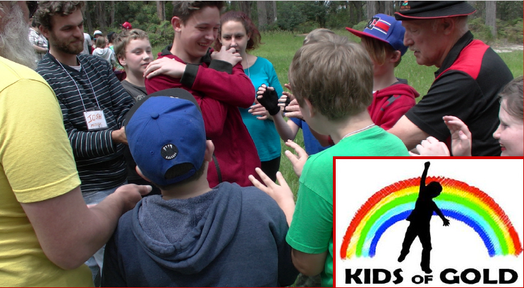
CAMP FOR BUILDING SELF ESTEEM & CONFIDENCE FOR KIDS!

HELPING KIDS BUILD SELF-ESTEEM AND CONFIDENCE
KIDS OF GOLD, 323 MONBULK RD SILVAN VIC 3795 – ABN 57 327 231 83

Open to Primary kids in grades 4-6 in 2023 (and 9 year olds in grade 3). This is a Level 1 camp, designed for those who are completely new to Kids of Gold camps.

Activities are fun: from low ropes, initiative activities, wall climbing, games, drama and challenging interactive sessions.

Starting in Feb 2003, this camp has continued for one reason– because it works! It builds kids to be much more confident and increases their self esteem. We just finished our Level 3 camp at the end of May 2023, and already we have a number of bookings for October. We find parents Currently, many children are suffering from the long term affects of Covid, which, although this was not anticipated when these camps first began, has become increasingly important to address as a direct result.

Google kids of gold to see who we are, what we do and to apply online or download a form for the Oct 23 camp. The form and website have more on how the camp started and where it is situated in the beautiful Yarra Valley.

Fri 27th – Sun 29th Oct 2023
$85 Full Fee *
www.kidsofgold.org.au

Held at Lyrebird Park
Beenak Rd, Yellingbo
Melways 307 K10

*Cost of $85 is subsidised by
sponsors such as Bendigo Bank,
Bunnings and Yarra Ranges Council.

Contact Kids of Gold
0415 427 396, 9737 9475 (Gary) or 0403 271 987 (Melissa) to hold a place and/or find out more

