CHRISTMAS 2022 HAMPERS
& CHILDRENS GIFT WISH TREE
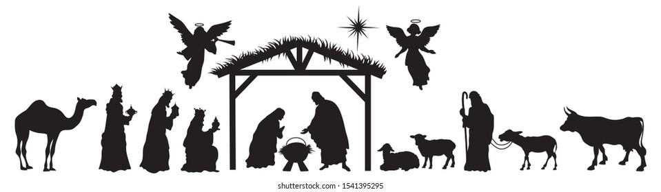

We have 81 families on our Christmas Hamper list this year. To help you prepare your hamper a range of suggested items can be found on the back of this letter. Please keep in mind that all food items should be non-perishable and their “best before” dates after December. If you wish to provide gifts specifically for children, age tags can be found on the Gift Wish Tree in the Church Foyer. When packing your hamper please ensure it can be lifted easily by one person if not, please use two containers. Please also remember to attach hamper number tags to each container and do not include your name on any greeting card or tag. You can however write ‘From the Parishes of Holy Spirit, St. Anne & St Gerard if you wish.

If you have any queries, please contact Joe on: 0418 565 795 or Sue on 0419 339 048

Thank you for your generous support.

Thank you again and best wishes to you from the St. Vincent de Paul Society
To add that extra touch of Christmas you may wish to include Christmas Cake, Christmas Pudding, Mince Pies, bonbons and one or two small decorations and don’t forget if you’re out of ideas Movie tickets are always very well received.
Christmas Hamper Suggestions
O Sweet Biscuits
O Breakfast Cereals
O Muesli Bars
O Lollies
O Tinned Fruit
O Sugar
O Baked Beans
O Tinned Spaghetti
O Tomato Sauce
O Tinned Tuna/Salmon
O Pasta Noodles
O Pasta Sauce
O Potato Chips
O Corn Chips
O Salsa
O Savoury Biscuits
O Rice
O Le Snack Cheese
& Biscuit dip
O Soup
O Vegemite
O Honey
O Jam
O Nutella
O Sultanas
O Dried Apricots
O Milo
O Tea
O Coffee
O Cordials
O Toothpaste O Toothbrush O Soap
O Comb O Hair Brush O Face Washer

Thank you again and best wishes to you from the St. Vincent de Paul Society

