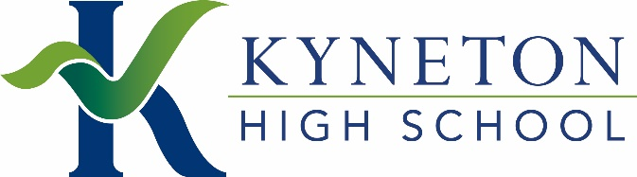

A message from Kyneton High School to Grade 6 families
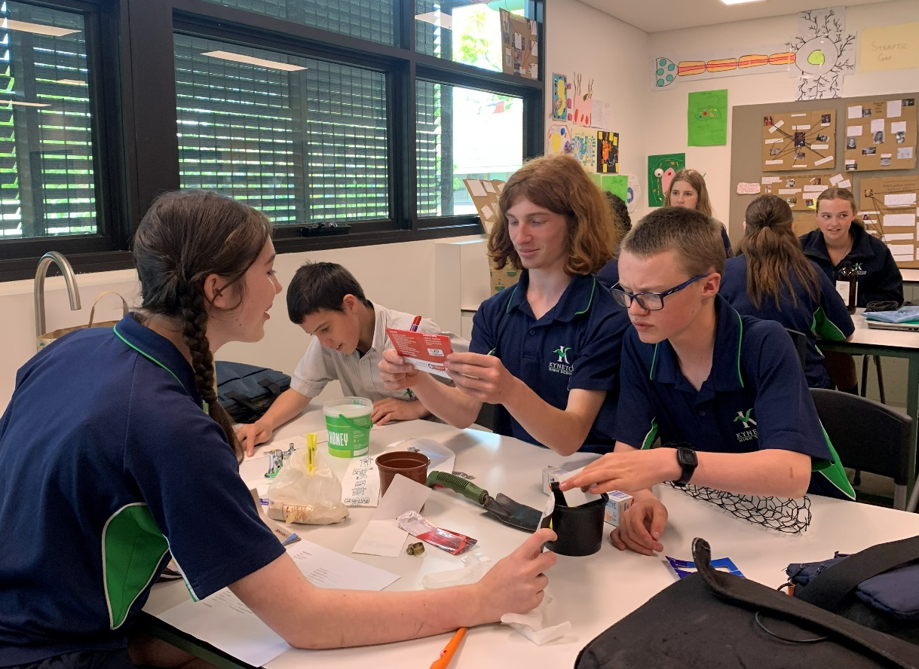
At Kyneton High School, we know that choosing a secondary school is an important decision. As the Year 6–7 transition process begins in Term 2, your primary school is providing families with a Transition Pack in which you will be asked to nominate the school you would prefer your child to attend in Year 7, 2027.
For families living in our zone, Kyneton High School is your local neighbourhood school, and every student has the right to enrol here. We are proud to be a public school at the heart of our community, and we see every year the value this brings to our students.
As a local public school, our students learn alongside peers from across our local communities. This means they build lasting friendships with local peers, learn in a diverse and inclusive environment, and develop the skills to work with a wide range of people. Most importantly, at Kyneton High School, students learn in a culture where staff and families have high expectations for the success of all learners.
At Kyneton High School, our focus is on ensuring every student is supported and challenged. In every classroom, teachers use inclusive practices as part of their everyday teaching. This is supported by:
- targeted literacy, numeracy and wellbeing support where needed
- individual learning adjustments for students who require them
- extension, enrichment and acceleration opportunities for students ready for further challenge.
We also place a strong emphasis on supporting students through the transition period between primary and secondary schooling.
We work closely with primary schools and families to ensure students feel known and supported before they arrive. This includes:
- sharing information about each child’s strengths and needs
- additional transition opportunities for students requiring extra support
- a structured start to Year 7, including family interviews and a strong home group program.
Beyond the classroom, students are encouraged to get involved in school life. Whether through music, drama, sport, clubs or leadership, these opportunities help students build confidence and a strong sense of belonging.
As students progress through the school, they are supported to explore future pathways through career education, work experience and academic and applied senior programs, helping them move confidently into further study at University of TAFE, training, apprenticeships or employment.
For families in our local area, choosing your neighbourhood school means choosing a school that is connected to your community and committed to knowing and supporting your child as an individual.
We encourage families to learn more about Kyneton High School, attend a tour, and consider what a strong local public school can offer.
We look forward to working with you and your child as they begin this next stage of their education.
If you have any further questions, please see the resources listed below, or you may wish to get in touch with us on kyneton.hs@education.vic.gov.au.
Resources:
Find My School website – use this site to find your local zoned school
Kyneton High School website
Kyneton High School Policies website
How we support students with additional needs at Kyneton High School Booklet – for students with diagnosed or suspected disabilities or learning difficulties, and neurodiverse students
The Student Excellence Program at Kyneton High School Booklet – for students with high ability in one or more areas

